

HR Project
Team Members
Nada Youssif Sultan
Reham Ashraf
Mai Ayman
Mai Mossad
Farah Mohamed

Supervised By:
Eng. Ahmed Samir

CONTENTS
Chapter 1: Introduction …………………………………………….....………….……………Page 5
- Introduction ………………………………………………………………………………………….....7
- Problem statement……………………………………………………………………………………...7
- Objective of project……………………….........………………………………………………………8
- Data sources & Description……………….........………………………………………………………9
4.1. Employees dataset……………………………………………………………………….........…...9
4.2. performance rating Dataset………………………….…………………………………........….....9
4.3. satisfaction level dataset…………………………………..…………………………….......…….9
4.4. Education level dataset………………………………………..………………………….......…...9
4.5. Rating Level Dataset…………………………………………………………………….......……9
- Analysis & finding ………………………………………………………...……………….….....…...9
  - Attrition rate analysis……………………………………………….....………………….....…...10
  - Job satisfaction & attrition………………………………………………………….…….....…...10
  - Salar & employee attrition………………………………………………………….…….....…...10
  - Performance rating & attrition…………………………………………………..………..…........10
  - Department-wise Attrition trends………………………………………………………..…….....11
- Solutions & Recommendations………………………………………………………………....….....11
  - Retention strategies for high-risk employees………..……………………………..……..….......11
  - Enhancing Job satisfaction & employee engagement.……………………………………….......11
  - Performance-Based compensation & development………………………………………….......11
  - Managerial improvement & feedback culture…..……………………………………………......11
  - Data-drive HR decision making………………………………………………………………....12
Chapter 2: Data Modeling Data Cleaning & Preprocessing...........................................................13
2.1. Introduction………………………………………………………………………….………13
2.1.1. Data understanding…………………………………………………………………..……13
2.1.2. handling missing values…………………………………………………………………...13
2.1.3. Removing Duplicates……………………………………………………………………...13
2.1.4. Data type corrections…………………………………………………………...……….....13
2.1.5. standardizing and encoding data…………………………………………….......………....13
2.1.6 Feature engineering………………………………………………………………...…….....14
2.1.7. Data integration…………………………………………………………………….…..…..14
2.1.8 Final Data quality check……………………………………………………………..……..14

2.2. Data cleaning and preprocessing using PYTHON…………......……………………………14
2.2.1. Importing needed libraries……….……………………………………………………..…15
2.2.2. Reading CSV files for data 5 tables……………………………………………………....15
2.2.3. Cleaning for employee table…………………………………………………………..….16
2.2.4. Cleaning for performance rating table……………………………………………………28
2.2.5. Cleaning for satisfactions rating table…………………………………………………….33
2.2.6. Cleaning for rating table…………..……………………………………………....………35
2.2.7. Cleaning for education rating table………………………………………………...……..37
2.2.8. Save cleaned files to CSV files………………………………………………………...…39

2.3. Data cleaning and preprocessing using SQL……………………....……….....………………..39
2.3.1.(From Table: Employees)…………………………………….………....…………………39
2.3.1.1. Remove duplicate ……….……………………………….………...…………………..40
2.3.1.2. Retrieving columns that have null values……………….………..……………………40
2.3.1.3. Remove spaces using trim………………………………..……….……………………41
2.3.1.4. Check if there are empty values…………………………..……………………………41
2.3.1.5. Replace columns names and values……………………...…………………………….42
2.3.1.6. Update values……………………………………………..……………………………42
2.3.1.7. Change hire date column data type………………………...…………………………..44
2.3.2.(From Table: Performance)……………………………….....………..……………………45
2.3.2.1. Remove duplicate ……….………………………………………....…………………45
2.3.2.2. Replace blank or invalid with null……………………….………...………………….45
2.3.2.3. Replace invalid with null………………………………….………....………………..45
2.3.2.4. Replace null values in numeric columns with default values…….....…..…………….45
2.3.3.(From Table: Educational level)…………………………………......…..…………………46
2.3.3.1. Trim unnecessary spaces ……….………………………………...………………….46
2.3.3.2. Check duplicates rows………………………………………...…...…………………47
2.3.3.3. Correcting wrong values…………………………………………...…………………47
2.3.3.4. Check if there are null values………..……………………………....………………..47
2.3.4.(From Table: Rating level)………………………………………......…...…………………47
2.3.4.1. Trim unnecessary spaces ……….……………………………………………………47
2.3.4.2. Standardization of Educational level values………………………………………….48
2.3.4.3. Check duplicates rows……………………………………………….……………….48
2.3.4.4. Check if there are null values………..…………………………….....………………48
2.3.5. (From Table: Satisfaction level)………………………………......……………………48
2.3.5.1. Trim unnecessary spaces ……….……………………………………………………48
2.3.5.2. Check duplicates rows…………………………………………………………….….48
2.3.5.3. Check if there are null values………………………….………..……………………49
2.3.6. Outliers of Dataset………………………………………………....……...…………….49
2.3.7. Data after Cleaning of Dataset………………………………………………….………49
2.4. Data Modeling…………………………………………………………...………….....………..49
2.4.1. Add primary keys…………………………………………………………....………….49
2.4.2. Add foreign keys………………………………………………….…………....……….50
2.4.3. Check if all Tables is related successfully…………………………………....………... 51
Chapter 3: Analysis Questions ……………………………………………...…………………….52
1.1 Introduction ...............................................................................................................................52
1.2 HR Analysis ............................................................................................................................52
1.2.1 Employee demographics & general information..............................................................53
1.2.2 Attrition Analysis ............................................................................................................53
1.2.3 Performance Analysis......................................................................................................54
1.2.4 Job Satisfaction Analysis.................................................................................................54
1.2.5 Overtime .........................................................................................................................54
1.2.6 Salary & Compensation Analysis ..................................................................................54
2.Analysis Questions using python ................................................................................................55
3. Analysis question by SQL.............................................................................................................89
Chapter 4: Forecasting Questions ……………………………………………………………......109
4.1. Introduction.........................................................................................................................109
4.2 Chart 1 Employee Attrition Forecast...................................................................................110
4.2.1. Insights from the attrition forecast................................................................................111
4.2.2 Predicted problem.........................................................................................................111
4.2.3 Mitigation Srategies......................................................................................................112
4.3 Chart 2 performance Rating Forecast..................................................................................113
4.3.1 Insight from performance Rating ...............................................................................114
4.3.2 Features affecting performance ..................................................................................114
4.3.3 Predicted problem ......................................................................................................115
4.3.4 Mitigation Strategies .................................................................................................115
4.3.5 Strengthen leadership and managerial support...............................................................115
4.3.6 Reduce Attrition & Retain skilled employee..................................................................115
4.4 Chart 3 Correlation Matrix ....................................................................................................116
4.4.1 Insight from correlation Matirx.......................................................................................118
4.4.2 Feature selection for forecasting.....................................................................................118
4.2.3 Understanding Key influences........................................................................................119
4.5 Chart 4 Salary Growth Projection.........................................................................................120
4.5.1 insights from salary growth projection..........................................................................120
4.5.2 predicted problem .........................................................................................................121
4.5.3 Mitigation strategy.........................................................................................................121
4.6 Chart 5 Work-Life Balance Impact on satisfaction.............................................................122
4.6.1 Insights from work-life balance forecast........................................................................123
4.6.2 Predicted problem ..........................................................................................................123
4.6.3. Suggested solutions ......................................................................................................124
4.7 Chart 6 Workforce Education Trends.................................................................................125
4.7.1 Insights from chart.......................................................................................................126
4.7.2 Predicted problem........................................................................................................127
4.7.3 Mitigation Strategy ......................................................................................................127
Chapter 5: Visualization Dashboard……………………………………………………...……139
5.1. Employee Demographics Dashboard……………………………………………..….139
5.2. Attrition Analysis Dashboard ……………………………………………………..….142
5.3. Job Satisfaction Analysis Dashboard……………………………………………..…..149
5.4. Salary Analysis Dashboard ……………………………………………………….…..152
Chapter 6: Conclusions and Recommendations……………………………………….……..155
6.1. Retention in Sales & Technology …………………………………………………..…155

6.2. Improve Compensation & Benefits……………………………………………….155
6.3 Manage overtime……………………………………………………………………158
6.4. Support for early-Career employees …………………………………………….158
6.5. sustain & enhance diversity & inclusion…………………………………………158
6.6. Improve work -life balance ………………………………………………………159
6.7. Leverage & retain tenured employees…………………………………………..159
6.8. Address Mid-Tenure Performance decline…………………………………….159
6.9. Strengthen the link between job satisfaction& performance…………………160
6.10. Address departmental performance gaps…………………………………….160
6.11. Optimize salary for performance ……………………………………………..161
6.12. Final Note………………………………………………………………………..161

List of Figures
Title | Page
Figure (1): Importing needed libraries | 17
Figure (2): Reading csv file | 17
Figure (3): Reading employees table | 17
Figure (4): Reading Performance table | 17
Figure (5): Reading satisfaction table | 18
Figure (6): Reading rating table & education level table | 18
Figure (7): employee table info | 19
Figure (8): Check duplicate | 19
Figure (9): check null | 19
Figure (10): show shape of data | 20
Figure (11): show first 10 rows | 20
Figure (12): show statistics | 20
Figure (13): Trim unnecessary spaces values | 21
Figure (14): show data types of existing columns | 21
Figure (15): Hire date needs to be converted to date time | 21
Figure (16): check if hire data changed to date time | 22
Figure (17): check values of education column to give more expressive name | 22
Figure (18): update to values to column & unique values | 22
Figure (19): check age column outliers & there is non outlier | 23
Figure (20): check for year at company column outliers | 23
Figure (21): check (1) salary outliers according to job | 24
Figure (22): check (2) salary outliers according to job | 24
Figure (23): check (3) salary outliers according to job | 24
Figure (24): check (4) salary outliers according to job | 25
Figure (25): check (5) salary outliers according to job | 25
Figure (26): check (6) salary outliers according to job | 25
Figure (27): check (7) salary outliers according to job | 26
Figure (28): check (8) salary outliers according to job | 26
Figure (29): check salaries have outliers | 28
Figure (30): count employees who have salaries < 100000 $ | 28
Figure (31): check properties of all employees who have highest salaries | 28
Figure (32): Job roles that need search to check if their salaries have outliers | 29
Figure (33): count of employee’s software engineer has salaries < 100000$ | 30
Figure (34): check properties of all who have highest salaries | 31
Figure (35): Info of tables | 32
Figure (36): show shape of data frame & first 10 rows | 32
Figure (37): show some statistical info of data | 33
Figure (38): check null & duplicate values | 33
Figure (39): show data types of existing columns to check any wrong data type | 34
Figure (40): Review date column data type & convert to date time | 34
Figure (41): check if review date column data type changed to date time | 35
Figure (42): Add new calculated column to merge all performance rate | 35
Figure (43): Delete unnecessary column | 35
Figure (44): check training opportunities taken column & training opportunities at year | 36
Figure (45): Trim unnecessary spaces values of string columns | 36
Figure (46): info of cleaning of performance table | 37
Figure (47): shape of data frame & show rows of data | 37
Figure (48): check if duplicate & null values exists | 38
Figure (49): trim unnecessary spaces | 38
Figure (50): info on cleaning of rating table | 39
Figure (51): show table of shape and data types of data | 39
Figure (52): show 5 rows of data in rating level table | 40
Figure (53): check duplicate & null values is exist in rating level table | 40
Figure (54): trims unnecessary spaces in rating level table | 40
Figure (55): info of education level table | 41
Figure (56): show shape & data types of data of educations level table | 41
Figure (57): correct wrong entered values & check if changed successfully | 42
Figure (58): show data types & trim unnecessary spaces | 42
Figure (59): save cleaned & preprocessed data to csv files to be used for analysis phase | 43
Figures (60…78): Data cleaning by SQL | 43…56
Figures (79…144): Analysis Questions using python | 57….95
Figures (80….182): Analysis questions by SQL | 96….116
Figure (183): Attrition forecast for next 5 years | 120
Figure (184): Performance rating forecast for next 5 years | 123
Figure (185): Correlation between performance & other factors | 127
Figure (186): Salary growth projection for next 5 years | 129
Figure (187): Forecast of work-life balance for next 5 years | 132
Figure (188): Project workforce in 5 years by department | 137
Figure (189): Employee demographics dashboard | 139
Figure (190): Attrition analysis dashboard | 143
Figure (191): Job satisfaction analysis dashboard | 150
Figure (192): Salary Analysis Dashboard | 153

CHAPTER 1
INTRODUCTION
1. Introduction
Human Resources (HR) analytics plays a crucial role in helping organizations make data-driven decisions regarding employee retention, performance, and satisfaction. Employee attrition is one of the most significant challenges companies face, as it directly impacts productivity, recruitment costs, and overall company performance. High turnover rates can lead to increased hiring and training costs, loss of organizational knowledge, and disruptions in business processes.
This project aims to analyze HR data to uncover insights into employee attrition, job satisfaction, and performance levels, ultimately providing solutions to improve employee retention and workforce efficiency.
2. Problem Statement
Many organizations struggle with high employee attrition rates without fully understanding the underlying causes. Key challenges include:
- Lack of visibility into the factors influencing employee turnover.
- Inability to predict attrition trends based on historical data.
- Unclear correlation between employee satisfaction, job performance, and attrition.
- Difficulty in optimizing HR policies to retain high-performing employees.
By conducting a comprehensive data-driven analysis, this project will answer critical questions such as:
- What factors contribute most to employee attrition?
- How does job satisfaction impact employee turnover?
- Which departments experience the highest attrition rates, and why?
- How does salary influence employee retention?

How do performance ratings correlate with attrition and satisfaction levels?
3. Objectives of the Project
1️. Identify key drivers of attrition by analyzing various employee attributes such as age, salary, department, job satisfaction, and education level.
2️. Assess the relationship between job satisfaction and attrition to determine whether low satisfaction levels lead to higher turnover rates.
3️. Analyze employee performance ratings (self-rating & manager rating) to understand how performance affects attrition and retention.
4️. Compare attrition rates across different age groups and departments to detect patterns that HR teams can address.
5️. Recommend data-driven solutions to reduce attrition, enhance job satisfaction, and improve workforce management strategies.
4. Data Sources & Description
The project is built on five primary datasets, each providing crucial information for HR analysis:
1. Employees Dataset
- Stores general employee information, including:
  - EmployeeID (Unique identifier for each employee)
  - Age (Employee’s age)
  - Department (The department the employee belongs to)
  - Salary (Annual salary)
  - YearsAtCompany (Total years spent at the company)
  - Attrition ( Yes Value = Employee left, No Value = Employee stayed)
2. Performance Rating Dataset
- Contains employee performance evaluations, including:
  - SelfRating (Employee’s self-assessment of their performance)
  - ManagerRating (Supervisor’s rating of the employee’s performance)
  - WorkLifeBalance (Employee’s perception of their balance between work and personal life)
  - EnvironmentSatisfaction (Employee’s satisfaction with their work environment)
  - JobSatisfaction (Employee’s satisfaction with their job role and responsibilities)
  - RelationshipSatisfaction (Employee’s satisfaction with workplace relationships)
  - TrainingOpportunitiesWithinYear (Number of training opportunities provided to the employee within a year)
  - TrainingOpportunitiesTaken (Number of training programs the employee has attended)
3. Satisfaction Level Dataset
- Includes employee satisfaction scores, such as:
  - JobSatisfaction (Employee's perception of their job satisfaction)
  - SatisfactionLevel (Overall satisfaction rating)
4. Educational Level Dataset
- Captures employees' educational qualifications.
  - Doctorate
  - Master's
  - Bachelor's
  - High School
  - No Formal Qualifications
5. Rating Level Dataset
- Contains performance evaluation categories for employees.
  - Very Dissatisfied
  - Dissatisfied
  - Neutral
  - Satisfied
  - Very Satisfied
5. Analysis & Findings
5.1 Attrition Rate Analysis
- Observation: Employees in certain departments, salary ranges, and experience levels exhibit higher attrition rates.
- Findings:
- Employees aged 25-35 have the highest attrition rate (~49.79%).
- Departments such as Technology & Customer Support face higher attrition.
- Lower salaries (<50,000) are associated with increased turnover.
- Actionable Solution:
- Implement targeted retention strategies for at-risk employees.
- Provide career growth opportunities to employees within critical age ranges.
- Offer competitive compensation packages to retain top talent.
5.2 Job Satisfaction & Attrition
*** Observation: Employees with lower job satisfaction scores tend to leave at a higher rate.
-Findings:
- Employees with Job Satisfaction scores below 3 exhibit a 35% higher risk of attrition.
- Work-life balance and manager relationships significantly impact satisfaction.
-Actionable Solution:
- Improve workplace policies to enhance employee engagement.
- Conduct employee feedback surveys to address dissatisfaction.
- Strengthen manager-employee relationships through mentorship programs.
5.3 Salary & Employee Attrition
Observation: Salary is a key factor influencing Attrition
Findings:
- Employees earning <50,000 have a significantly higher attrition rate compared to those earning above 100,000.
- Employees in higher salary brackets tend to stay longer at the company.
Actionable Solution:
- Offer competitive salary increments based on market trends.
- Implement performance-based bonuses to improve retention.
5.4 Performance Ratings & Attrition
Observation: Employees with low performance ratings are more likely to leave.
Findings:
- ManagerRating and SelfRating are strong indicators of attrition risk.
- Employees with consistent low performance scores often feel disengaged and undervalued.
Actionable Solution:
- Provide training and development programs for employees with low ratings.
- Improve manager feedback systems to ensure fair evaluations.
- Encourage continuous learning and upskilling opportunities.
5.5 Department-wise Attrition Trends
Observation: Certain departments experience higher attrition than others.
Findings:
- Technology And Sales and have the highest attrition rates.
- HR departments show higher retention due to better career growth opportunities.
Actionable Solution:
- Introduce department-specific engagement programs.
- Offer career development pathways in high-turnover departments.
6. Solutions & Recommendations
1. Retention Strategies for High-Risk Employees
- Focus on employees aged < 25 and 25-35, low-salary groups, and customer-facing roles.
- Offer career progression plans(Trainings) and competitive salaries.
2. Enhancing Job Satisfaction & Employee Engagement
- Implement flexible work policies and mental health programs.
- Encourage employee recognition programs to boost morale.
3. Performance-Based Compensation & Development
- Introduce performance-linked salary hikes.
- Provide upskilling and leadership training programs.
4. Managerial Improvements & Feedback Culture
- Train managers in effective employee communication.
- Conduct regular 360-degree feedback reviews.
5. Data-Driven HR Decision Making
- Utilize predictive analytics to identify employees at risk of leaving.
- Develop AI-powered HR dashboards for real-time monitoring.

CHAPTER 2
DATA MODELING, DATA CLEANING & PREPROCESSING
1.Introduction
1.1. Introduction
Data cleaning and preprocessing are crucial steps in ensuring that the dataset is accurate, consistent, and ready for analysis. This phase involves handling missing values, correcting inconsistencies, removing duplicates, and transforming data into a structured format suitable for analysis.

1.2. Data Understanding

Before cleaning the data, we first explored its structure, identifying the key attributes, data types, and potential issues. The dataset consists of five main tables:
Employees Table: Contains employee demographic and job-related information.
Performance Rating Table: Includes ratings from employees and their managers.
Satisfaction Level Table: Stores employee satisfaction scores.
Educational Level Table: Details employee education backgrounds.
Rating Level Table: Categorizes employee performance levels.
Each table was examined for data quality issues such as missing values, incorrect data types, and duplicate records.
1.3. Handling Missing Values
Strategy Used:
  - We Checked If missing values were found in critical columns (e.g., EmployeeID, JobRole),if they were exist they were investigated and removed if necessary But We didn't Found Any Duplicates.
  - If numerical fields like Salary or JobSatisfaction had missing values, we decided to handle it IF exist by:
    - Mean/Median Imputation: For continuous data (e.g., salary, experience).
    - Mode Imputation: For categorical data (e.g., department, education level).
    - BUT We didn't find Any Missing Values
1.4. Removing Duplicates
- Duplicate EmployeeIDs were checked but our data has no duplicates.
- Duplicates were identified using SQL queries and Python's pandas library.
1.5. Data Type Corrections
Check categorical columns (e.g., Department, Job Role) to make sure if it has appropriate categorical formats.
Ensured numerical columns were correctly formatted (e.g., age as integer, salary as float).
Dates(e.g.,HireDate,ReviewDate) were standardized for consistency.
1.6. Standardizing and Encoding Data
Standardized text values (e.g., department names ) to ensure uniformity.
Encoded categorical variables (e.g., Attrition) into numerical values where needed for analysis and modeling.
1.7. Feature Engineering
Created a Performance Score by combining:
SelfRating, ManagerRating, and WorkLifeBalance into a Scaled score.
Added an Attrition Indicator for better visualization and prediction.
Categorized Age into age groups (e.g., "<25", "25-35", "36-45", ">45").
Created a Satisfaction Scaled Score combining JobSatisfaction, EnvironmentSatisfaction, and RelationshipSatisfaction.
1.8. Data Integration
Merged all five tables using the primary and forging keys to create a final dataset for analysis.
Used SQL joins and pandas merge in Python to integrate data.
1.9. Final Data Quality Check
After cleaning, checked for any remaining issues in data consistency.
Verified the number of records after preprocessing matched expectations.
Conducted exploratory data analysis (EDA) to confirm data readiness.

2.1. Data Cleaning And Preprocessing Using Python
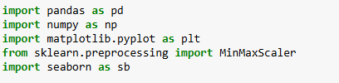
2.1.1. Importing Needed Libraries
Figure (1): Importing needed libraries

2.1.2. Reading CSV Files For Data's 5 Tables
    - Employee AS df_emp
    - Performance Rating AS df_pr
    - Satisfaction Level AS df_st
    - Rating Level AS df_rt
    - Education Level AS df_edu

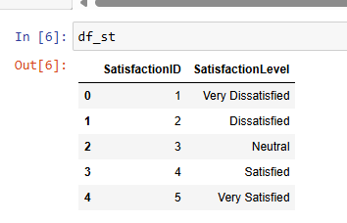
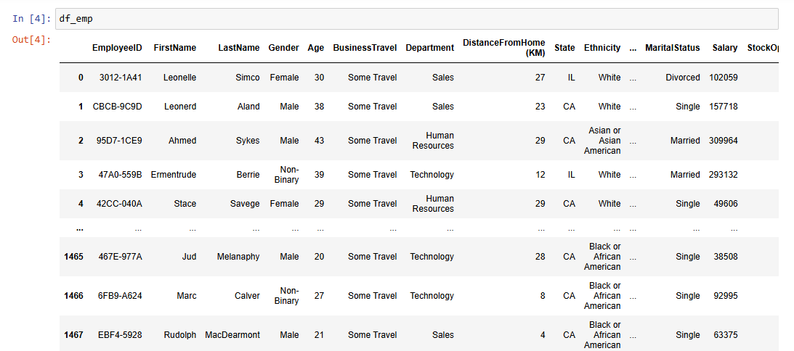
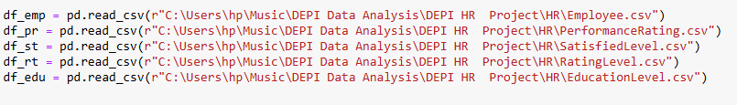
Figure (4): Reading satisfaction table
Figure (3): Reading employees table
Figure (5): Reading satisfaction table
Figure (2): Reading csv file
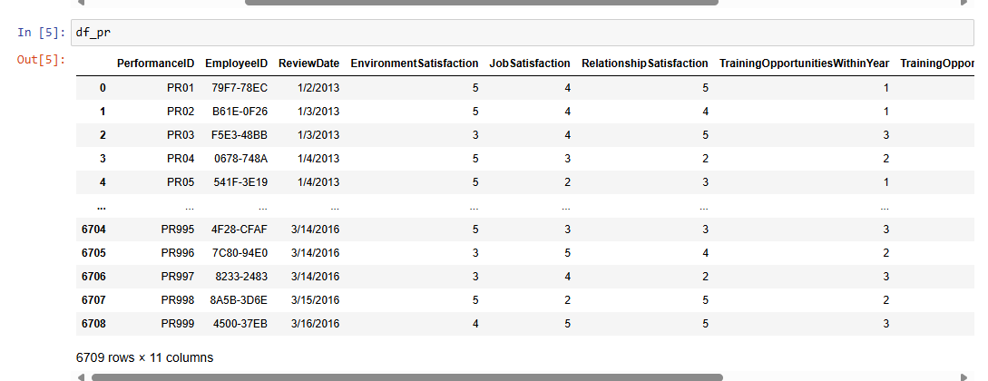
Figure (5): Reading Performance

2.3. Cleaning For Employee Table
  - Show Table information like :
    - Number of Rows à 1470
    - Number of Columns à 23
    - Index Of Table à From 0 To 1469
    - Show Data Types Of Columns
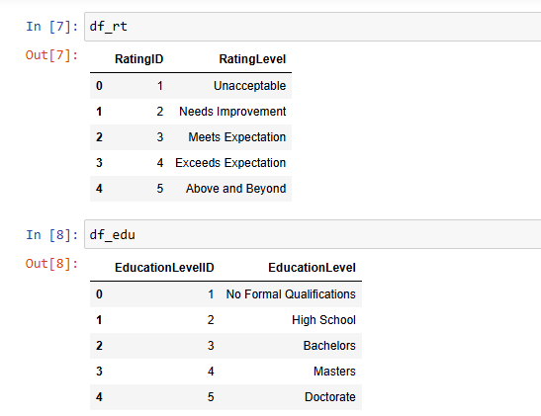
    - Show Columns that have Null and Non Null Values
Figure (6): Reading Rating Table & Education level table
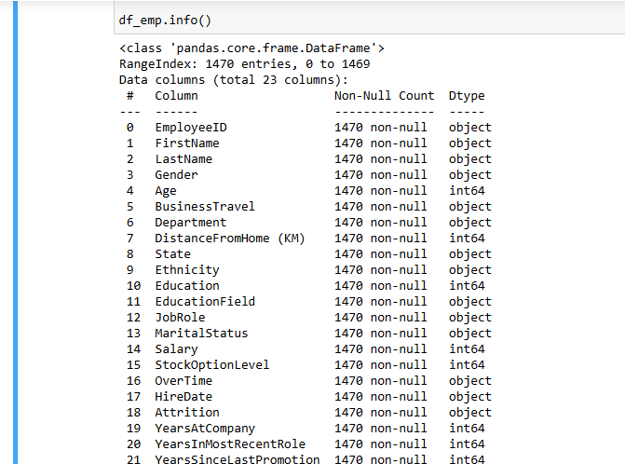
Figure (7): employee table info

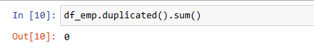
  - Check if there is any duplicate values
Figure (8): check duplicate

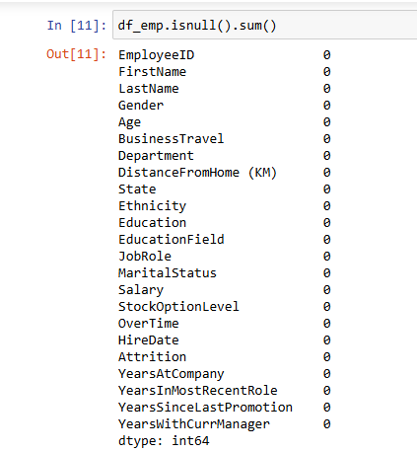
  - Check if there is any NULL values
Figure (9): check null
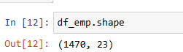
  - Show the shape of Data frame
Figure (10): show shape of data

  - Show first 10 row of data
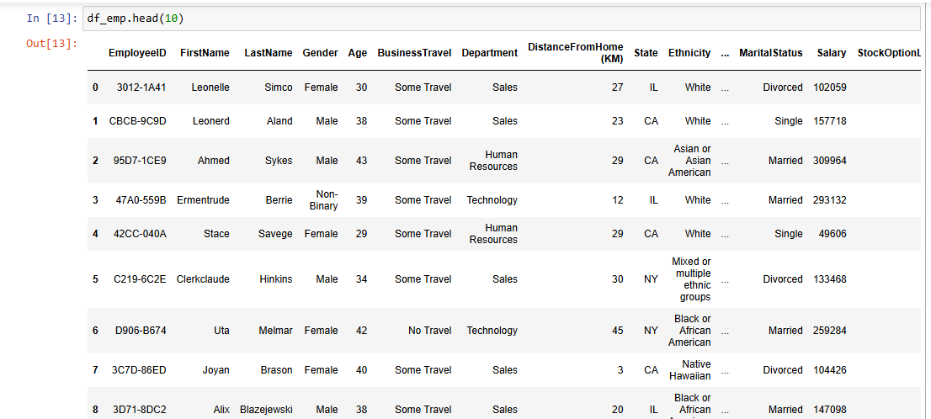
Figure (11): show first 10 row

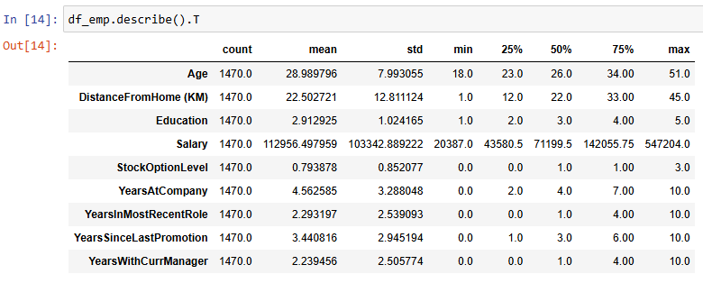
  - Show some statistics info of Data
Figure (12): show statistics info

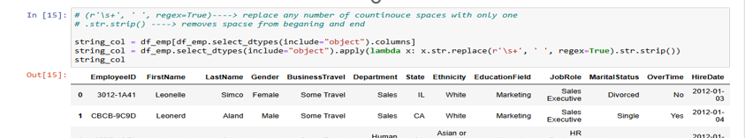
  - Trim unnecessary Spaces values of string columns data
Figure (13): Trim unnecessary Spaces
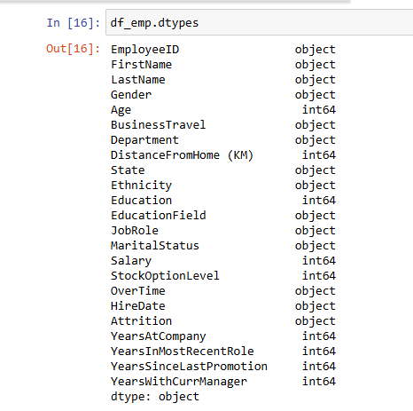
  - Show data types of existing columns to check if there is any wrong data type of any column
Figure (14): show data types of existing columns

  - (HireDate) column's data type is object and need to be converted to datetime
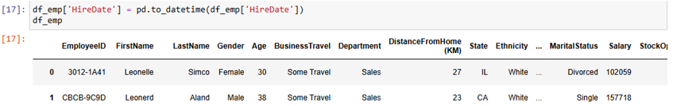
Figure (15): Hire date need to be converted to data time
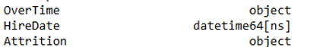
  - Check if (HireDate) column's data type changed to datetime successfully
Figure (16): check if hire data changed to data time successfully

  - Check values of (Education) column to give it more expressive name like
(Education Level) and check if it updated successfully
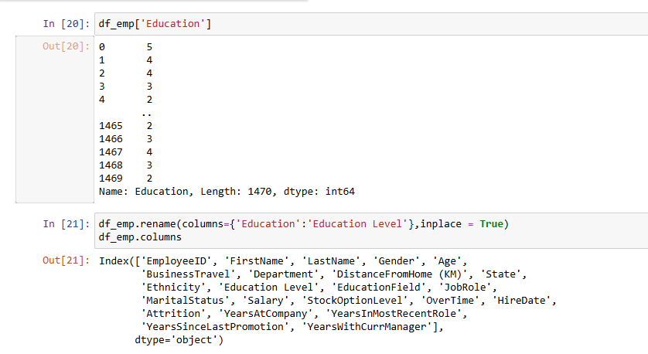
Figure (17): check values of education column

  - Update value (frequent Traveler ) to (freq Traveler) in (Business Travel ) column
Update value (Human resources ) to (HR) in (Department ) column
Check unique values of (YearsAtCompany) Column
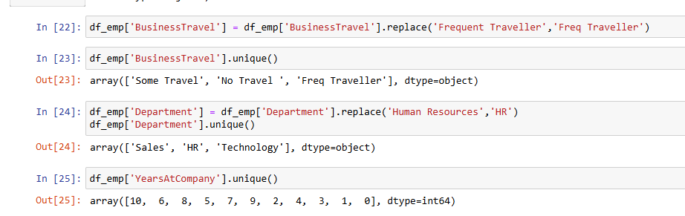
Figure (18): update values to column & unique values

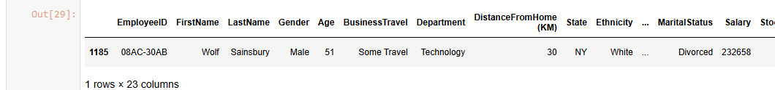
  - Check for (Age) column outliers and there is no outlier
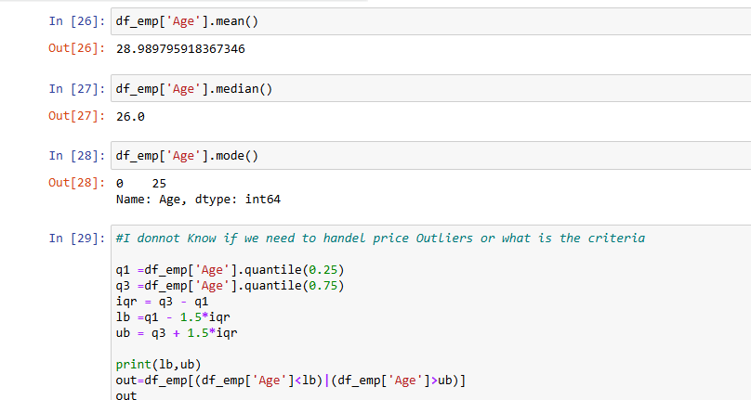
Figure (19): check age column outliers & there is no outliers

  - Check for (YeraAtCompany) column outliers and there is no outlier
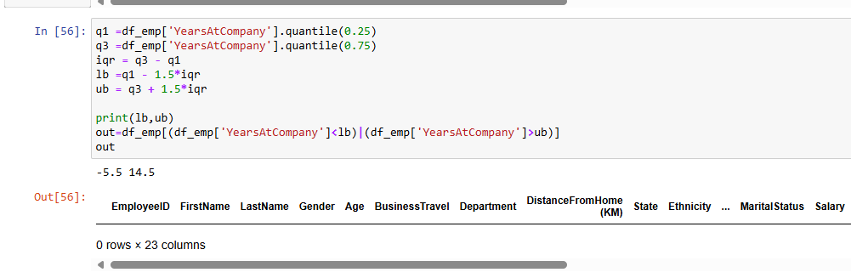
Figure (20): check for Year at company column outliers

  - Check (Salary) Outliers according to Job Role
This job roles' Salaries have no outlier
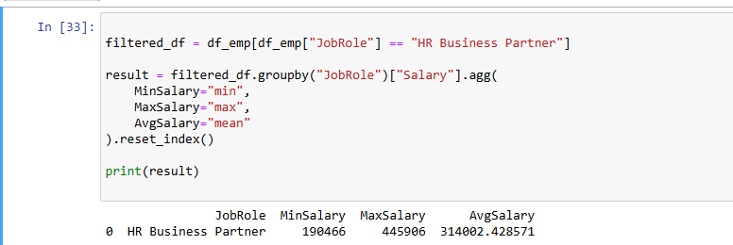
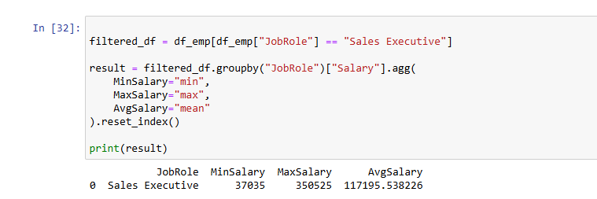
Figure (21): check (1) salary outliers according to job Role
Figure (22): check (2) salary outliers according to job Role
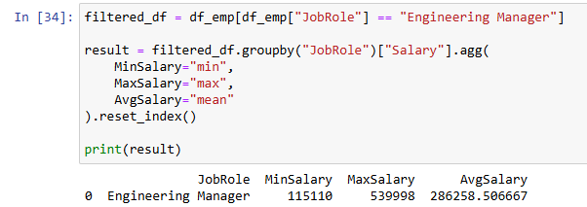
Figure (23): check (3) salary outliers according to job Role
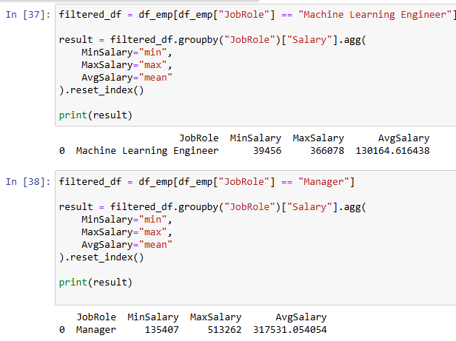
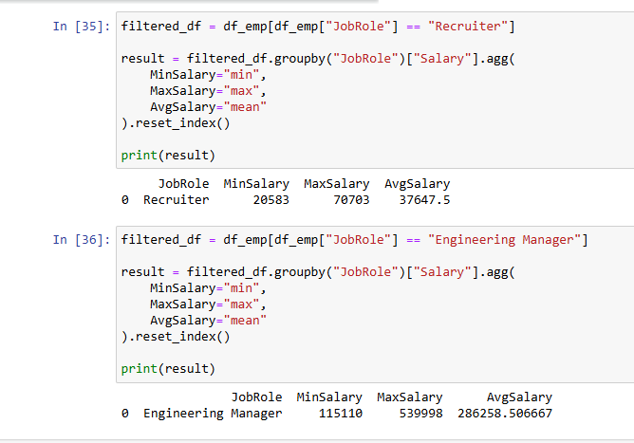
Figure (24): check (4) salary outliers according to job Role
Figure (25): check (5) salary outliers according to job Role
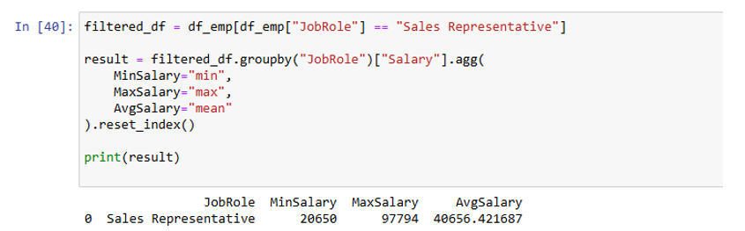
Figure (26): check (6) salary outliers according to job Role
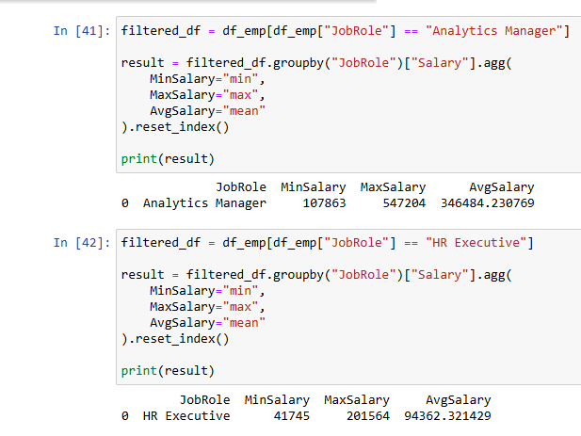
Figure (27): check (7) salary outliers according to job Role
Figure (1): check (8) salary outliers according to job
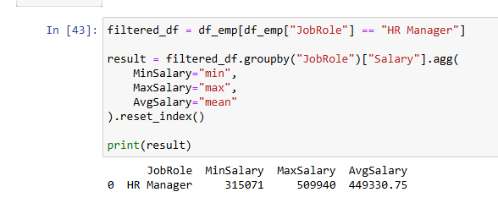
Figure (28): check (8) salary outliers according to job Role

  - Job Roles that need search to check if their salaries have outlier
(Data Scientist)
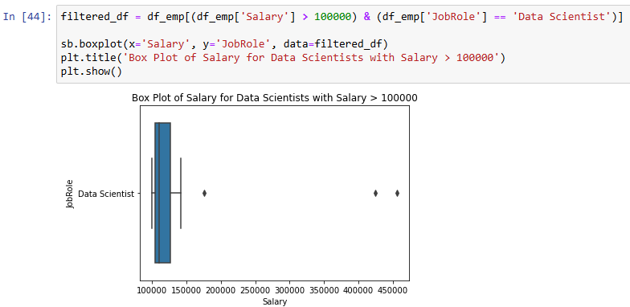
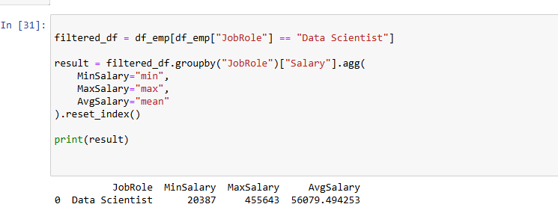
Figure (29): check salaries have outliers

  - Count of employees for (data scientist) who have salaries > 100000 $ and
employees who have salaries we need to check if they are really outlier
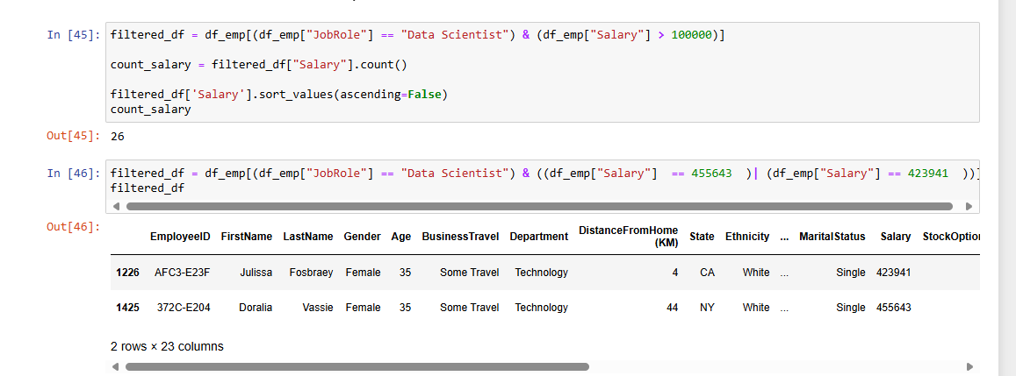
Figure (30): count employees who have salaries> 100000 $

  - Check properties of all employees who have the highest salaries in (data scientist)

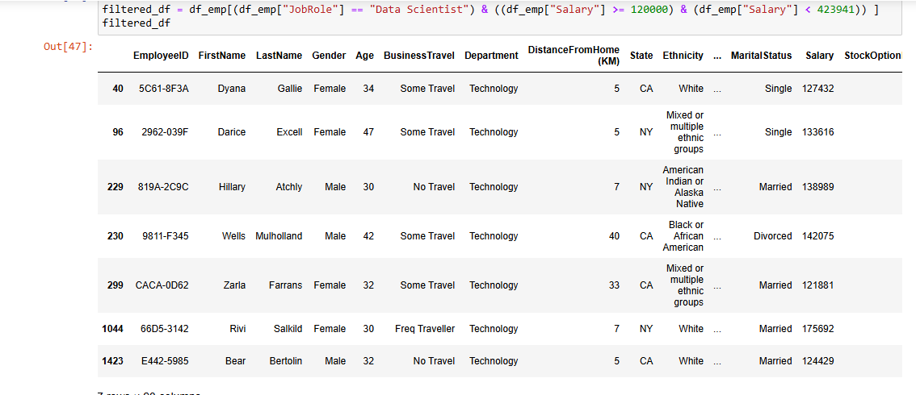
Figure (31): check properties of all employees who have highest salaries

  - Job Roles that need search to check if their salaries have outlier
(Software Engineer)
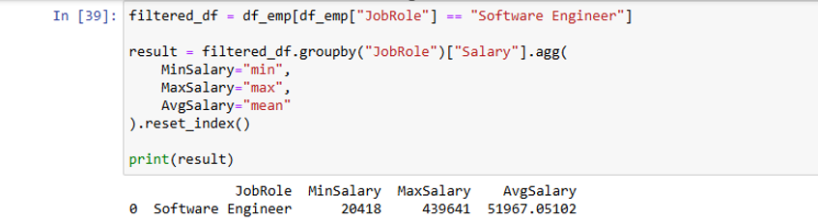
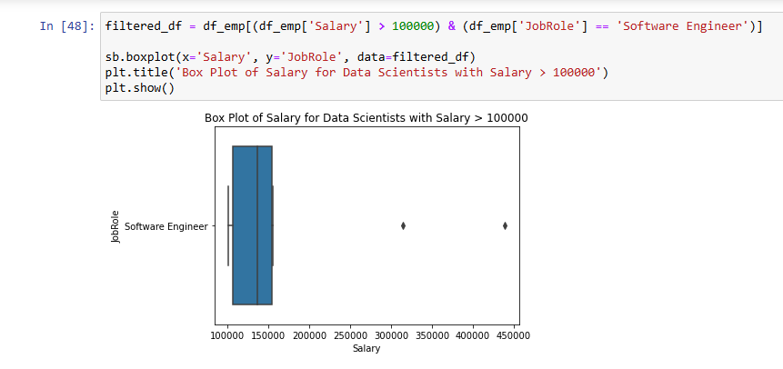
Figure (32): Job roles that need search to check if their salaries have outliers

  - Count of employees for (Software Engineer) who have salaries > 100000 $ and
employees who have salaries we need to check if they are really outlier
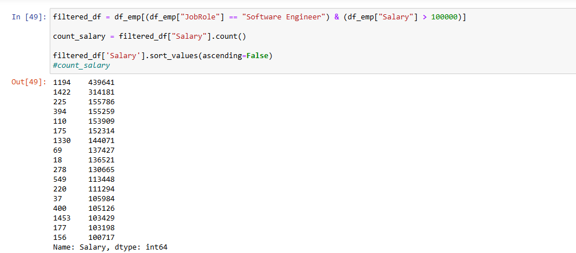
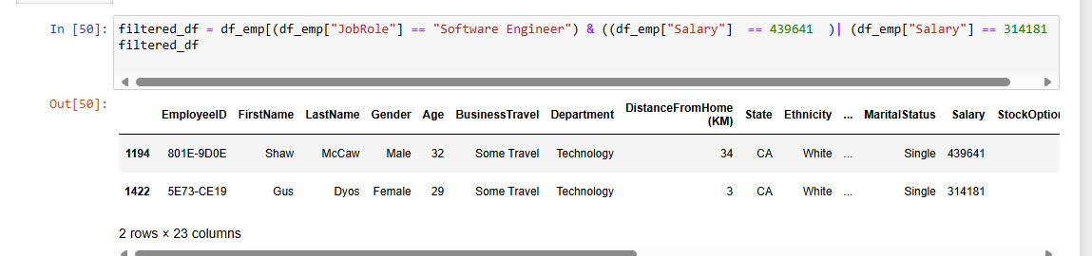
Figure (33): Count of employees Software Engineer have salaries > 100000 $

  - Check properties of all employees who have the highest salaries
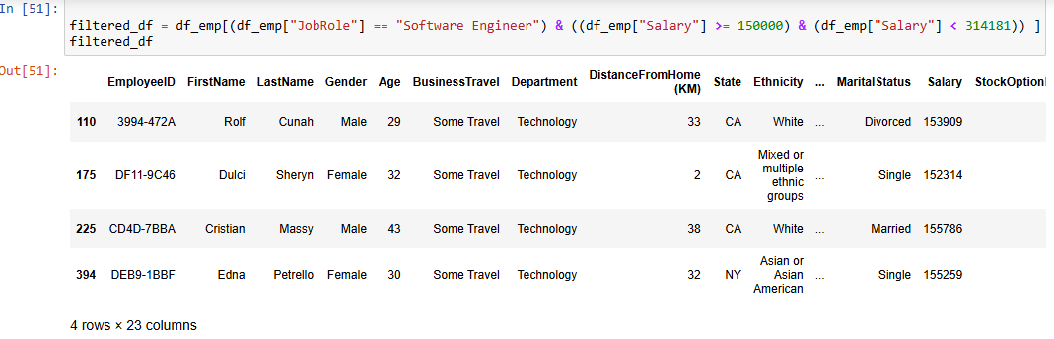
in (software Engineer)
Figure (34): check properties of all who have highest salaries

  - We found that max salary of (Data Scientist) and (Software Engineer) are very
large compared to the average, and when we searched for the rest of the
characteristics of the employees who received these salaries, we found that they
have higher experience and positions, so we conclude that these values are not
outliers
2.4. Cleaning For Performance Rating Table
4.1. Show Table information like :
    - Number of Rows à 6709
    - Number of Columns à 11
    - Index Of Table à From 0 To 6708
    - Show Data Types Of Columns
    - Show Columns that have Null and Non Null Values
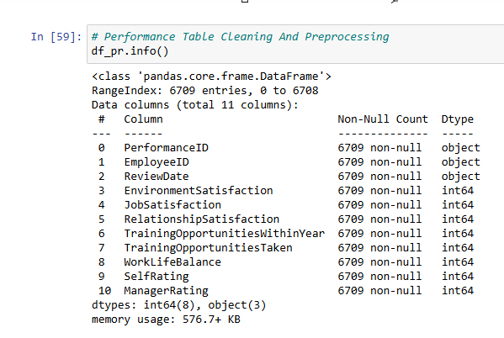
Figure (35):info of tables

4.2. Show shape of Data frame and first 10 rows
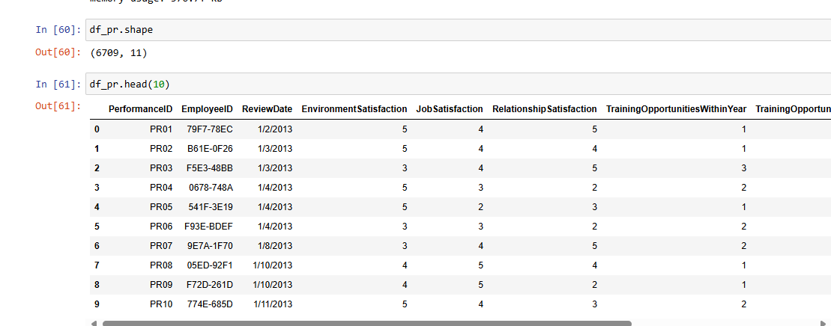
Figure (36): show shape of data frame & first 10 rows

4.3. Show some statistics info of Data
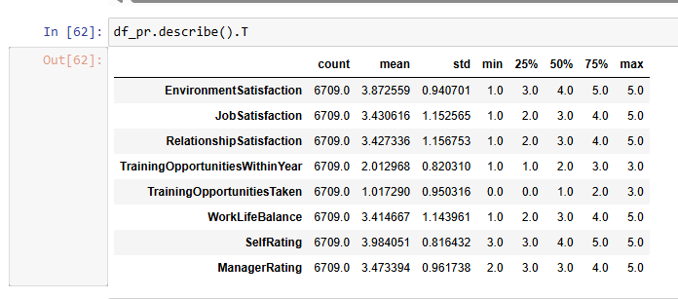
Figure (37): show some statistics info of data

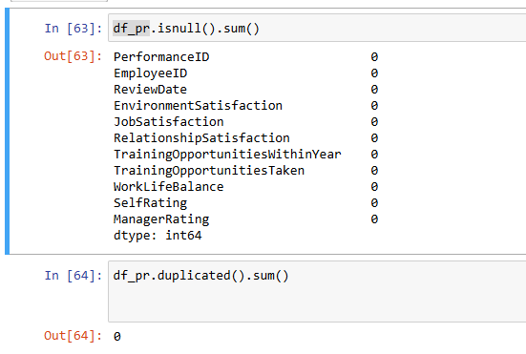
4.4. Check for NULL And Duplicate values
Figure (38): check null & duplicate values
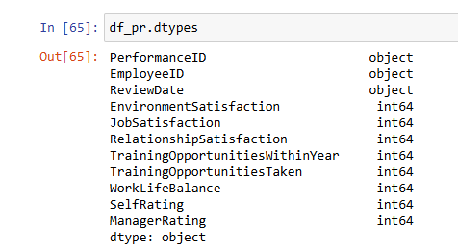
4.5. Show data types of existing columns to check if there is any wrong data type of any column
Figure (39): show data types of existing columns to check any wrong data type
4.6. (ReviewDate) column's data type is object and need to be converted to datetime
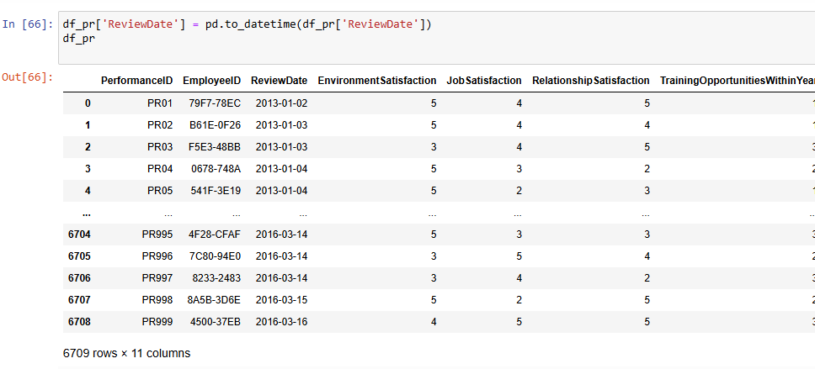
Figure (40): Review date column data type & convert to date time

2.7. Check if (ReviewDate) column's data type changed to date time successfully
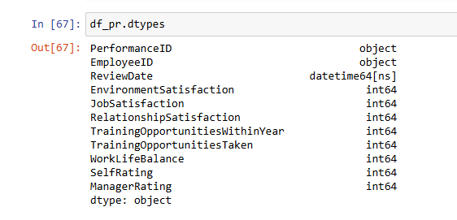
Figure (41): check if review date column-data type changed to date time

4.8. Add new calculated column to merge all Performance Rate columns into one Scaled column
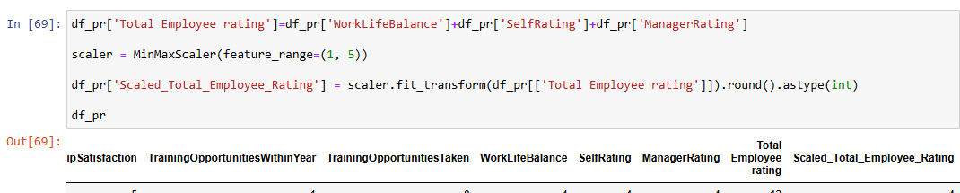
Figure (42): add new calculated column to merge all performance rate

4.9. delete unnecessary column
Figure (43): delete unnecessary column

4.10. Check (TrainingOpportunitiesTaken) column and (TrainingOpportunitiesAtYear) columns
To investigate whether the employee takes the number of training times available to him
during the year, or more or less, we found that (823) employees take more than what is
available to them during the year, so we analyzed that it is possible that he took training
from other sources or even courses.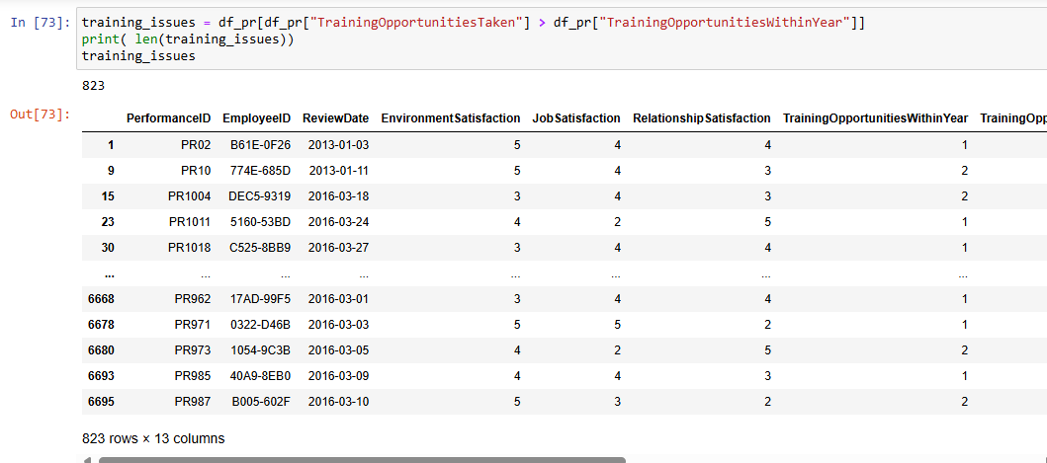
Figure (44): check training opportunities taken column and training opportunities at year

4.11. Trim unnecessary Spaces values of string columns data
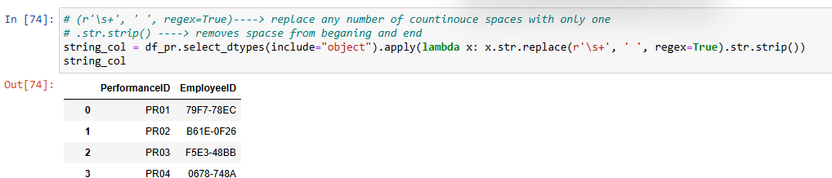
Figure (45): trim unnecessary spaces values of string columns data

5.Cleaning For Satisfaction Rating Table
5.1. Show Table information like :
    - Number of Rows à 5
    - Number of Columns à 2
    - Index Of Table à From 0 To 4
    - Show Data Types Of Columns
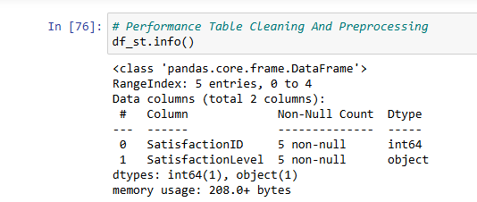
    - Show Columns that have Null and Non Null Values
Figure (46): Info of cleaning of performance table
5.2. Shape of Data Frame ,show rows of data
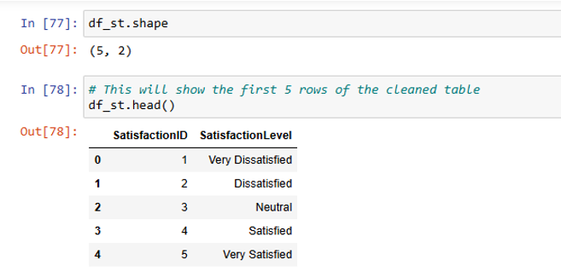
Figure (47): shape of data frame & show rows of data

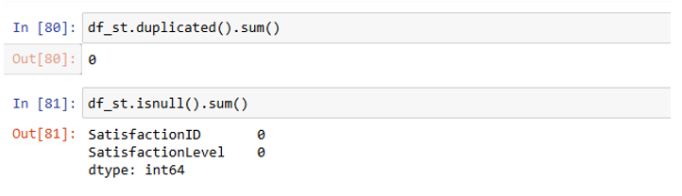
5.2. Check if Duplicate and NULL values is Exist
Figure (48): check if duplicate & null values is exist

5.2. Trim Unnecessary Spaces
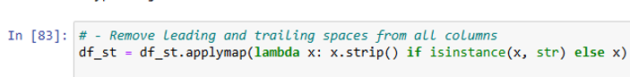
Figure (49): trim unnecessary spaces

6.Cleaning For Rating Table
6.1. Show Table information like :
    - Number of Rows à 5
    - Number of Columns à 2
    - Index Of Table à From 0 To 4
    - Show Data Types Of Columns
    - Show Columns that have Null and Non Null Values
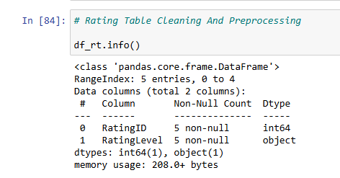
Figure (50): info of cleaning of Rating table

6.2. Show shape and Data types of data
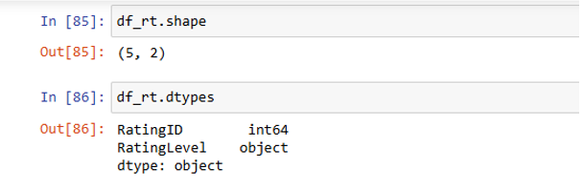
Figure (51): show table shape and data types of data

6.3. show 5 rows of data
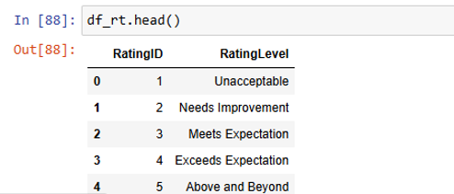
Figure (52): show 5 rows of data in rating level table

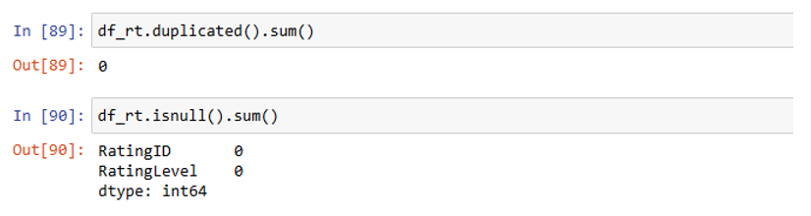
6.4. Check if Duplicate and NULL values is Exist
Figure (53): check duplicate & null values is exist in rating level table
6.5. Trim Unnecessary Spaces
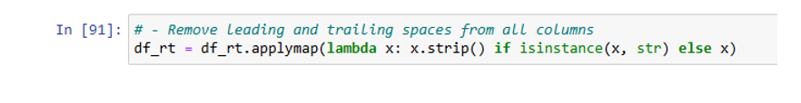
Figure (54): Trims unnecessary spaces in rating level table

7.Cleaning For Education Rating Table
7.1. Show Table information like:
    - Number of Rows à 5
    - Number of Columns à 2
    - Index Of Table à From 0 To 4
    - Show Data Types Of Columns
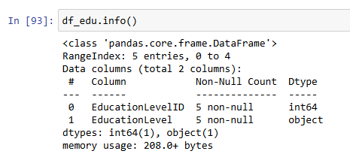
    - Show Columns that have Null and Non Null Values
Figure (55): info of education level table

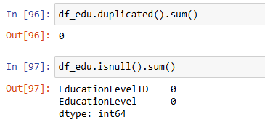
7.2. Show shape and Data types of data
Figure (56): show shape & data types of data of education level table

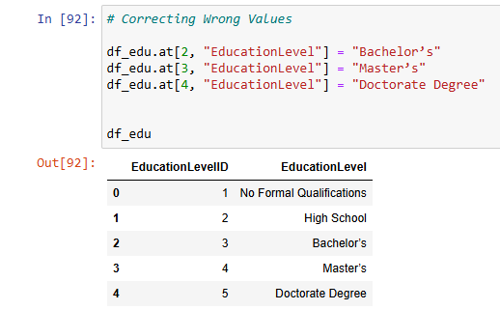
7.3. Correct wrong entered values and check if changed successfully
Figure (57): correct wrong entered values & check if changed successfully

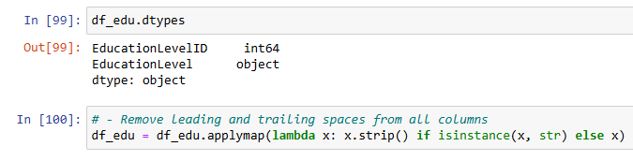
7.4. show data types and Trim unnecessary Spaces
Figure (58): show data types & trim unnecessary spaces

2.8. Save Cleaned Files to CSV Files
8.1. save cleaned and preprocessed data to CSV files To be used for Analysis phase
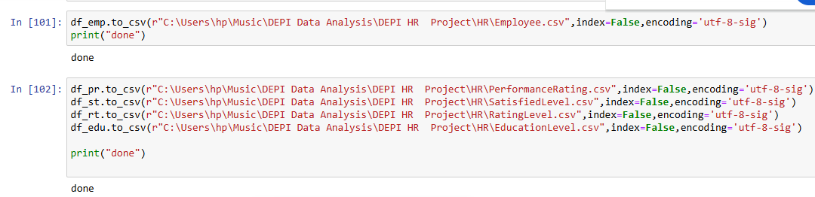
Figure (59): Save cleaned & preprocessed data to csv files to be used for analysis phase

3.Data Cleaning & Preprocessing Using SQL;

3.1Table: Employees;
-- COPPING ORIGINAL TABLE OF DATA INTO ANOTHER TABLE

select *
into Employee_Copy_Final
from Employee

-- COUNT # OF ROWS **BEFORE** REMOVE DUPLICATS -- 1740 ROWS

select COUNT(*) as "# OF ROWS"
from Employee_Copy_Final

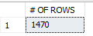
Figure (60): Count of rows

-- COUNT # OF COLUMNS -- 23 COLUMNS

select count(*) as "Number of columns"
from INFORMATION_SCHEMA.COLUMNS
where TABLE_NAME = 'Employee_Copy_Final'

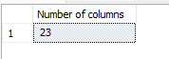
Figure (61): Count of columns

3.1.1 Remove Duplicates if exists;
SQL Query:

select *
from Employee_Copy_Final e
where e.EmployeeID in (select EmployeeID
from Employee_Copy_Final
group by EmployeeID
having COUNT(*) >1)

-- Another method

select distinct *
from Employee_Copy_Final

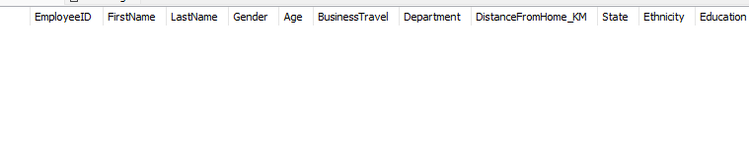
Figure (62): Remove Duplicates

3.1.2 Retrieving columns that have NULL values -- THERE IS NO NULL VALUES;
SQL Query;

select *
from Employee_Copy_Final e
where e.Age is null
or e.Department is null
or e.EducationField is null
or e.EmployeeID is null
or e.FirstName is null
or e.HireDate is null
or e.JobRole is null
or e.LastName is null
or e.OverTime is null
or e.Salary is null
or e.State is null
or e.StockOptionLevel is null
or e.YearsAtCompany is null
or e.YearsInMostRecentRole is null
or e.YearsSinceLastPromotion is null
or e.YearsWithCurrManager is null
or e.Gender is null
or e.BusinessTravel is null
or e.Attrition is null
or e.DistanceFromHome_KM is null
or e.Education is null
or e.YearsInMostRecentRole is null


Figure (63): Retrieving column that have null values

3.1.3 Remove spaces using Trim if exists;
-- WE USE TRIM FOR COLUMNS WHICH HAVE STRING VALUES AND MORE THAN 1 BIT
SQL Query;

UPDATE Employee_Copy_Final
SET EmployeeID = TRIM(EmployeeID),
FirstName = TRIM(FirstName),
LastName = TRIM(LastName),
Gender = TRIM(Gender ),
BusinessTravel = TRIM(BusinessTravel),
Department = TRIM(Department),
State = TRIM(State),
EducationField = TRIM(EducationField),
JobRole = TRIM(JobRole)

3.1.4 Check if there are empty values -- THERE IS NO EMPTY VALUES
SQL Query:

select count(*) as "empty cells in Stock_Option_Level"
from Employee_Copy_Final e
where e.StockOptionLevel =' ' and e.StockOptionLevel <> 0

select count(*) as "empty cells in Years_At_Company"
from Employee_Copy_Final e
where e.YearsAtCompany = ' ' and e.YearsAtCompany <> 0

select count(*) as "empty cells in Years_In_Most_Recent_Role"
from Employee_Copy_Final e
where e.YearsInMostRecentRole = ' ' and e.YearsInMostRecentRole <> 0

select count(*) as "empty cells in Years_SinceLast_Promotion"
from Employee_Copy_Final e
where e.YearsSinceLastPromotion = ' ' and e.YearsSinceLastPromotion <> 0

select count(*) as "empty cells in Years_With_Curr_Manager"
from Employee_Copy_Final e
where e.YearsWithCurrManager = ' ' and e.YearsWithCurrManager <> 0

select count(*) as "empty cells in Over Time"
from Employee_Copy_Final e
where e.OverTime = ' ' and e.OverTime <> 0 ….. etc.

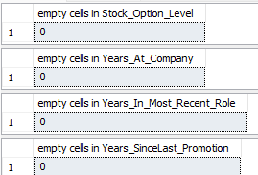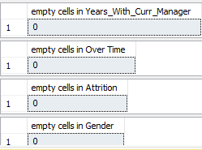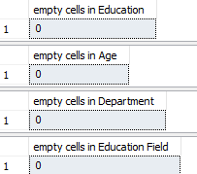

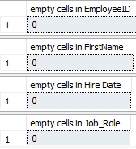
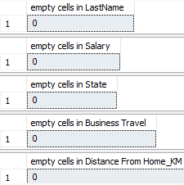
Figure (64): Check if there are empty values

3.1.5 Replace columns names and values if needed;
--UPDATE COLUMNS NAME
SQL Query;

ALTER TABLE Employee_Copy_Final ADD Education_Level tinyint;

UPDATE Employee_Copy_Final SET Education_Level = Education;
ALTER TABLE Employee_Copy_Final DROP COLUMN Education;

select*from Employee_Copy_Final

3.1.6 Update Values;

-- RETRIVING ALL OF DISTINCT VALUES OF COLUMNS TO DETERMINE IF THERE IS ANY VALUE NEED TO BE REPLACED
SQL Query;

select distinct e.EducationField
from Employee_Copy_Final e

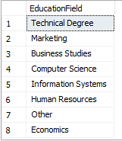
Figure (65): Unique value of education field

select distinct e.BusinessTravel
from Employee_Copy_Final e

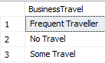
Figure (66): Unique value of business travel

select distinct e.Department
from Employee_Copy_Final e

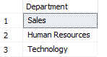
Figure (67): Unique value of Department

select distinct e.State
from Employee_Copy_Final e
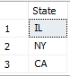
Figure (68): Unique value of state

select distinct e.JobRole
from Employee_Copy_Final e
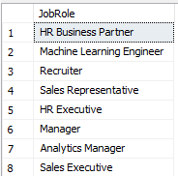
Figure (69): Unique value of Jobe role

select distinct e.Age
from Employee_Copy_Final e

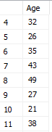
Figure (70): Unique value of Age

select distinct e.YearsAtCompany
from Employee_Copy_Final e

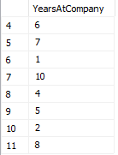
Figure (71): Unique value of years at company

-- Updated values

update Employee_Copy_Final
set BusinessTravel = 'Freq Traveller'
where BusinessTravel = 'Frequent Traveller'

COMMIT

update Employee_Copy_Final
set Department = 'HR'
where Department = 'Human Resources'

COMMIT
3.1.7 Change HireDate column data type from varchar to date time;
SQL Query;

UPDATE Employee_Copy_Final
SET HireDate = TRY_CAST(HireDate AS DATETIME)
WHERE TRY_CAST(HireDate AS DATETIME) IS NOT NULL;

-- check if the data type updated correctly

SELECT COLUMN_NAME , DATA_TYPE
FROM INFORMATION_SCHEMA.COLUMNS
WHERE TABLE_NAME = ' Employee_Copy_Final' AND COLUMN_NAME = 'HireDate';

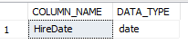
Figure (72): Unique value of hire date

3.2. Table Performance;
-- COPPING ORIGINAL TABLE OF DATA INTO ANOTHER TABLE
select *
into Performance_Rating
from PerformanceRating

SELECT * FROM Performance_Rating;

3.2.1. Remove duplicates;
SQL Query;

WITH CTE AS (
SELECT *,
ROW_NUMBER() OVER (
PARTITION BY PerformanceID, EmployeeID, ReviewDate, EnvironmentSatisfaction,
JobSatisfaction, RelationshipSatisfaction, TrainingOpportunitiesWithinYear,
TrainingOpportunitiesTaken, WorkLifeBalance, SelfRating, ManagerRating
ORDER BY PerformanceID
) AS RowNum
FROM Performance_Rating
)

DELETE FROM CTE
WHERE RowNum > 1;

3.2.2. Replace blank or invalid values with NULL;
SQL Query;

UPDATE Performance_Rating
SET ReviewDate = NULL
WHERE ReviewDate IS NULL OR LTRIM(RTRIM(ReviewDate)) = '';

-- Update valid dates
UPDATE Performance_Rating
SET ReviewDate = TRY_CONVERT(DATE, ReviewDate)
WHERE TRY_CONVERT(DATE, ReviewDate) IS NOT NULL;

3.2.3. Replace invalid dates with NULL;
SQL Query;

UPDATE Performance_Rating
SET ReviewDate = NULL
WHERE TRY_CONVERT(DATE, ReviewDate) IS NULL;

3.2.4. Replace NULL values in numeric columns with default values (0)
SQL Query;

UPDATE Performance_Rating
SET EnvironmentSatisfaction = ISNULL(EnvironmentSatisfaction, 0),
JobSatisfaction = ISNULL(JobSatisfaction, 0),
RelationshipSatisfaction = ISNULL(RelationshipSatisfaction, 0),
TrainingOpportunitiesWithinYear = ISNULL(TrainingOpportunitiesWithinYear, 0),
TrainingOpportunitiesTaken = ISNULL(TrainingOpportunitiesTaken, 0),
WorkLifeBalance = ISNULL(WorkLifeBalance, 0),
SelfRating = ISNULL(SelfRating, 0),
ManagerRating = ISNULL(ManagerRating, 0);

-- Check for invalid values
SELECT *
FROM Performance_Rating
WHERE EnvironmentSatisfaction NOT BETWEEN 1 AND 5
OR JobSatisfaction NOT BETWEEN 1 AND 5
OR RelationshipSatisfaction NOT BETWEEN 1 AND 5
OR WorkLifeBalance NOT BETWEEN 1 AND 5;

Figure (73): Unique value of performance rating

-- Correct invalid values
UPDATE Performance_Rating
SET EnvironmentSatisfaction = NULLIF(EnvironmentSatisfaction, 0)
WHERE EnvironmentSatisfaction NOT BETWEEN 1 AND 5;

3.3. Table EducationLevel;
-- COPPING ORIGINAL TABLE OF DATA INTO ANOTHER TABLE
SQL Query:

select *
into Education_L
from EducationLevel

SELECT *
FROM Education_L;

3.3.1. Trim Unnecessary Spaces;
SQL Query;

UPDATE Education_L
SET EducationLevel = TRIM(EducationLevel);

-- Standardization of EducationLevel Values

UPDATE Education_L
SET EducationLevel = UPPER(LEFT(EducationLevel, 1)) + LOWER(SUBSTRING(EducationLevel, 2, LEN(EducationLevel)));

3.3.2. Check duplicates Rows;
SQL Query;

SELECT EducationLevel, COUNT(*)
FROM Education_L
GROUP BY EducationLevel
HAVING COUNT(*) > 1;

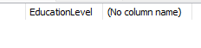
Figure (73): check duplicates of educational level

3.3.3.Correcting Wrong Values;
SQL Query;

UPDATE Education_L
SET EducationLevel =
CASE
WHEN EducationLevel = 'Bachelors' THEN 'Bachelor’s'
WHEN EducationLevel = 'Masters' THEN 'Master’s'
WHEN EducationLevel = 'Doctorate' THEN 'Doctorate Degree'
ELSE EducationLevel
END;

3.3.4. Check if there are NULL Values;
SQL Query;

SELECT * FROM Education_L WHERE EducationLevel IS NULL;

-- Data AFTER Cleanning
SELECT * FROM Education_L

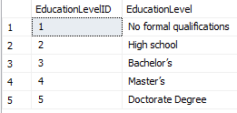
Figure (74): Unique value of educational level
3.4. Table Rating Level;
-- COPPING ORIGINAL TABLE OF DATA INTO ANOTHER TABLE
select *
into Rating_L
from RatingLevel

select * from Rating_L

3.4.1. Trim Unnecessary Spaces;
SQL Query;

UPDATE Rating_L
SET RatingLevel = TRIM(RatingLevel);

3.4.2. Standardization of EducationLevel Values;
SQL Query;

UPDATE Rating_L
SET RatingLevel = UPPER(LEFT(RatingLevel, 1)) + LOWER(SUBSTRING(RatingLevel, 2, LEN(RatingLevel)));

3.4.3. Check duplicates Rows;
SQL Query;

SELECT RatingLevel, COUNT(*)
FROM Rating_L
GROUP BY RatingLevel
HAVING COUNT(*) > 1;
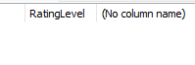
Figure (75): Unique value of rating level

3.4.4. Check if there are NULL Values;
SQL Query;

SELECT * FROM Rating_L WHERE RatingLevel IS NULL;

--Data AFTER Cleanning

SELECT * FROM Rating_L

3.5. Table SatisfactionLevel;
-- COPPING ORIGINAL TABLE OF DATA INTO ANOTHER TABLE

select *
into Satisfied_L
from SatisfiedLevel

select * from Satisfied_L

3.5.1. Trim Unnecessary Spaces;
SQL Query;

UPDATE Satisfied_L
SET SatisfactionLevel = TRIM(SatisfactionLevel);

3.5.2. Check duplicates Rows;
SQL Query;

SELECT SatisfactionLevel, COUNT(*)
FROM Satisfied_L
GROUP BY SatisfactionLevel
HAVING COUNT(*) > 1;

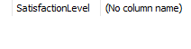
Figure (76): Unique value of years at company

3.5.3. Check if there are NULL Values;
SQL Query;

SELECT * FROM Satisfied_L WHERE SatisfactionLevel IS NULL;

Outliers:
SQL Query;
select e.JobRole ,min(e.Salary ) ,max(e.Salary ), avg(e.Salary)
from Employee_Copy_Final e
where e.JobRole = 'Machine Learning Engineer'--**--
group by e.JobRole

select e.JobRole ,min(e.Salary ) as"min" ,max(e.Salary ) as"max" , avg(e.Salary)as"avg"
from Employee_Copy_Final e
where e.JobRole = 'Data Scientist'
group by e.JobRole

select e.JobRole ,min(e.Salary ) ,max(e.Salary ) , avg(e.Salary)
from Employee_Copy_Final e
where e.JobRole = 'Sales Executive'--**--
group by e.JobRole etc.

Data After Cleaning;
SQL Query;

SELECT * FROM Employee_Copy
SELECT * FROM Performance_Rating
SELECT * FROM Education_L
SELECT * FROM Rating_L
SELECT * FROM Satisfied_L

4.Data Modeling;

4.1.Add primary keys;
SQL Query;

alter table Employee_Copy_Final
add constraint emp_idf_pk primary key(EmployeeID)

alter table Performance_Rating
add constraint per_id_pk primary key(PerformanceID)

alter table Education_L
add constraint edu_l_id_pk primary key(EducationLevelID)

alter table Rating_L
add constraint rate_id_pk primary key(RatingID)

alter table Satisfied_L
add constraint sat_l_pk primary key(SatisfactionID)

4.2.Add foreign Key;
SQL Query;

alter table Employee_Copy_Final
add constraint edu_lf_fk foreign key(Education_Level) references Education_L(EducationLevelID)

alter table Performance_Rating
add constraint emp_idf_fk foreign key(EmployeeID) references Employee_Copy_Final(EmployeeID)

alter table Performance_Rating
add constraint env_l_fk foreign key(EnvironmentSatisfaction) references Satisfied_L(SatisfactionID)

alter table Performance_Rating
add constraint job_l_fk foreign key(JobSatisfaction) references Satisfied_L(SatisfactionID)

alter table Performance_Rating
add constraint rel_l_fk foreign key(RelationshipSatisfaction) references Satisfied_L(SatisfactionID)

alter table Performance_Rating
add constraint work_s_fk foreign key(WorklifeBalance) references Rating_L(RatingID)

alter table Performance_Rating
add constraint slf_r_fk foreign key(SelfRating) references Rating_L(RatingID)

alter table Performance_Rating
add constraint mang_r_fk foreign key(ManagerRating) references Rating_L(RatingID)

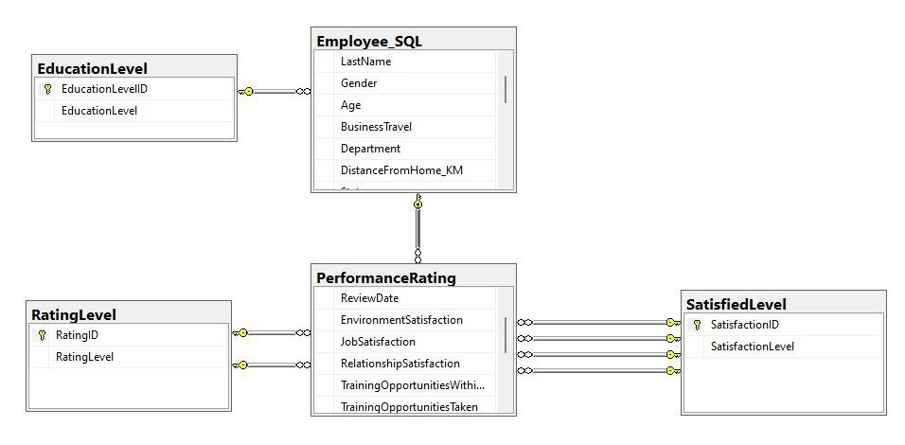
Figure (77): Schema

4.3.Check if ALL Tables is Related Successfully;
SQL Query;

select e.FirstName , p.SelfRating , r.RatingLevel , ed.EducationLevel , s.SatisfactionLevel
from Employee_Copy_Final e join Performance_Rating p
ON e.EmployeeID = p.EmployeeID join Rating_L r
ON p.SelfRating = r.RatingID join Education_L ed
ON e.Education_Level = ed.EducationLevelID join Satisfied_L s
ON p.JobSatisfaction = s.SatisfactionID

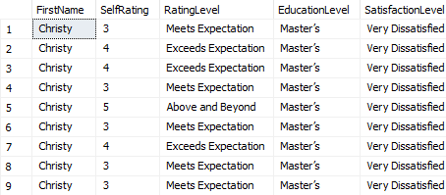
Figure (78): Check All Table

CHAPTER 3
Analysis Questions
1.1. Introduction
After ensuring data quality through cleaning and preprocessing, the next step in this HR Analytics project is to conduct exploratory and analytical queries to uncover insights related to employee performance, satisfaction, and attrition. The goal of this chapter is to answer key business questions that help HR teams and management make data-driven decisions to improve employee retention, job satisfaction, and overall organizational performance.
Through a series of structured SQL queries, visualizations, and statistical analysis, we examine trends, relationships, and patterns within the dataset. The analysis focuses on:
- Employee Attrition: Understanding why employees leave, identifying high-risk groups, and determining the impact of factors like age, department, and job satisfaction.
- Job Satisfaction and Performance: Exploring how different job roles, departments, and satisfaction levels affect performance ratings.
- Demographic and Experience Factors: Analyzing the role of education, training, work-life balance, and tenure in employee success and retention.
- Predictive Insights: Using data trends to provide recommendations for HR policies and employee engagement strategies.
Each section of this chapter presents a business question, Python and the SQL query used to answer it, and an interpretation of the findings to provide actionable insights.

1.2. HR Analytics - Key Analytical Questions
1.2.1. Employee Demographics & General Information
These questions help in understanding the distribution of employees across the organization.
Analytical Questions:
- What is the count of employees in the company ?
- What is the average number of years employees have spent in the company (YearsAtCompany) per job role?
- What is the count of employees in the company per ethnicity ?
- What percentage of employees belong to each education level?
- What is the gender distribution among employees?
- How many employees are there in each department?
- What is the age distribution of employees? (e.g., "<25", "25-35", "35-45", ">45")
- How many times each employee had performance rating in the company?
1.2.2. Attrition Analysis:
Analytical Questions:
- What is the overall attrition rate in the company?
- Is there a correlation between years at the company (YearsAtCompany) and attrition?
- How does attrition vary by job role?
- What is the overall attrition rate per Age groups?
- Is there a relationship between job satisfaction and attrition?
- Is there a relationship between bonus and attrition?
- How does attrition vary by job role?
- How does overtime affect attrition rates?
- What is the overall attrition rate per Department ?
- Are employees with lower salaries more likely to leave?
- What is the overall attrition rate per Gender?
1.2.3. Performance Analysis
Analytical Questions:
- What is the average performance rating in the company?
- How does performance vary across job roles?
- Is there a relationship between salary and performance ratings?
- How does performance differ by education field?
- Do employees who work overtime receive higher performance ratings?
- How does experience (YearsAtCompany) impact performance?
- Is there a correlation between job satisfaction and performance?
- What is the effect of overtime on performance?

1.2. 4. Job Satisfaction Analysis
Analytical Questions:
- What is the average job satisfaction level across the company?
- What is the average job satisfaction per age?
- How does job satisfaction vary by job role?
- Is there a relationship between salary and job satisfaction?
- What is the effect of education field on job satisfaction?
- How does overtime impact employee job satisfaction?
- What is the average job satisfaction per Gender?
1.2.5. Overtime Analysis
Analytical Questions:
- What percentage of employees work overtime?
- What percentage of employees work overtime per marital stateus?
1.2. 6. Salary & Compensation Analysis
Analytical Questions:
- What is the average monthly salary in the company?
- How does salary vary by job role?
- Is there a difference in salaries based on education level?

2.Analysis Questions Using Python
    - 2.1.BMJ,J
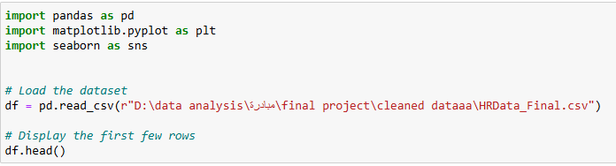
Figure (79): Import Dataset
    - Q1 Count of Employees
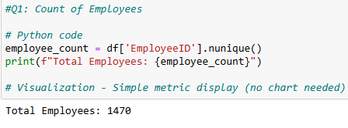
Figure (80): Q1 Count of Employees
    - Q2 AVG Years of Experience at Company
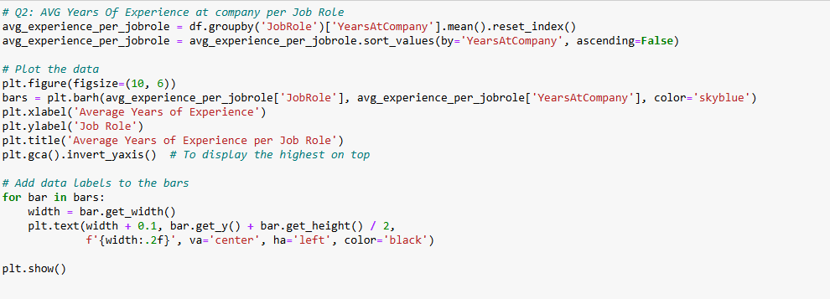
Figure (81): Q2 AVG Years of Experience at Company
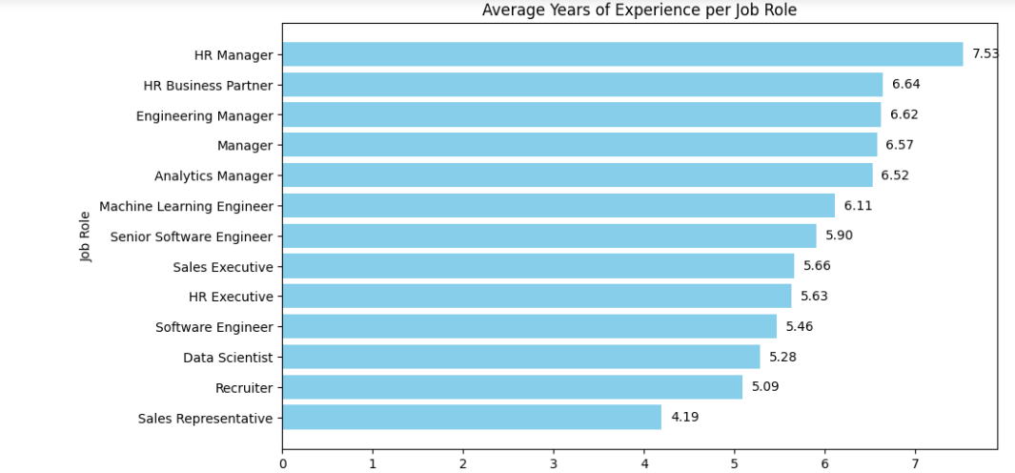
Figure (82): Q2 Result of Average years of experience
    - Q3 Count of employees per ethnicity
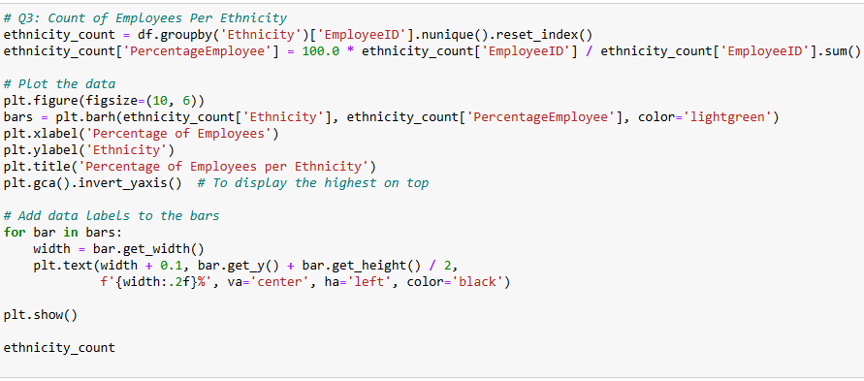
Figure (83): Q3 Count of employees per ethnicity
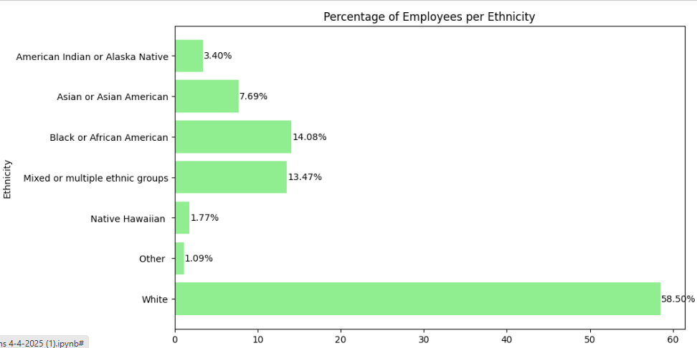
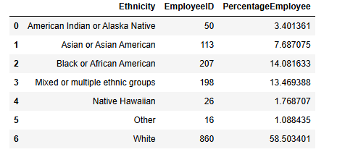
Figure (84): Q3 Result of Count of employees
    - Q4 % of employees per education level
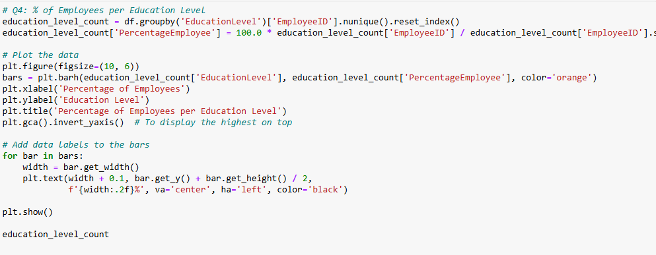
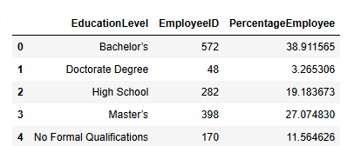
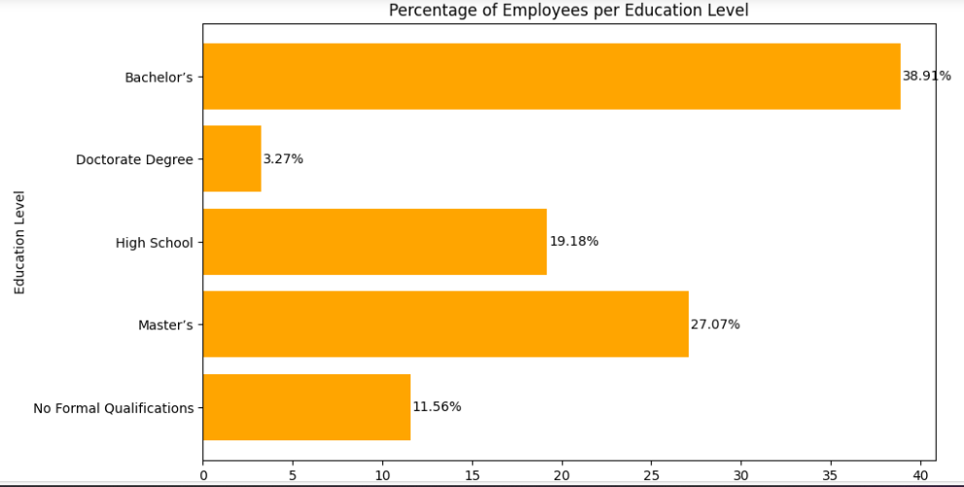
Figure (85): Q4 % of employees per education level
Figure (86): Q4 Result of %of employees per education level
    - Q5 Result of %of employees per Gender
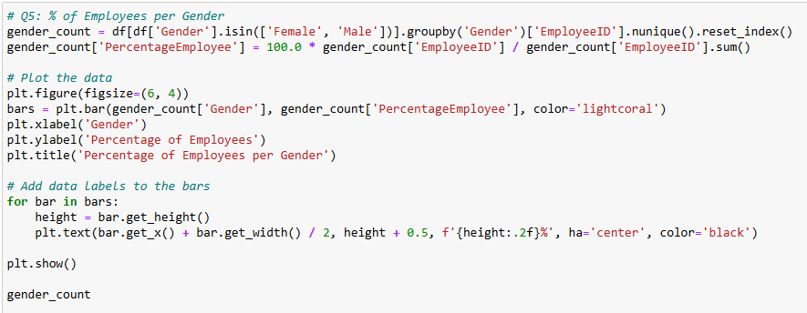
Figure (87): Q5 Result of %of employees per Gender
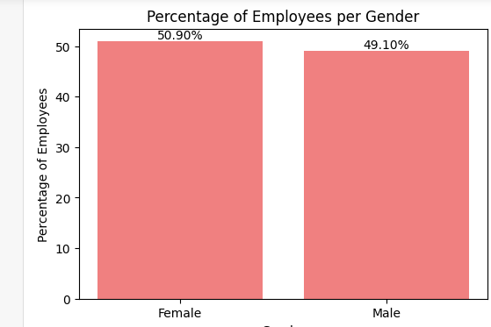
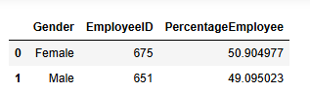
Figure (88): Q5 Result of %of employees per Gender
    - Q6 % & # of employees per department
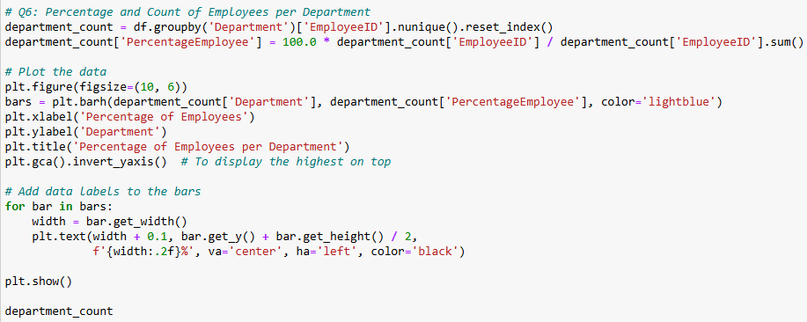
Figure (89): Q6 % & # of employees per department
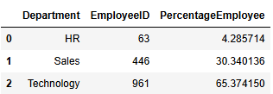
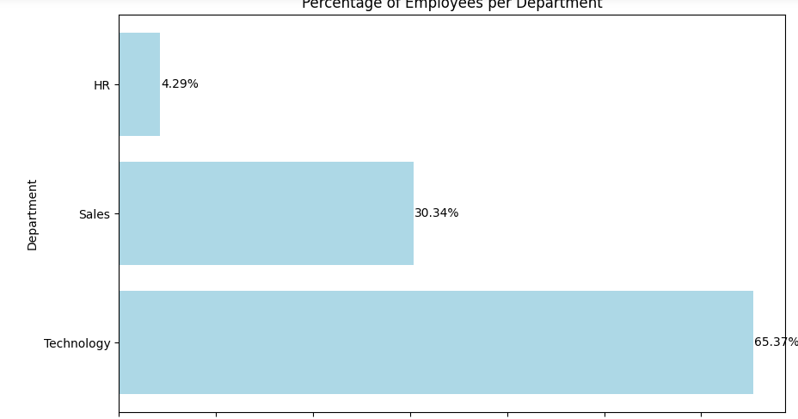
Figure (90): Q6 Result % & #of employees per department
    - Q7 Attrition Rate Per Average Yearsatcompany for active employee
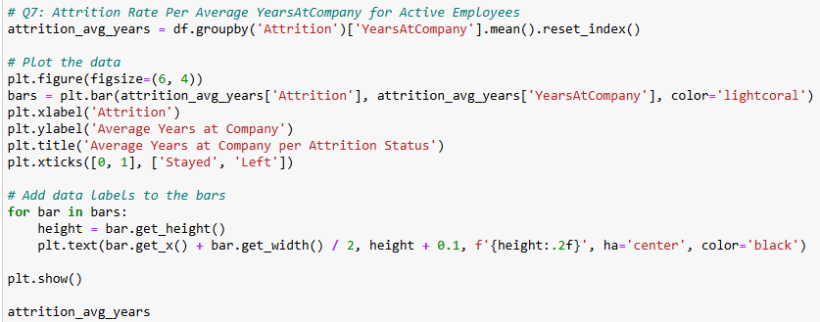
Figure (91): Q7 Attrition Rate Per Average Yearsatcompany for active employee
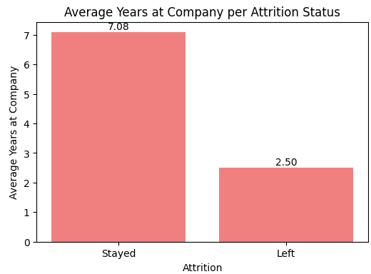
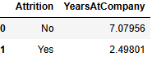
Figure (92): Q7 Result of Attrition Rate Per Average Yearsatcompany for active employees

    - Q8 Attrition Rate
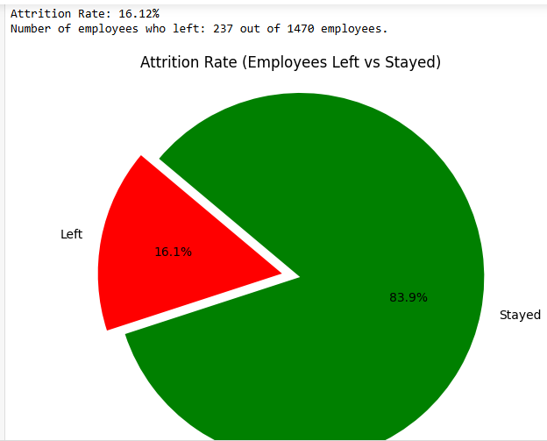
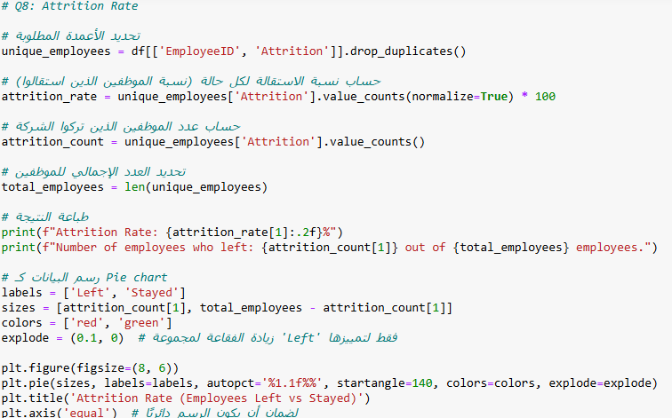
Figure (93): Q8 Attrition Rate
Figure (94): Q8 Result of Attrition Rate

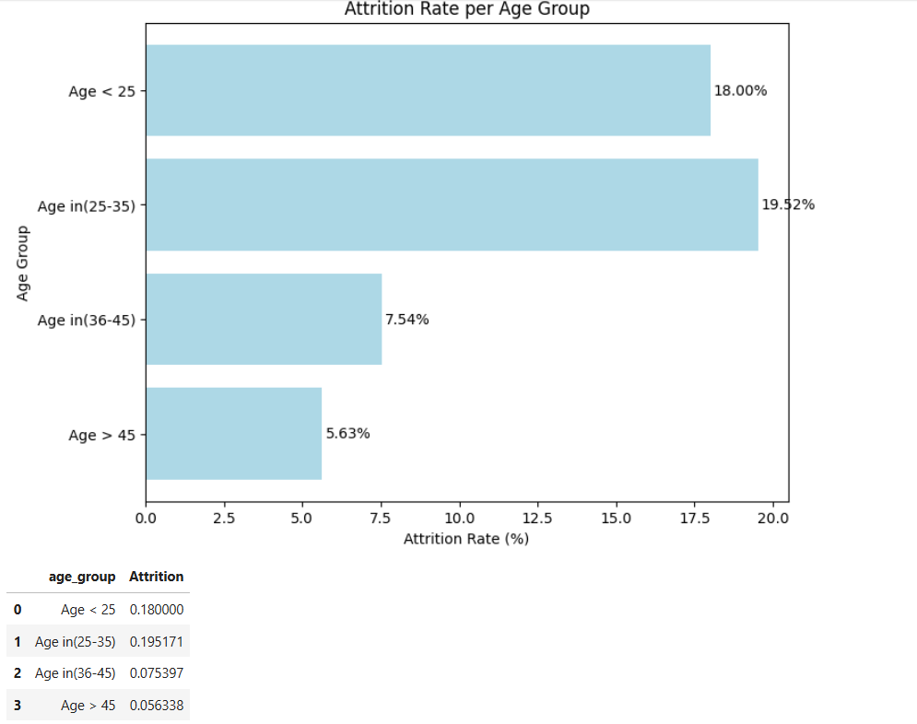
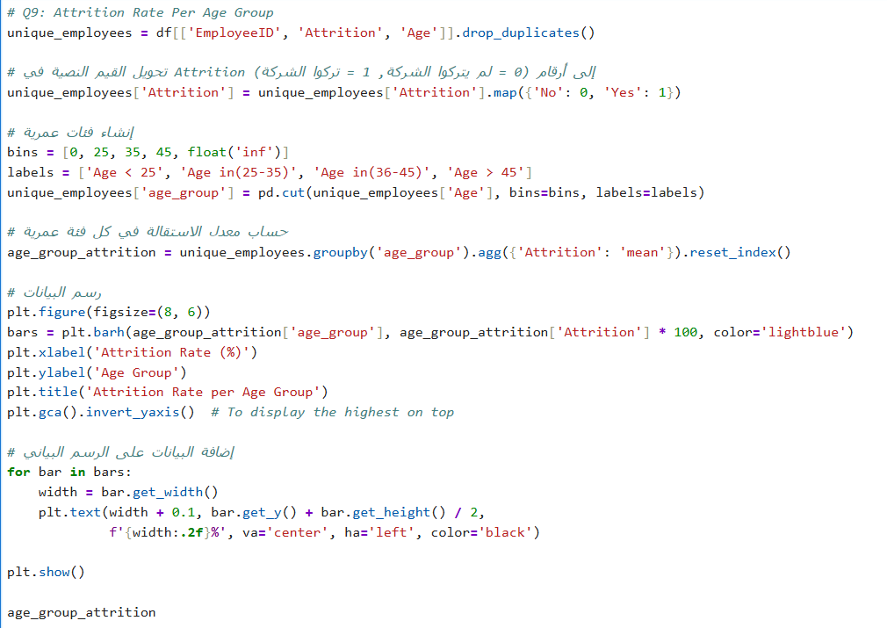
Figure (95): Q9 Attrition Rate per Age group
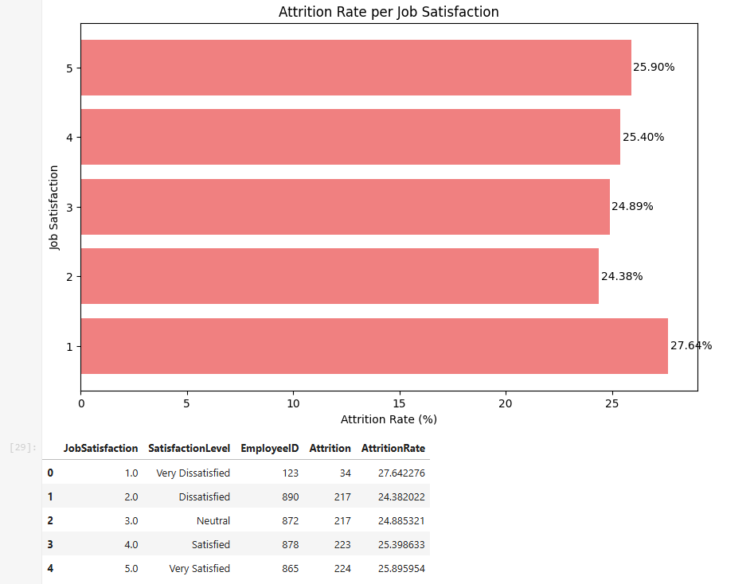
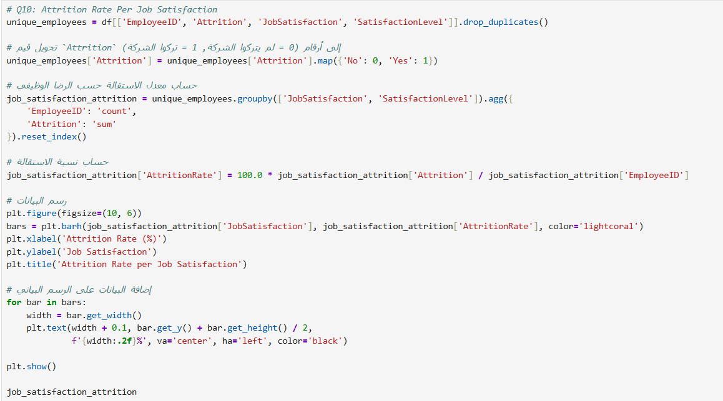
Figure (96): Q10 Attrition Rate per Job Satisfaction
Figure (97): Q10 Result of Attrition Rate per Job Satisfaction
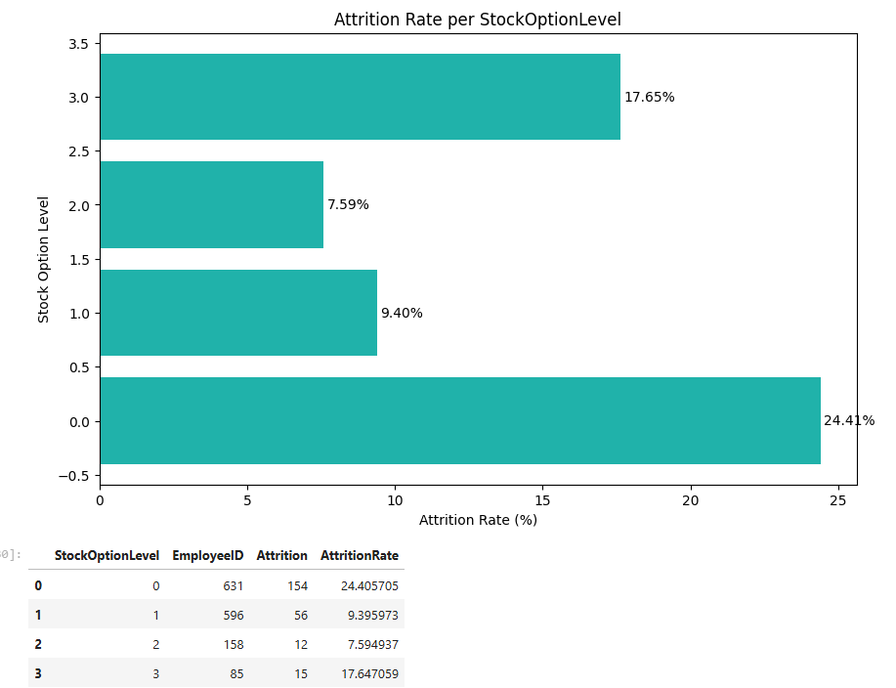
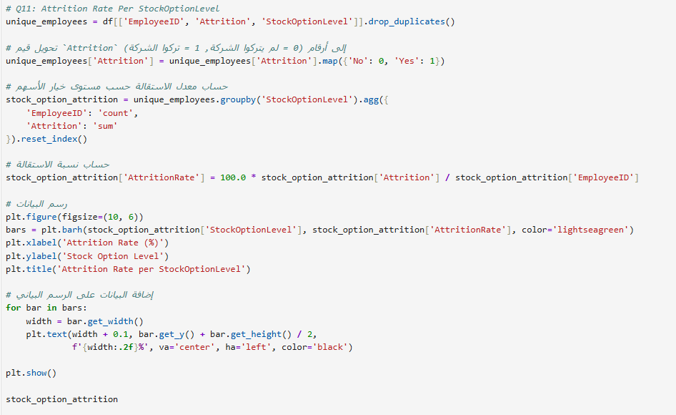
Figure (98): Q11 Attrition Rate per Stockoption Level
Figure (99): Q11 Attrition Rate per Stockoption Level
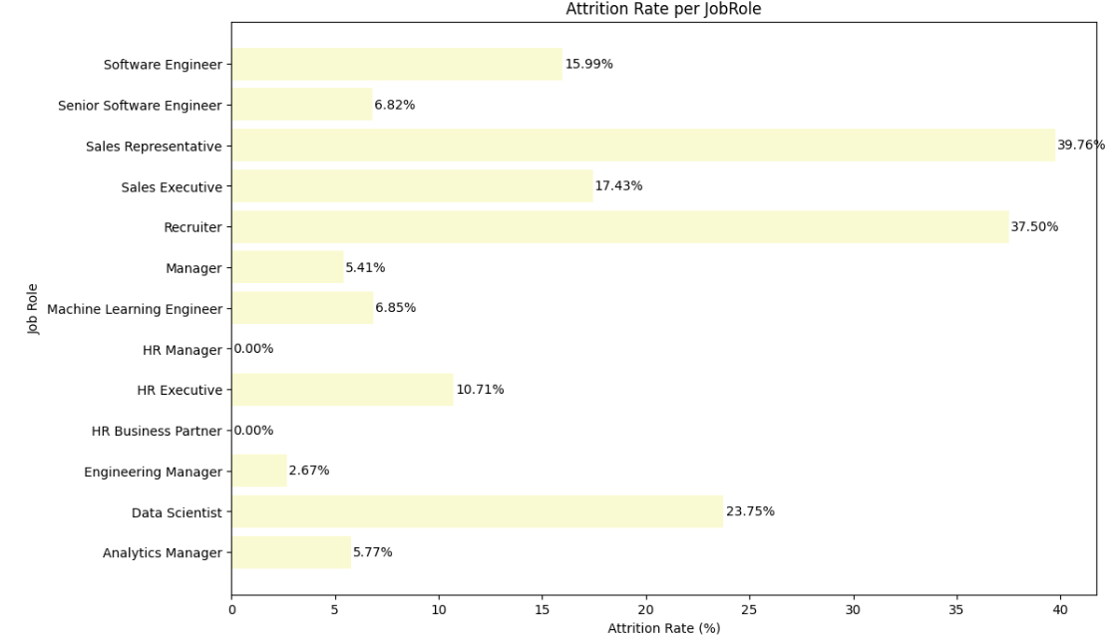
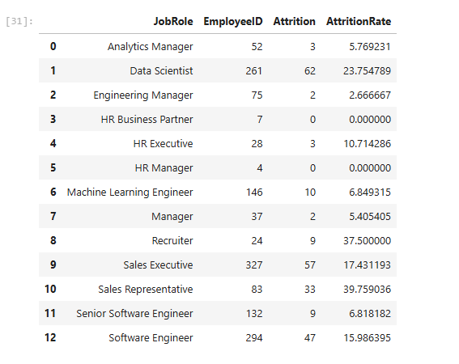
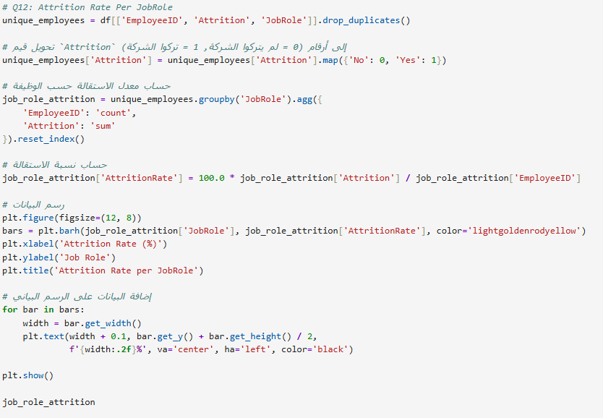
Figure (100): Q12 Attrition Rate per JobRole
Figure (101): Q12 Result Attrition Rate per JobRole

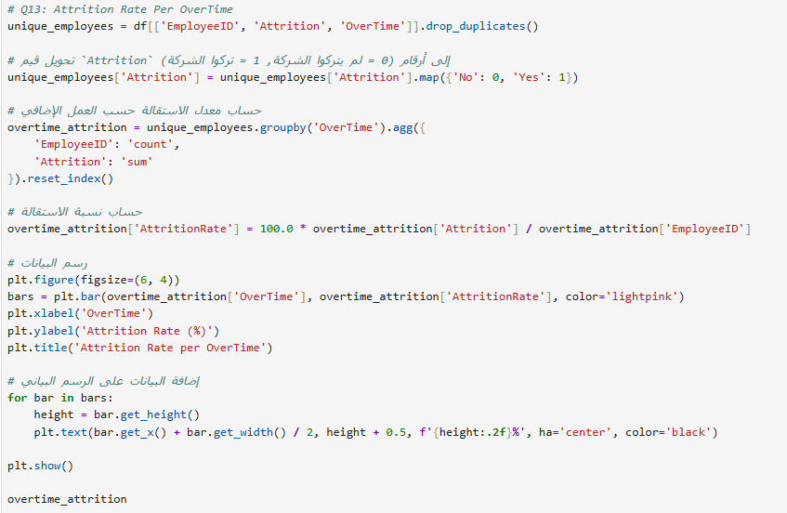
Figure (102): Q13 Attrition Rate per Overtime
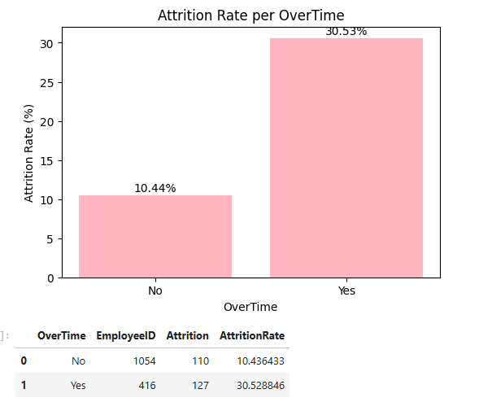
Figure (103): Q13 Result Attrition Rate per Overtime
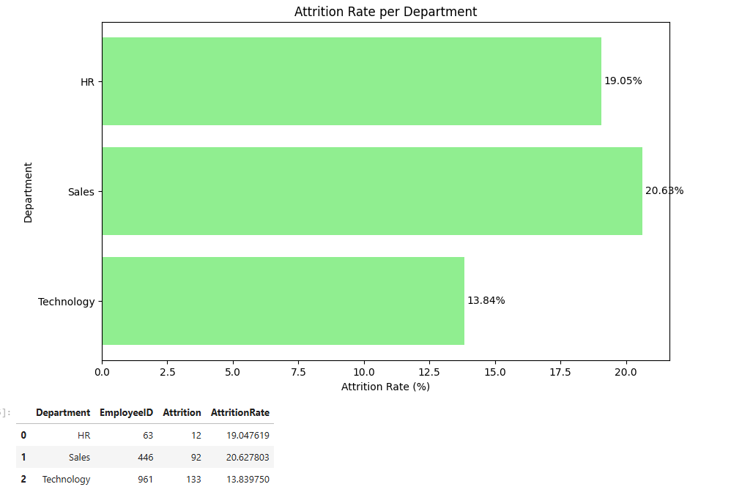
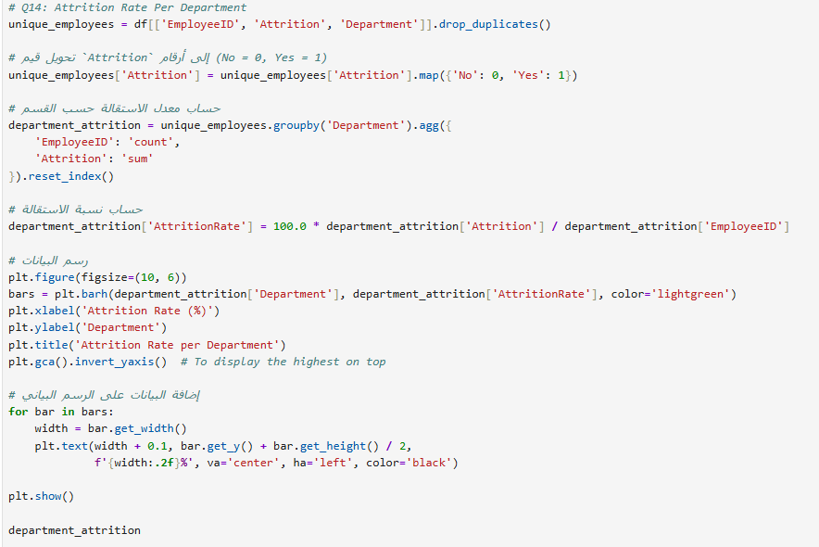
Figure (105): Q14 Result Attrition Rate per Department
Figure (104): Q14 Attrition Rate per Department

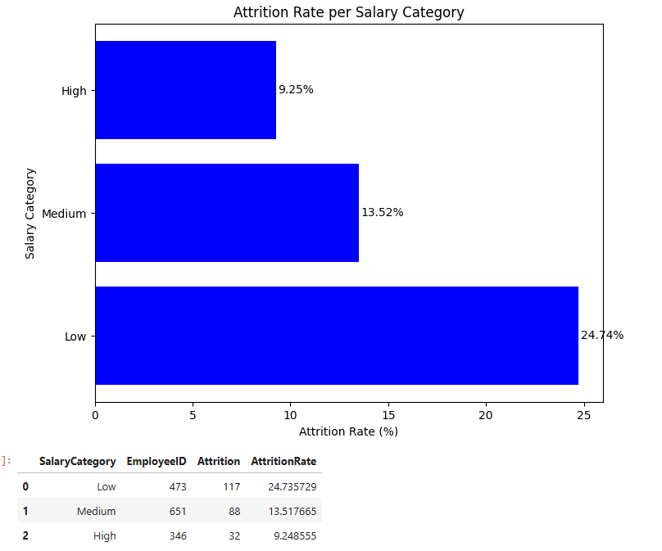
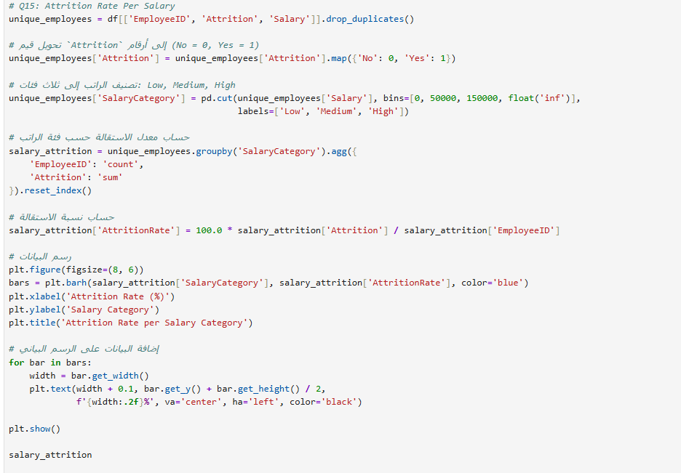
Figure (106): Q15 Attrition Rate per Salary
Figure (107): Q15 Result Attrition Rate per Salary
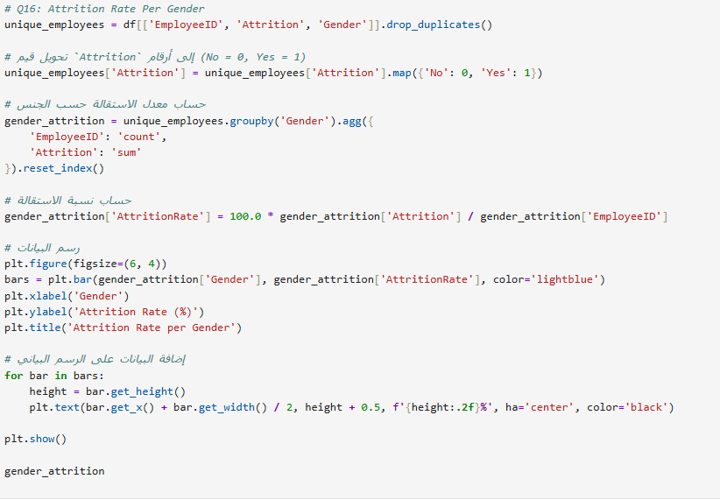
Figure (108): Q16 Result Attrition Rate per Gender
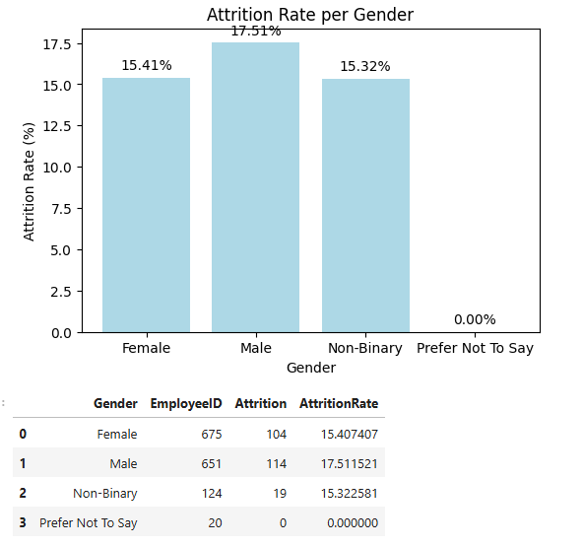
Figure (109): Q16 Result Attrition Rate per Gender
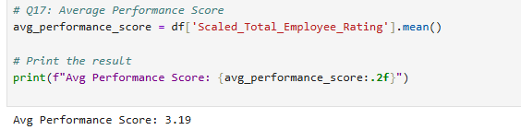
Figure (110): Q17 Average Performance Score & Result

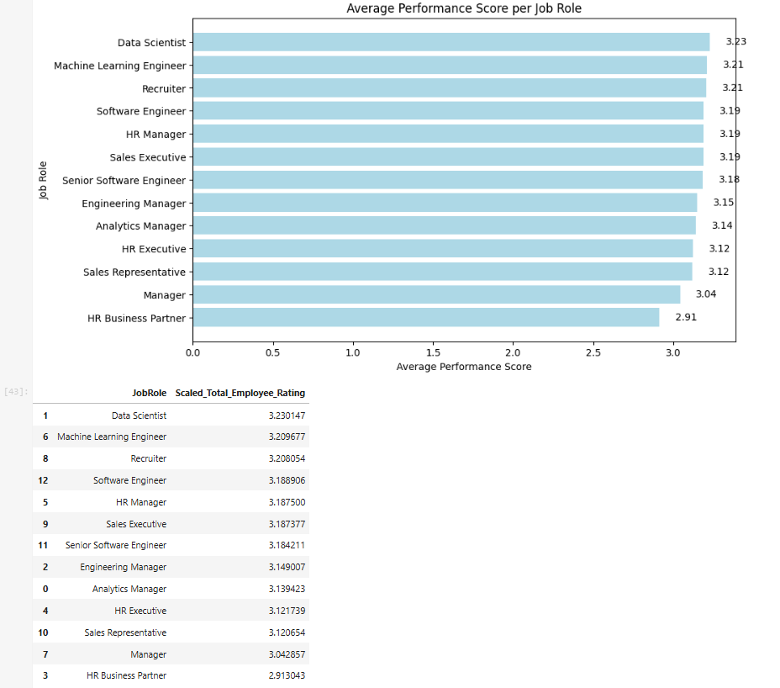
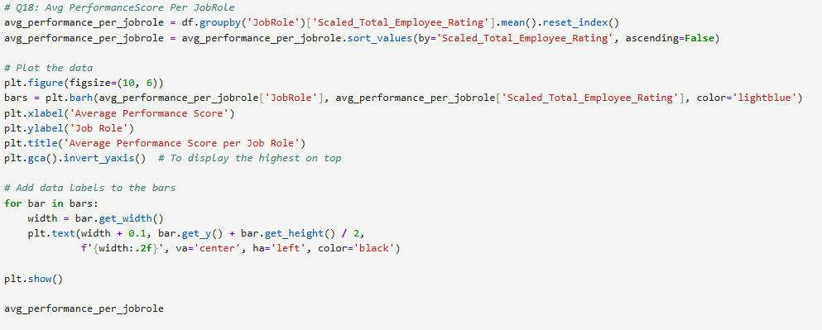
Figure (112): Q17 Result Average Performance Score per JobRole
Figure (111): Q17 Average Performance Score per JobRole

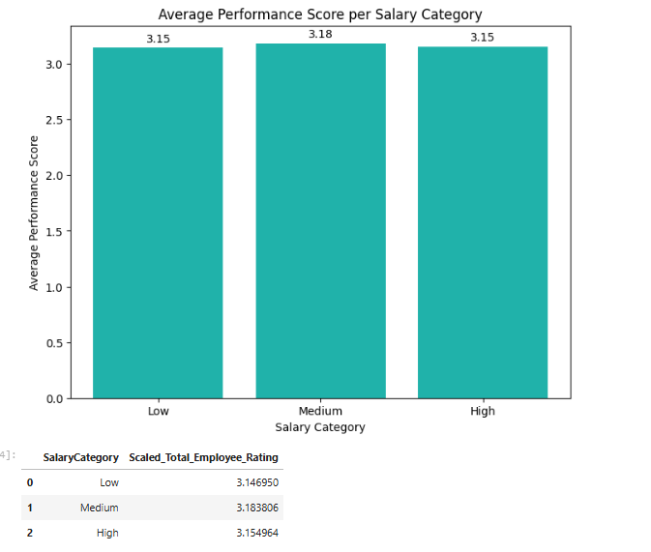
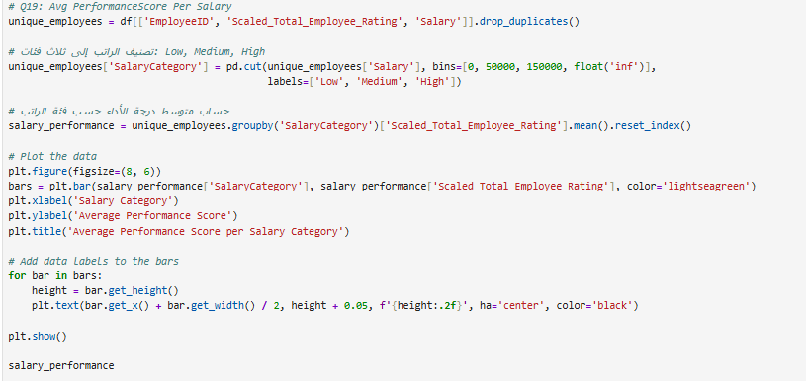
Figure (114): Q19 Result of Average Performance Score per salary
Figure (113): Q19 Average Performance Score per salary
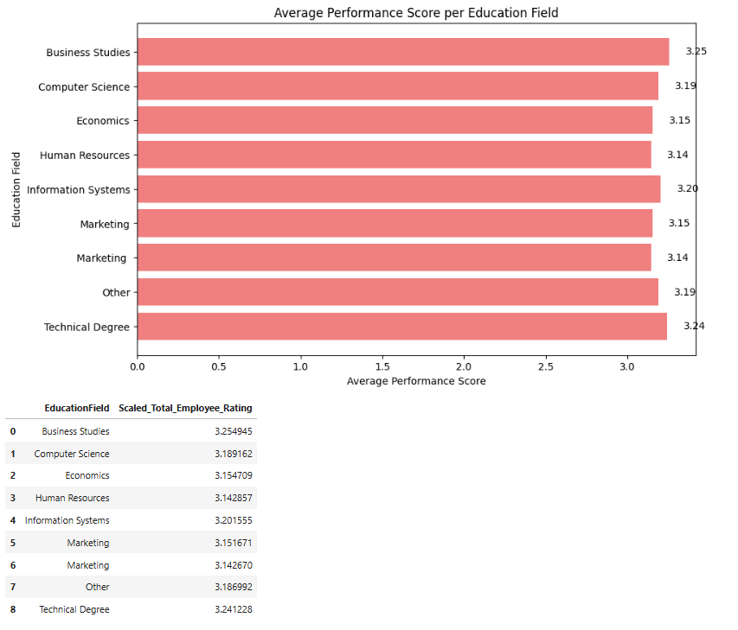
Figure (115): Q20 Average Performance Score per Education field
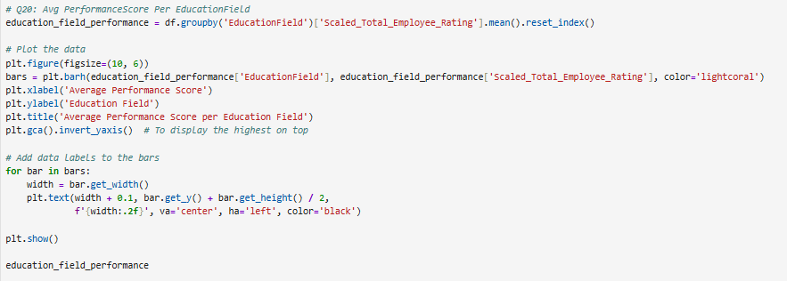
Figure (116): Q20 Average Performance Score per educational level

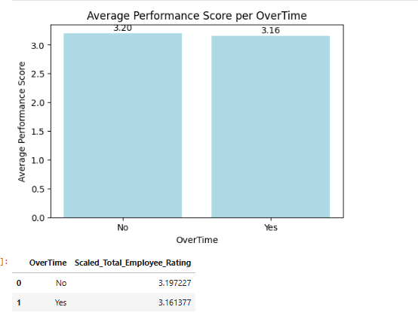
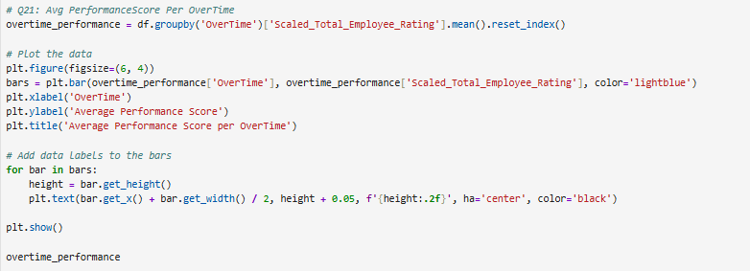
Figure (117): Q21 Average Performance Score per overtime
Figure (118): Q21 result of Average Performance Score per overtime
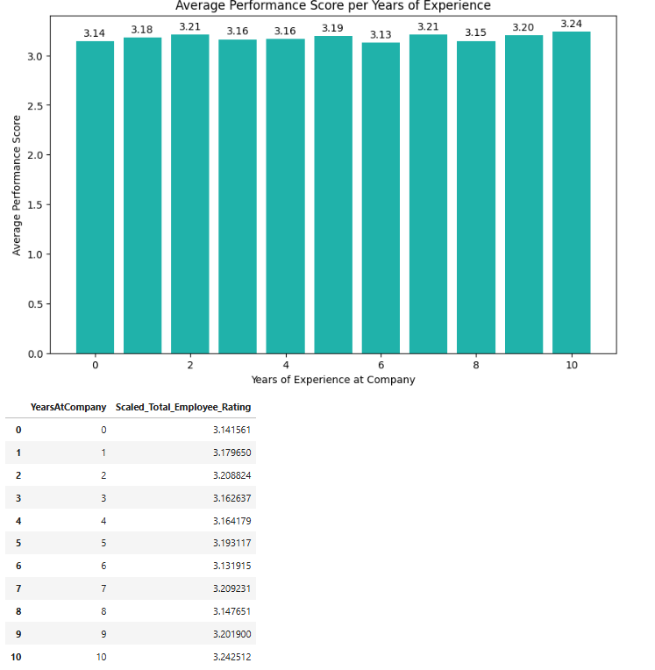
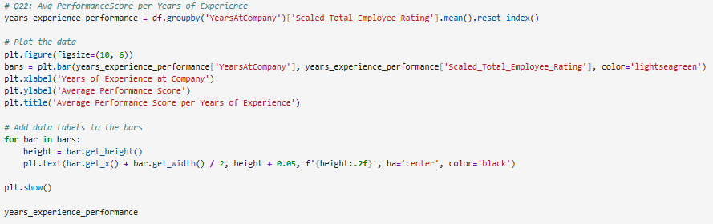
Figure (119): Q22 Average Performance Score per years of Experience

Figure (120): Q22 Average Performance Score per years of experience

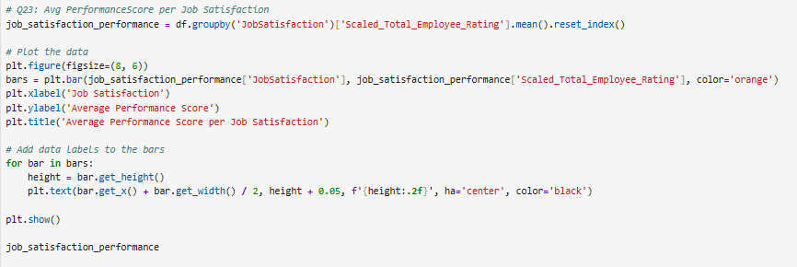
Figure (121): Q23 Average Performance Score per job satisfaction
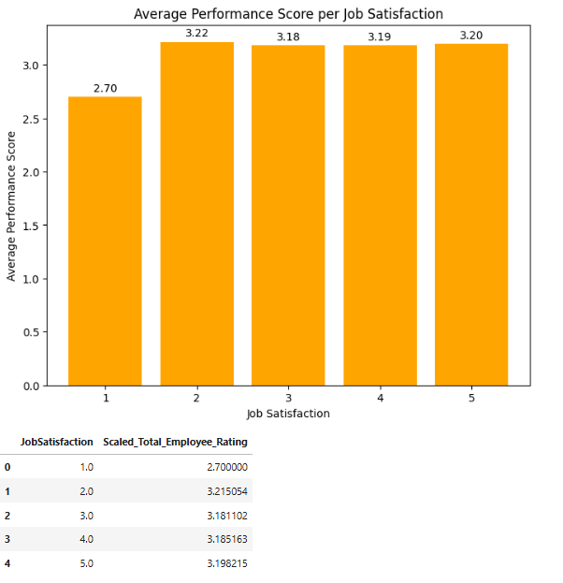
Figure (122): Q23 Result of Average Performance Score per job satsifaction

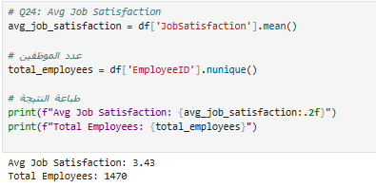
Figure (123): Q24 Average job satisfaction & Results

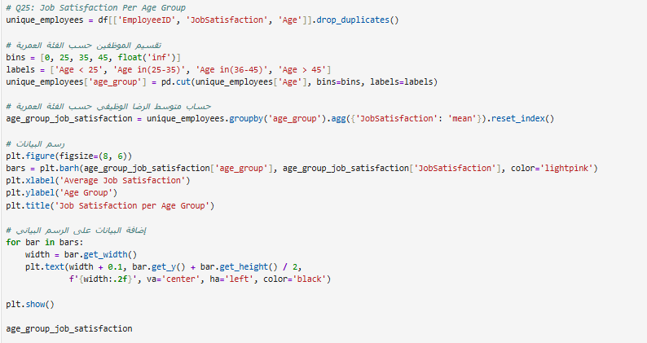
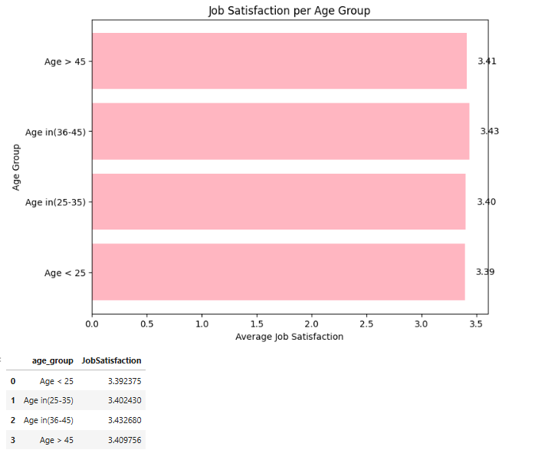
Figure (124): Q25 job satisfaction per Age Group
Figure (125): Q25 result of job satisfaction per Age
Figure (126): Q26 job satisfaction per job role
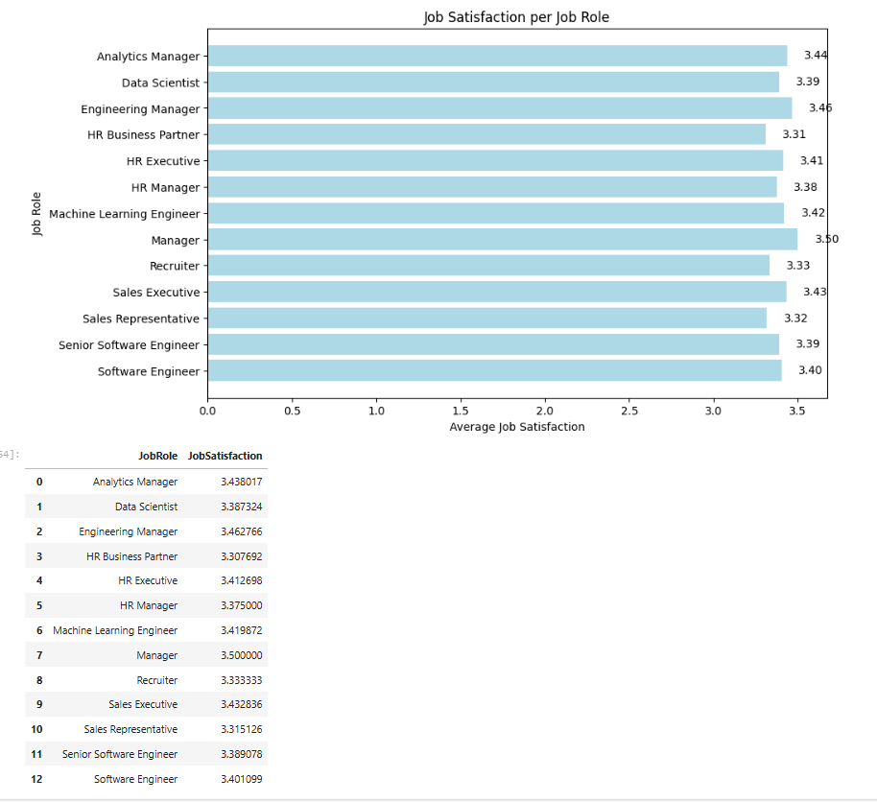
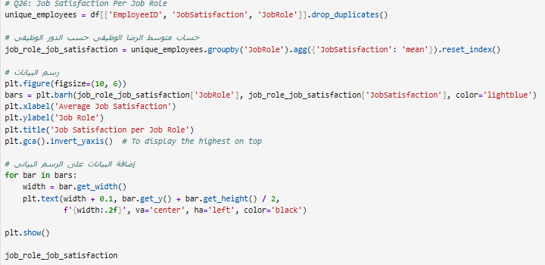
Figure (127): Q26 result of job satisfaction per job role
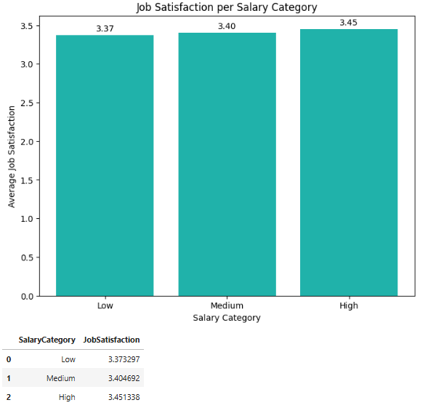
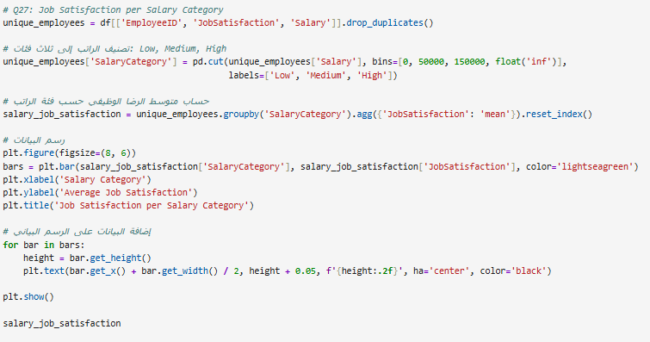
Figure (129): Q27 result of job satisfaction per salary category
Figure (128): Q27 job satisfaction per salary category

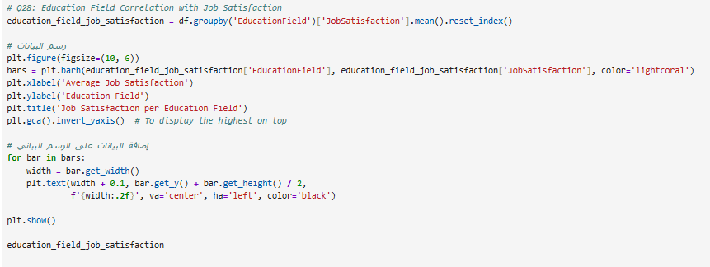
Figure (130): Q28 education field correlation job satisfaction
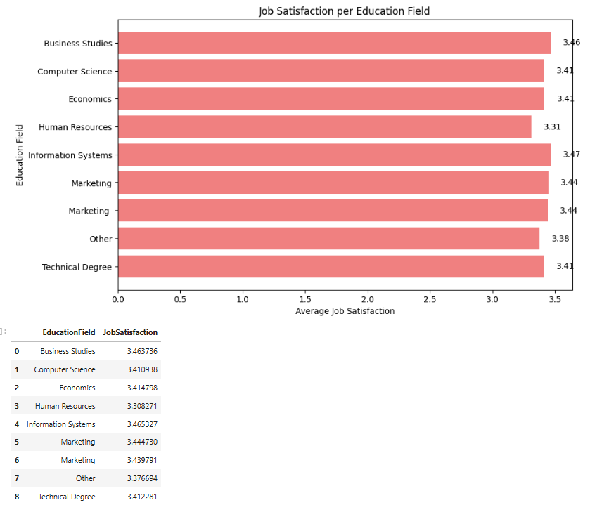
Figure (131): Q28 result of education field correlation job satisfaction

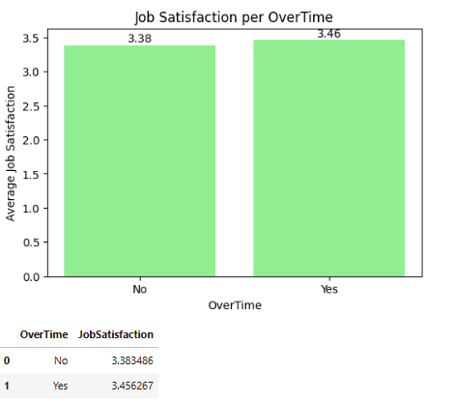
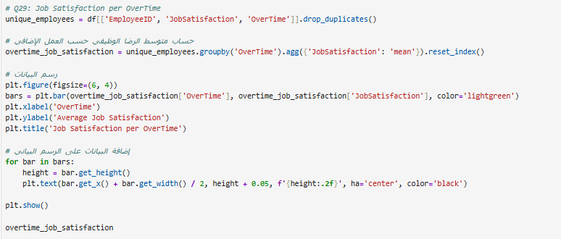
Figure (133): Q29 result of job satisfaction per overtime
Figure (132): Q29 job satisfaction per Age per overtime
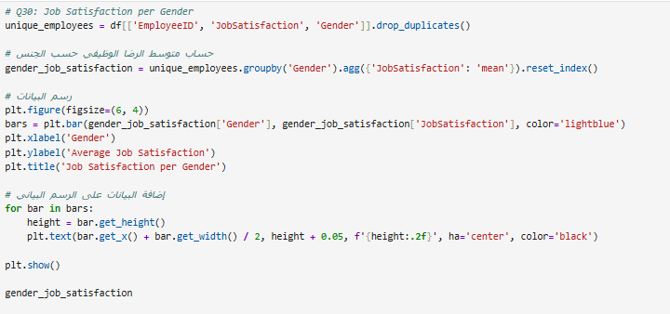
Figure (134): Q30 job satisfaction per gender
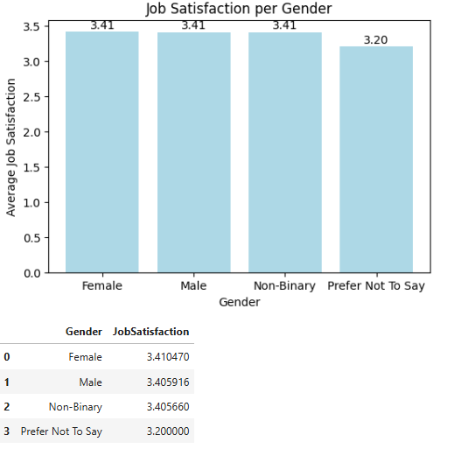
Figure (135): Q30 result of job satisfaction per gender
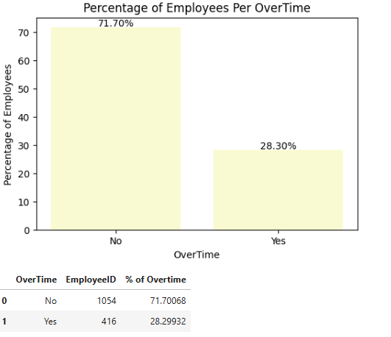
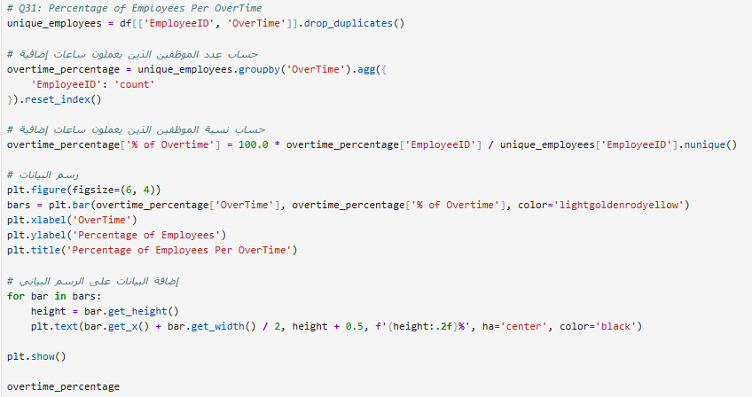
Figure (136): Q31 percentage of employees per overtime
Figure (137): Q31 result of percentage of employees per overtime

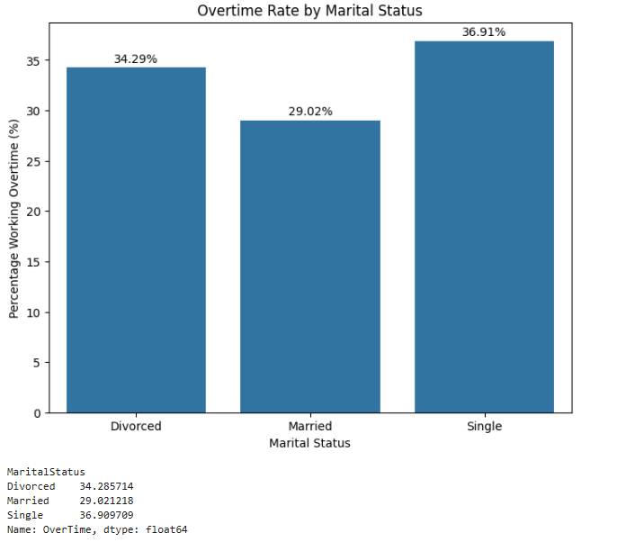
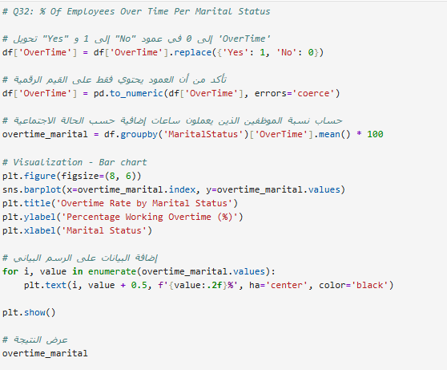
Figure (138): Q32 % of employees overtime per marital status
Figure (139): Q32 result of % of employees overtime per marital status

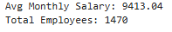
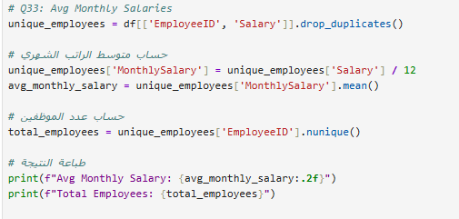
Figure (140): Q33 Avg monthly salaries & result

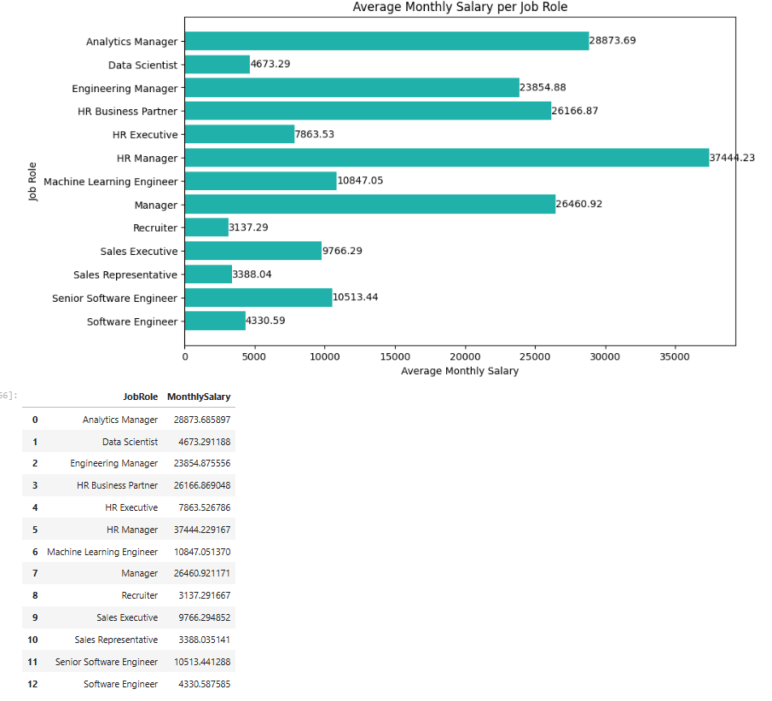
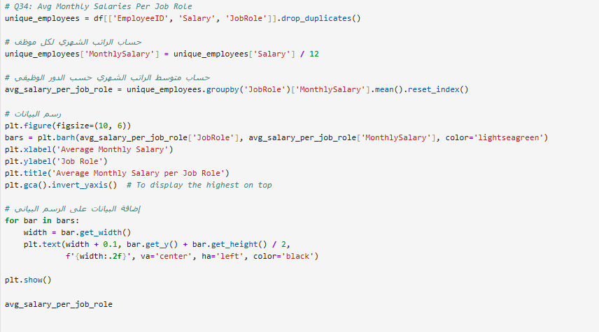
Figure (141): Q34 Avg monthly salaries per job role
Figure (142): Q34 result of Avg monthly salaries per job role
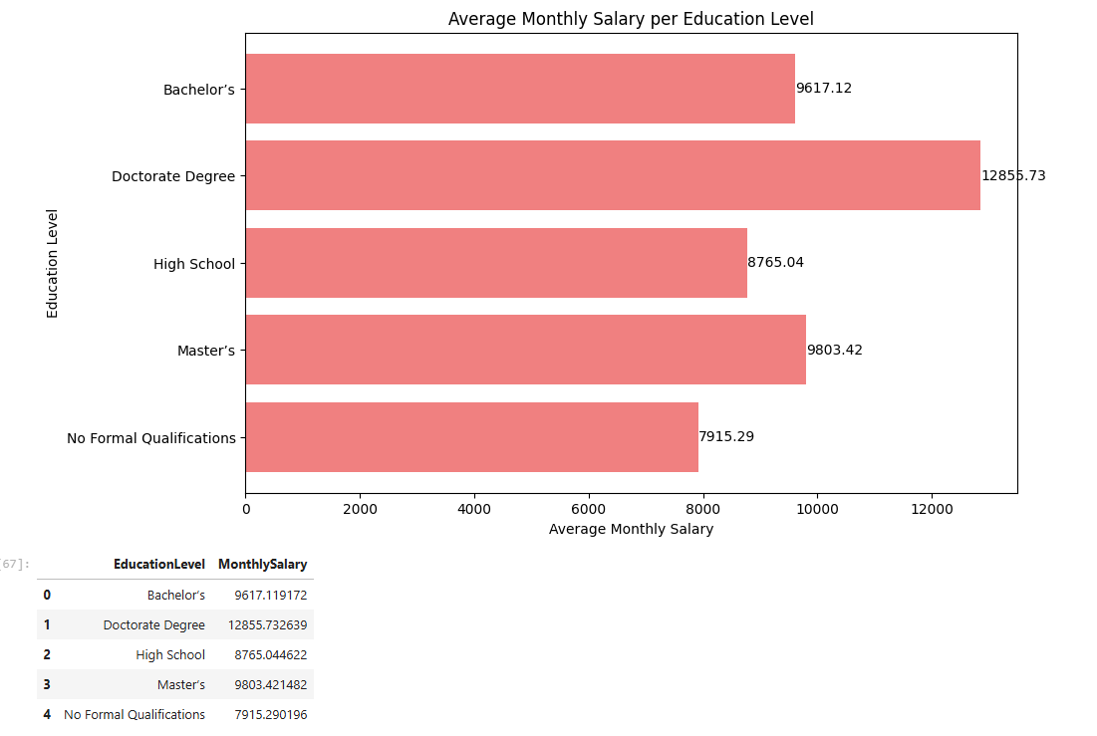
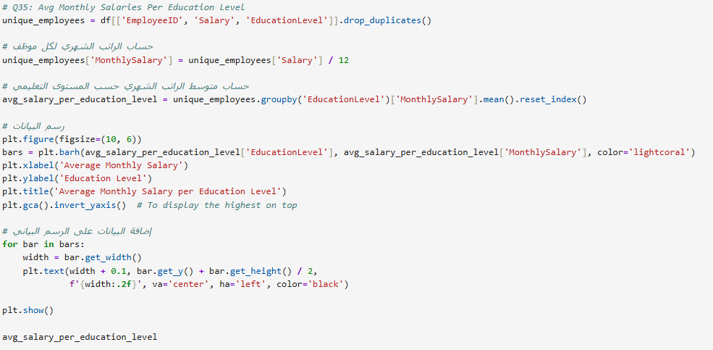
Figure (143): Q35 Avg monthly salaries per education level
Figure (144): Q35 result of Avg monthly salaries per education level

3.Analysis Questions Using SQL
  - Creating data base to import necessary tables
3.1.1 import Tables as Flat files and Check :
      - Check data types and Null Values
      - Select Primary Keys columns
3.1.2. Select Imported files to Check it

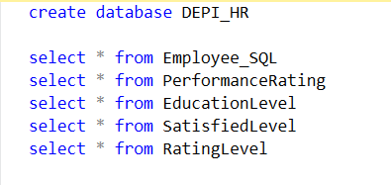
Figure (145): Import data in SQL
  - Add foreign keys to tables to relate them to each other
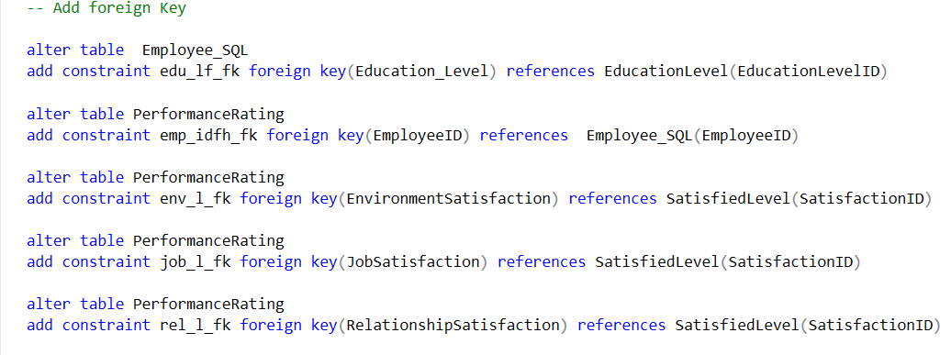

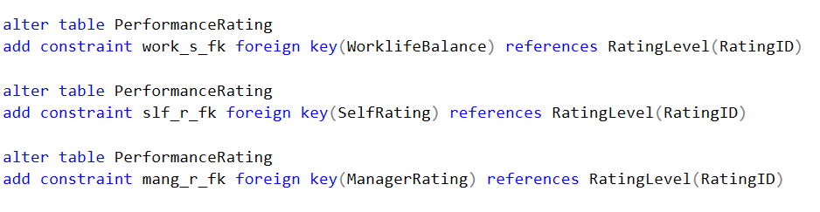
Figure (146): Add foreign key

  - Create table to merge all data tables to start analysis
2.3.1. select new merged table to check New table
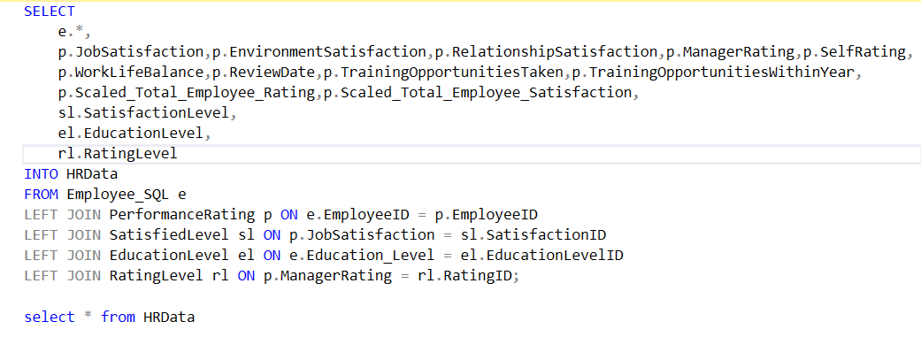
Figure (147): select new merged table to check new table
  - Count number of distinct Employees
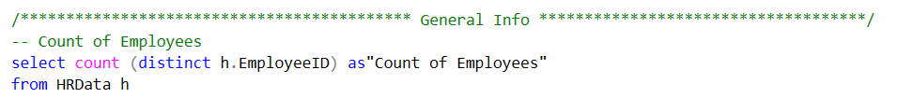
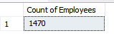
Figure (148): Q1 Count no. of distinct employees

  - --Q2 AVG Years Of Experience at campony per JobRole
select h.JobRole, AVG (h.YearsAtCompany) as "AVG Years Of Experience"
from HRData h
group by h.JobRole
ORDER BY "AVG Years Of Experience" desc
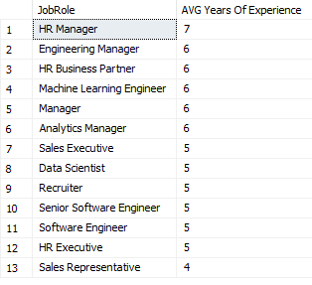
Figure (149): Q2 Avg years of experience at company per jobrole

  - -- Q3 Count of Employees Per Ethnicity

SELECT
h.Ethnicity,
COUNT(DISTINCT h.EmployeeID) AS TotalEmployees,
ROUND(100.0 * COUNT(DISTINCT h.EmployeeID) / (Select COUNT(DISTINCT EmployeeID) FROM HRData), 2) AS PercentageEmployee
FROM HRData h
GROUP BY h.Ethnicity
ORDER BY PercentageEmployee DESc

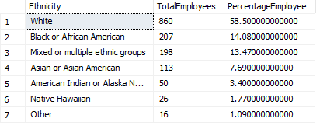
Figure (150): Q3 result of count employees per ethnicity

  - -- Q4 % OF Employees per education level
SELECT
h.EducationLevel,
COUNT(DISTINCT h.EmployeeID) AS TotalEmployees,
ROUND(100.0 * COUNT(DISTINCT h.EmployeeID) / (Select COUNT(DISTINCT EmployeeID) FROM HRData), 2) AS PercentageEmployee
FROM HRData h
GROUP BY h.EducationLevel
ORDER BY PercentageEmployee DESC
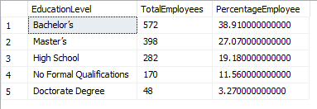
Figure (151): Q35 result of Avg monthly salaries per education level

  - –- Q5 % OF Employees per Gender
SELECT
h.Gender,
COUNT(DISTINCT h.EmployeeID) AS TotalEmployees,
ROUND(100.0 * COUNT(DISTINCT h.EmployeeID) / (Select COUNT(DISTINCT EmployeeID) FROM HRData), 2) AS PercentageEmployee
FROM HRData h
where h.Gender in ('Female','Male')
GROUP BY h.Gender
ORDER BY PercentageEmployee DESC;

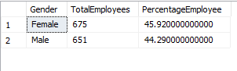
Figure (151): Q5 % of employees per gender

  - -- Q6 % and Count of employee per each Department
select h.Department ,count(distinct h.EmployeeID)as Count_of_Employees,
ROUND(100.0 * COUNT(DISTINCT h.EmployeeID) / (Select COUNT(DISTINCT EmployeeID) FROM HRData), 2) AS PercentageEmployee
from HRData h
group by h.Department
order by Count_of_Employees desc

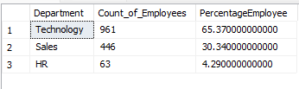
Figure (152): Q6 % & count of employee per each department

  - -- Q7 Count & Age Groups %
SELECT
CASE
WHEN Age < 25 THEN 'Age < 25'
WHEN Age BETWEEN 25 AND 35 THEN 'Age in(25-35)'
WHEN Age BETWEEN 36 AND 45 THEN 'Age in(36-45)'
ELSE 'Age > 45'
END
AS age_group,
COUNT(DISTINCT EmployeeID) AS total_employees,
ROUND(100.0 * COUNT(DISTINCT EmployeeID) / (SELECT COUNT(DISTINCT EmployeeID) FROM HRData), 2) AS "% of employees"
FROM HRData
GROUP BY
CASE
WHEN Age < 25 THEN 'Age < 25'
WHEN Age BETWEEN 25 AND 35 THEN 'Age in(25-35)'
WHEN Age BETWEEN 36 AND 45 THEN 'Age in(36-45)'
ELSE 'Age > 45'
END

ORDER BY total_employees DESC;
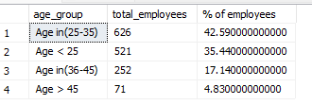
Figure (153): Q7 count & Age Group %

  - -- Q8 Count of performance rating

select h.EmployeeID ,count(EmployeeID)as Count_of_Employees_performance
from HRData h
group by h.EmployeeID
order by Count_of_Employees_performance desc

Sample of Output:
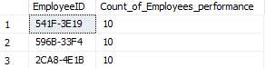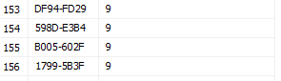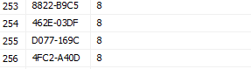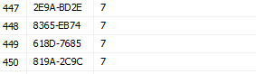
Figure (154): Q8 Count of performance rating

/******************************* Attrition Rate ******************************/
  - -- Q9 Attrition Rate Per average YearsAtCompany for Active Employees
SELECT
Attrition,
AVG(YearsAtCompany) AS "Avg YearsAtCompany"
FROM HRData
WHERE Attrition IN (0, 1)
GROUP BY Attrition;

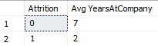
Figure (155): Q9 Attrition Rate per average for active employees

  - – Q10 Percentage of employees who leave the company

WITH UniqueEmployees AS (
SELECT DISTINCT EmployeeID, Attrition
FROM HRData
)
SELECT
COUNT(EmployeeID) AS TotalEmployees,
SUM(CASE WHEN Attrition = 1 THEN 1 ELSE 0 END) AS EmployeesLeft,
ROUND(100.0 * SUM(CASE WHEN Attrition = 1 THEN 1 ELSE 0 END) / COUNT(EmployeeID), 2) AS AttritionRate
FROM UniqueEmployees
WHERE Attrition IN (0, 1);

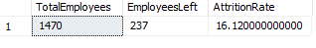
Figure (156): Q10 Attrition Rate per average for active employees

  - –Q11 Attrition Rate Per Age Group

WITH UniqueEmployees AS (
SELECT DISTINCT EmployeeID, Attrition,Age
FROM HRData
)
SELECT
CASE
WHEN Age < 25 THEN 'Age < 25'
WHEN Age BETWEEN 25 AND 35 THEN 'Age in(25-35)'
WHEN Age BETWEEN 36 AND 45 THEN 'Age in(36-45)'
ELSE 'Age > 45'
END
AS age_group ,
COUNT(EmployeeID) AS TotalEmployees,
SUM(CASE WHEN Attrition = 1 THEN 1 ELSE 0 END) AS EmployeesLeft,
ROUND(100.0 * SUM(CASE WHEN Attrition = 1 THEN 1 ELSE 0 END) / 237, 2) AS AttritionRate
FROM UniqueEmployees
WHERE Attrition IN (0, 1)
GROUP BY
CASE
WHEN Age < 25 THEN 'Age < 25'
WHEN Age BETWEEN 25 AND 35 THEN 'Age in(25-35)'
WHEN Age BETWEEN 36 AND 45 THEN 'Age in(36-45)'
ELSE 'Age > 45'
END
ORDER BY AttritionRate desc
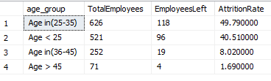
Figure (157): Q11 Attrition Rate per age group

  - -- Q12 Attrition Per job satisfaction
WITH UniqueEmployees AS (
SELECT DISTINCT EmployeeID, Attrition, JobSatisfaction , SatisfactionLevel
FROM HRData
)
SELECT
JobSatisfaction,
SatisfactionLevel,
COUNT(EmployeeID) AS TotalEmployees,
SUM(CASE WHEN Attrition = 1 THEN 1 ELSE 0 END) AS EmployeesLeft,
ROUND(100.0 * SUM(CASE WHEN Attrition = 1 THEN 1 ELSE 0 END) /915, 2) AS AttritionRate
FROM UniqueEmployees
WHERE Attrition IN (0, 1)
GROUP BY SatisfactionLevel ,JobSatisfaction
ORDER BY AttritionRate desc

NOTE : NULL Means that this employees didn't have Job Satisfaction Rating Yet

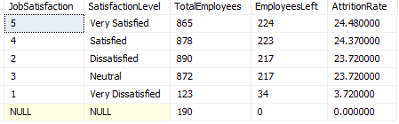
Figure (158): Q12 Attrition Rate job satisfaction

  - -- Q13 Attrition Rate Per StockOptionLevel

WITH UniqueEmployees AS (
SELECT DISTINCT EmployeeID, Attrition,StockOptionLevel
FROM HRData
)
SELECT
StockOptionLevel,
COUNT(distinct EmployeeID) AS TotalEmployees,
SUM(CASE WHEN Attrition = 1 THEN 1 ELSE 0 END) AS EmployeesLeft,
ROUND(100.0 * SUM(CASE WHEN Attrition = 1 THEN 1 ELSE 0 END) / 237, 2) AS AttritionRate
FROM UniqueEmployees
WHERE Attrition IN (0, 1)
GROUP BY StockOptionLevel
ORDER BY AttritionRate desc

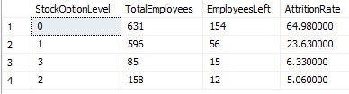
Figure (159): Q13 Attrition Rate per Stock option level

  - --Q14 Attrition Rate Per JobRole

WITH UniqueEmployees AS (
SELECT DISTINCT EmployeeID, Attrition,JobRole
FROM HRData
)
SELECT
JobRole,
COUNT(EmployeeID) AS TotalEmployees,
SUM(CASE WHEN Attrition = 1 THEN 1 ELSE 0 END) AS EmployeesLeft,
ROUND(100.0 * SUM(CASE WHEN Attrition = 1 THEN 1 ELSE 0 END) / 237, 2) AS AttritionRate
FROM UniqueEmployees
WHERE Attrition IN (0, 1)
GROUP BY JobRole
ORDER BY AttritionRate desc

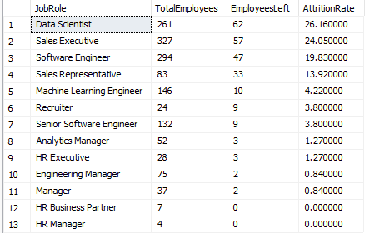
Figure (160): Q14 Attrition Rate per job role

  - --Q15 Attrition Rate Per Over Time

WITH UniqueEmployees AS (
SELECT DISTINCT EmployeeID, Attrition,OverTime
FROM HRData
)
SELECT
OverTime,
COUNT(EmployeeID) AS TotalEmployees,
SUM(CASE WHEN Attrition = 1 THEN 1 ELSE 0 END) AS EmployeesLeft,
ROUND(100.0 * SUM(CASE WHEN Attrition = 1 THEN 1 ELSE 0 END) / COUNT(EmployeeID), 2) AS AttritionRate
FROM UniqueEmployees
WHERE Attrition IN (0, 1)
GROUP BY OverTime
ORDER BY AttritionRate desc

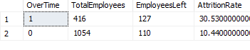
Figure (161): Q15 Attrition Rate per overtime

  - --Q16: Attrition rates Per Departments
WITH UniqueEmployees AS (
SELECT DISTINCT EmployeeID, Attrition, Department
FROM HRData
)
SELECT
Department,
COUNT(EmployeeID) AS TotalEmployees,
SUM(CASE WHEN Attrition = 1 THEN 1 ELSE 0 END) AS "EmployeesLeft",
ROUND(100.0 * SUM(CASE WHEN Attrition = 1 THEN 1 ELSE 0 END) / 237, 2) AS AttritionRate
FROM UniqueEmployees
WHERE Attrition IN (0, 1)
GROUP BY Department
ORDER BY AttritionRate desc

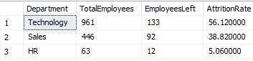
Figure (162): Q16 Attrition Rate per Departments

  - -- Q17: Salary Per Attrition rate? 237
WITH UniqueEmployees AS (
SELECT DISTINCT EmployeeID, Attrition,Salary
FROM HRData
)
SELECT
CASE
WHEN Salary < 50000 THEN 'Low'
WHEN Salary BETWEEN 50000 AND 150000 THEN 'Medium'
ELSE 'High'
END AS SalaryCategory,
COUNT(Distinct EmployeeID) AS TotalEmployees,
SUM(CASE WHEN Attrition = 1 THEN 1 ELSE 0 END) AS EmployeesLeft,
ROUND(100.0 * SUM(CASE WHEN Attrition = 1 THEN 1 ELSE 0 END) / 237, 2) AS AttritionRate
FROM UniqueEmployees
WHERE Attrition IN (0, 1)
GROUP BY
CASE
WHEN Salary < 50000 THEN 'Low'
WHEN Salary BETWEEN 50000 AND 150000 THEN 'Medium'
ELSE 'High'
END
ORDER BY AttritionRate DESC

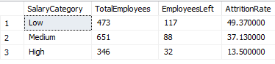
Figure (163): Q17 Attrition Rate per salary

  - -- Q18 Attrition Rate Per Gender

WITH UniqueEmployees AS (
SELECT DISTINCT EmployeeID, Attrition, Gender
FROM HRData
)
SELECT
Gender,
COUNT(EmployeeID) AS TotalEmployees,
SUM(CASE WHEN Attrition = 1 THEN 1 ELSE 0 END) AS EmployeesLeft,
ROUND(100.0 * SUM(CASE WHEN Attrition = 1 THEN 1 ELSE 0 END) / 237, 2) AS AttritionRate
FROM UniqueEmployees
WHERE Attrition IN (0, 1) and Gender in ('Female','Male')
GROUP BY Gender
ORDER BY AttritionRate desc

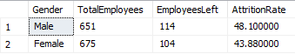
Figure (164): Q18 Attrition Rate per Gender

/******************************* Performance *******************************/
  - -- Q19 AVG Performance Score
SELECT

ROUND(AVG(CAST(Scaled_Total_Employee_Rating AS FLOAT)), 2) AS AvgPerformanceScore
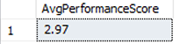
FROM HRData
Figure (165): Q19 Average Performance score

  - –Q20 avg Performance Score Per job role
SELECT
JobRole,
ROUND(AVG(CAST(Scaled_Total_Employee_Rating AS FLOAT)), 2) AS AvgPerformanceScore

FROM HRData
Group By JobRole
Order By AvgPerformanceScore desc

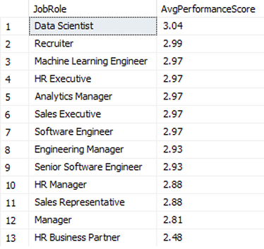
Figure (166): Q20 Average performance score per sob role

  - –Q21 avg PerformanceScore Per Salary
SELECT
CASE
WHEN Salary < 50000 THEN 'Low'
WHEN Salary BETWEEN 50000 AND 150000 THEN 'Medium'
ELSE 'High'
END AS SalaryCategory,
ROUND(AVG(CAST(Scaled_Total_Employee_Rating AS FLOAT)), 2) AS AvgPerformanceScore
FROM HRData

GROUP BY
CASE
WHEN Salary < 50000 THEN 'Low'
WHEN Salary BETWEEN 50000 AND 150000 THEN 'Medium'
ELSE 'High'
END

Order By AvgPerformanceScore desc

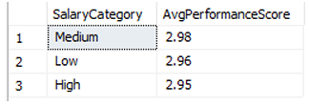
Figure (167): Q21 Average performance score per salary

  - --Q22 avg PerformanceScore Per Educatuion field

SELECT
EducationField,
ROUND(AVG(CAST(Scaled_Total_Employee_Rating AS FLOAT)), 2) AS AvgPerformanceScore
FROM HRData
Group By EducationField
Order By AvgPerformanceScore desc

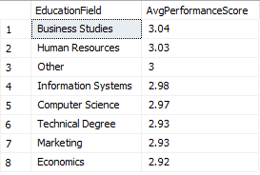
Figure (168): Q22 Average performance score per education

  - --Q23 avg PerformanceScore Per Over Time
SELECT
OverTime,
ROUND(AVG(CAST(Scaled_Total_Employee_Rating AS FLOAT)), 2) AS AvgPerformanceScore

FROM HRData

Group By OverTime
Order By AvgPerformanceScore desc

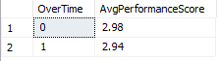
Figure (169): Q23 Average performance score per overtime

  - --Q24 avg PerformanceScore per Years of experience
SELECT
YearsAtCompany,
ROUND(AVG(CAST(Scaled_Total_Employee_Rating AS FLOAT)), 2) AS AvgPerformanceScore
FROM HRData

Group By YearsAtCompany
Order By AvgPerformanceScore desc

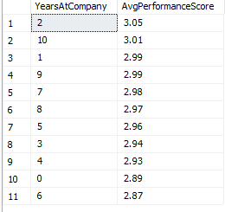
Figure (170): Q24 Average performance score per years of experience
  - --Q25 avg PerformanceScore per Job Satisfaction
SELECT
JobSatisfaction,
ROUND(AVG(CAST(Scaled_Total_Employee_Rating AS FLOAT)), 2) AS AvgPerformanceScore
FROM HRData

Group By JobSatisfaction
Order By AvgPerformanceScore desc
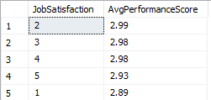
Figure (171): Q25 Average performance score per job satisfaction

/******************************* Satisfaction **********************************/
  - --Q26 AVG Job Satisfaction
SELECT
ROUND(AVG(CAST(JobSatisfaction AS FLOAT)), 2) AS AvgJobSatisfaction,
FROM HRData

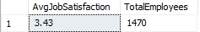
Figure (172): Q26 Average job satisfaction

  - --Q27 Job Satisfaction Per Age
SELECT
CASE
WHEN Age < 25 THEN 'Age < 25'
WHEN Age BETWEEN 25 AND 35 THEN 'Age in(25-35)'
WHEN Age BETWEEN 36 AND 45 THEN 'Age in(36-45)'
ELSE 'Age > 45'
END
AS age_group,
ROUND(AVG(CAST(JobSatisfaction AS FLOAT)), 2) AS AvgJobSatisfaction
FROM HRData
GROUP BY CASE
WHEN Age < 25 THEN 'Age < 25'
WHEN Age BETWEEN 25 AND 35 THEN 'Age in(25-35)'
WHEN Age BETWEEN 36 AND 45 THEN 'Age in(36-45)'
ELSE 'Age > 45'
End
ORDER BY AvgJobSatisfaction DESC;

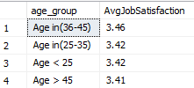
Figure (173): Q27 Average job satisfaction per Age

  - -- Q28 Job satisfaction Per Job Role
WITH UniqueEmployees AS (
SELECT DISTINCT JobRole, JobSatisfaction, EmployeeID
FROM HRData
)
SELECT
JobRole,
ROUND(AVG(CAST(JobSatisfaction AS FLOAT)), 2) AS AvgJobSatisfaction
FROM HRData
GROUP BY JobRole
ORDER BY AvgJobSatisfaction DESC;

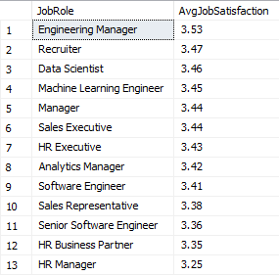
Figure (174): Q28 Average job satisfaction per role job

  - -- Q29 Job satisfaction per Salary Category
SELECT
CASE
WHEN Salary < 50000 THEN 'Low'
WHEN Salary BETWEEN 50000 AND 150000 THEN 'Medium'
ELSE 'High'
END AS SalaryCategory,
AVG(CAST(JobSatisfaction AS FLOAT)) AS AvgJobSatisfaction
FROM HRData
GROUP BY CASE
WHEN Salary < 50000 THEN 'Low'
WHEN Salary BETWEEN 50000 AND 150000 THEN 'Medium'
ELSE 'High'
END
ORDER BY AvgJobSatisfaction desc

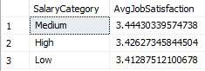
Figure (175): Q29 Average job satisfaction per salary category

  - – Q30 : How does education field correlate with JobSatisfaction ?
SELECT
EducationField,
COUNT(distinct EmployeeID) AS TotalEmployees,
ROUND(AVG(CAST(JobSatisfaction AS FLOAT)), 2) AS AvgJobSatisfaction
FROM HRData
GROUP BY EducationField
ORDER BY AvgJobSatisfaction desc

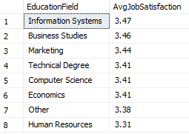
Figure (176): Q30 Average job satisfaction per education field

  - – Q31 JobSatisfaction per over time
SELECT
OverTime,
COUNT(distinct EmployeeID) AS TotalEmployees,
ROUND(AVG(CAST(JobSatisfaction AS FLOAT)), 2) AS AvgJobSatisfaction
FROM HRData
GROUP BY OverTime
ORDER BY AvgJobSatisfaction DESC

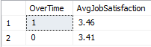
Figure (177): Q31 Average job satisfaction per overtime

  - -- Q32 Job satisfaction per Gender?
SELECT
Gender,
COUNT(distinct EmployeeID) AS TotalEmployees,
ROUND(AVG(CAST(JobSatisfaction AS FLOAT)), 2) AS AvgJobSatisfaction
FROM HRData
where Gender in ('Male','Female')
GROUP BY Gender
ORDER BY AvgJobSatisfaction DESC

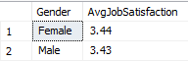
Figure (178): Q32 Average job satisfaction per Age

/******************************* Over Time **********************************/
  - -- Q33 % Of Employees Per Over Time -- AS Card
WITH UniqueEmployees AS (
SELECT DISTINCT EmployeeID, OverTime
FROM HRData
)
SELECT
COUNT(EmployeeID) AS TotalEmployees,
SUM(CASE WHEN OverTime = 1 THEN 1 ELSE 0 END) AS Employees_Overtime,
ROUND(100.0 * SUM(CASE WHEN OverTime = 1 THEN 1 ELSE 0 END) / COUNT(EmployeeID), 2) AS "% of Overtime"
FROM UniqueEmployees
WHERE OverTime IN (0, 1);

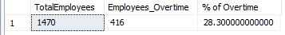
Figure (179): Q33 % of employees per overtime

  - --Q34 % Of Employees Over Time Per Marital Status

WITH UniqueEmployees AS (
SELECT DISTINCT EmployeeID, OverTime , MaritalStatus
FROM HRData
)
SELECT
MaritalStatus,
COUNT(EmployeeID) AS TotalEmployees,
SUM(CASE WHEN OverTime = 1 THEN 1 ELSE 0 END) AS Employees_Overtime,
ROUND(100.0 * SUM(CASE WHEN OverTime = 1 THEN 1 ELSE 0 END) / 416, 2) AS "% of Overtime"
FROM UniqueEmployees
WHERE OverTime IN (0, 1)
GROUP BY MaritalStatus
ORDER BY "% of Overtime" desc

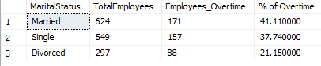
Figure (180): Q34 % of employee overtime per marital status

/********************************Saleries************************************/
  - – Q35 Avg Monthly Salaries

  - Q36 Avg Monthly Salaries Per Job role
WITH UniqueEmployees AS (
SELECT DISTINCT Salary, JobRole, EmployeeID
FROM HRData
)
SELECT
JobRole,
COUNT(distinct EmployeeID) AS TotalEmployees,
ROUND(AVG(CAST(Salary AS FLOAT)/12), 2) AS AvgSalary
FROM UniqueEmployees
GROUP BY JobRole
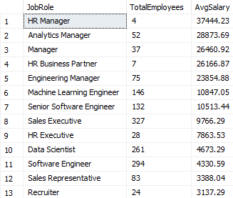
ORDER BY AvgSalary DESC
Figure (181): Q27 Average monthly salaries per job role

  - -- Q37 Avg Monthly Salaries Per Education Level
WITH UniqueEmployees AS (
SELECT DISTINCT Salary, EducationLevel, EmployeeID
FROM HRData
)
SELECT
EducationLevel,
COUNT(distinct EmployeeID) AS TotalEmployees,
ROUND(AVG(CAST(Salary AS FLOAT)/12), 2) AS AvgSalary
FROM UniqueEmployees
GROUP BY EducationLevel
ORDER BY AvgSalary DESC

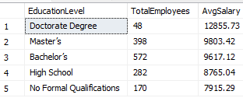
Figure (182): Q37 Average monthly salaries per education level

CHAPTER 4
Forecasting Questions
Introduction
The forecasting phase is a critical step in data analysis that involves using historical data to predict future trends, behaviors, or outcomes. By applying statistical models and machine learning techniques, forecasting helps businesses and decision-makers anticipate changes, prepare for upcoming challenges, and make proactive, data-driven decisions. This phase transforms raw data into valuable insights about what is likely to happen next making it a key component for strategic planning and resource allocation.

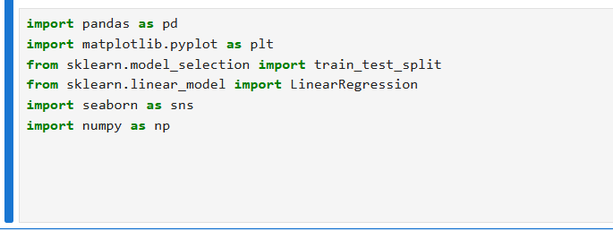
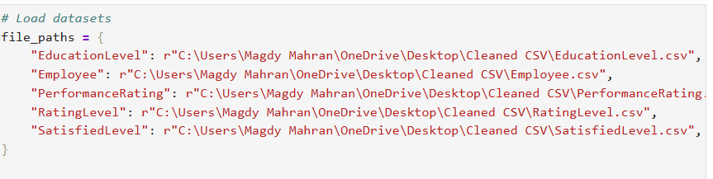
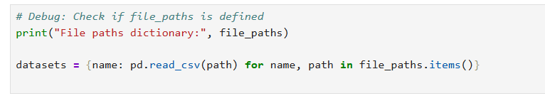
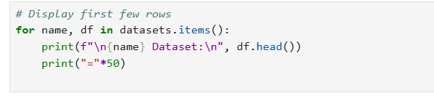
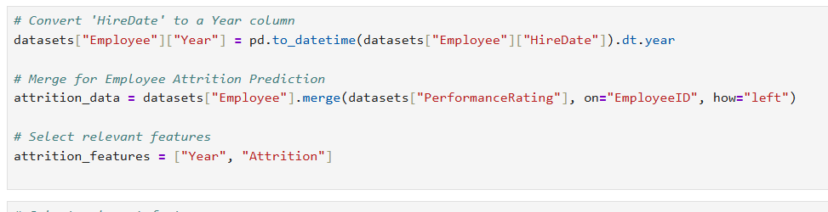
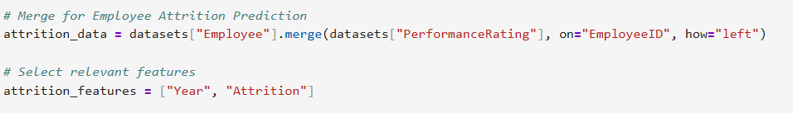
Chart 1 – Employee Attrition Forecast (Next 5 Years)
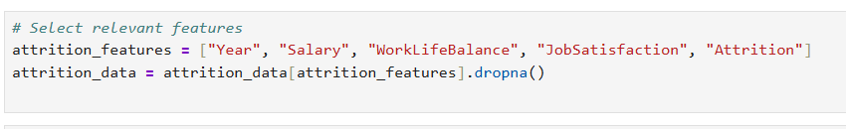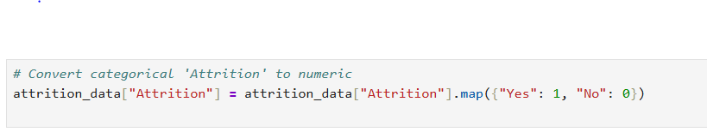
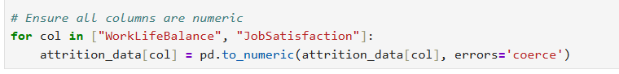
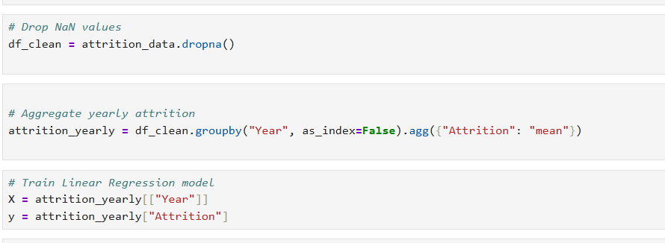

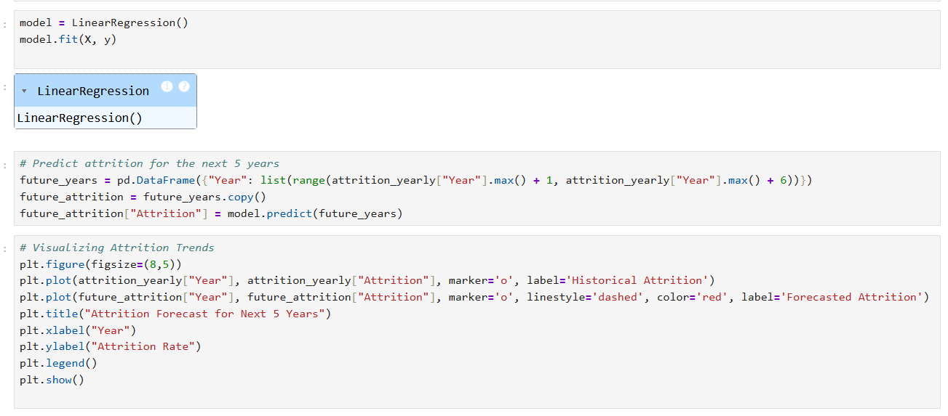
Insights from the Attrition forecast:
- The historical data shows an increasing attrition rate, particularly accelerating in recent years.
- The forecast suggests a continued rise in attrition over the next five years.
- Salary, Work Life Balance and Job Satisfaction appear to be the most influential factors affecting attrition.
- Employees with lower job satisfaction and poor work life balance tend to leave more frequently
- Age and salary trends also contribute as younger employees or those with stagnating salaries may be more likely to leave.
Predicted Problem:
- The chart shows a steady increase in employee attrition over the next five years.
- Likely concentrated among younger age groups or low-satisfaction employees.
- If no intervention is taken, employee attrition will continue to rise significantly.
- This could lead to increased hiring costs, loss of experienced employees and overall business instability.
Mitigation Strategies:
- Improve work life balance: Introduce flexible work schedules, remote work options and wellness programs to enhance employee satisfaction.
- Increase job satisfaction: Offer clear career progression paths, regular feedback and training programs to retain employees.
- Competitive compensation and benefits; Regular salary adjustments and performance-based bonuses can help retain top talent.
- Early warning system; Use predictive analytics to identify high-risk employees and implement targeted retention strategies.
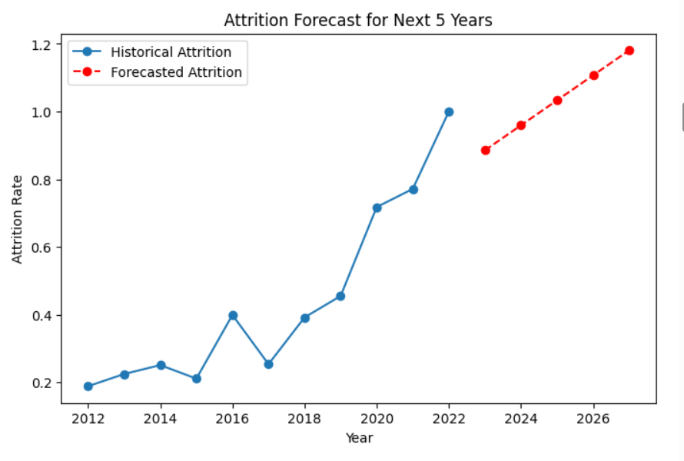
Figure (183): Attrition forecast for next 5 years

Chart 2 – Performance Rating Forecast
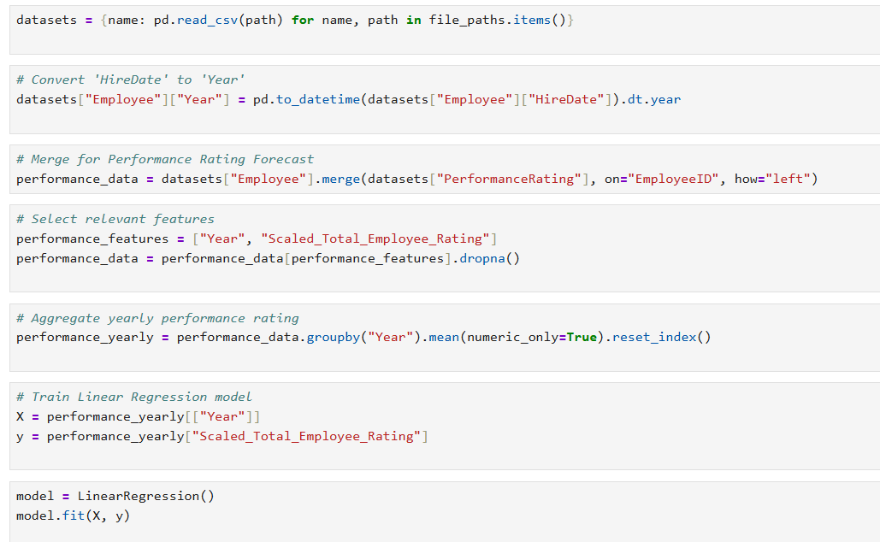
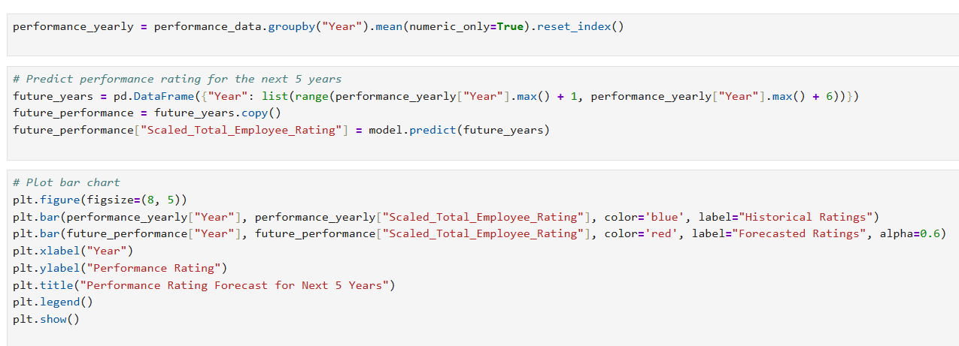
Insights from Performance Ratings:
- Declining performance ratings: The historical ratings (blue bars) remained relatively stable over the past years , but the forecasted ratings (red bars) indicate a significant decline in employee performance over the next 5 years.
- Potential causes of decline: The decline in performance ratings could be attributed to factors such as:
- Decreased job satisfaction; a drop in job satisfaction could lead to reduced performance.
- Lack of training opportunities; employees may not be receiving enough training and skill development opportunities.
- Work life balance issues; poor work life balance might be leading to burnout and lower engagement.
- Management and leadership issues; Declining manager ratings could be affecting overall employee performance.
- Attrition impact: High attrition rates might be leading to knowledge loss affecting team performance.
- Features affecting performance over years:
- Work-life balance.
- Job satisfaction.
- Training opportunities Taken.
- Manager Ratings.
- Years at company.
- Promotions and career growth opportunities.

Predicted Problem:
- Slight decline or stagnation in high performance ratings.
- Indicates potential disengagement or training gaps over time.
Mitigation Strategies:
- Introduce regular upskilling and mentorship programs.
- Align performance management systems with employee development and motivation.
- Enhance employee training and development :
- Increase training opportunities and encourage employees to participate in-skill building programs.
- Implement mentorship programs to improve knowledge transfer and performance.
- Improve job satisfaction and engagement:
- Conduct employee feedback surveys to identify key dissatisfaction points.
- Offer competitive incentives and career growth opportunities.
- Address work-life-balance concerns:
                - Implement flexible work schedules and remote work options.
                - Promote such as stress management programs.
4.Strengthen leadership and managerial support:
                - Train managers to improve communication, coaching and leadership skills.
                - Encourage regular feedback loops between employees and management.
5.Reduce Attrition and Retain skilled employee:
                - Offer career progression opportunities.
                - Recognize and reward high-performing employees.
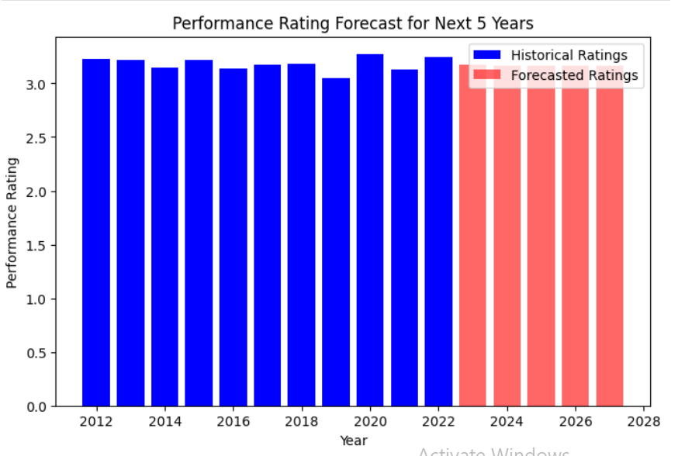
                - Improve work culture to enhance employee retention.
Figure (184): Performance Rating forecast for next 5 years

Chart 3 – Correlation Matrix:
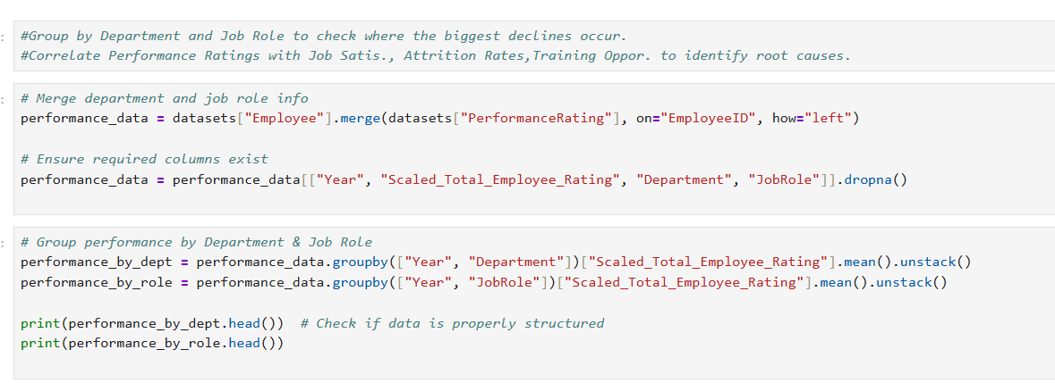
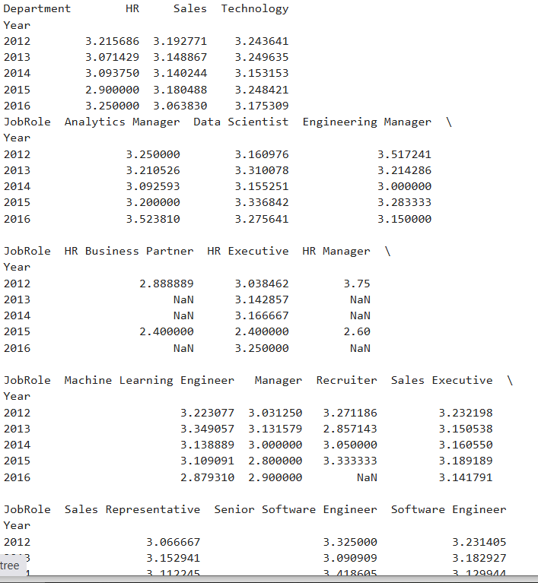
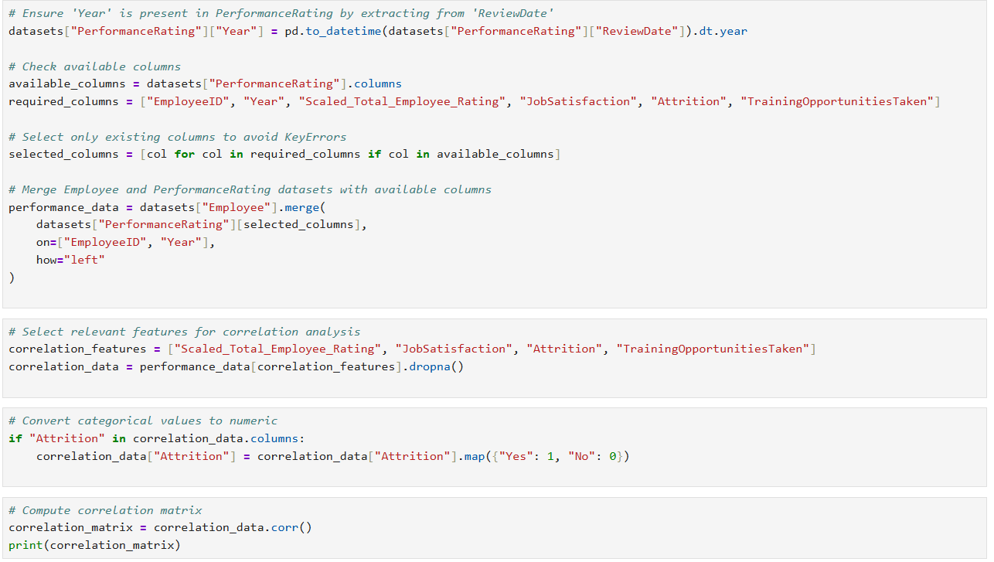
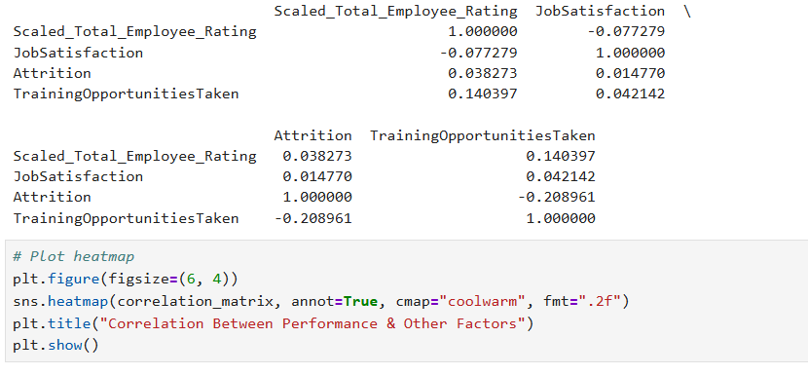
Insights from correlation Matrix:
1-Performance Rating vs. Job satisfaction (-0.075654): (Very weak negative correlation) Higher job satisfaction does not strongly indicate better performance ratings.
2.Performance Rating vs. Employee attrition (0.030041): (Almost no correlation) Employee attrition dose not directly impact performance ratings.
3.Performance Rating vs. Training opportunities (-0.196132): (Moderate negative correlation) Employees with more training tend to stay longer.
Actions to improve performance and reduce attrition:
- Enhance Training Programs.
- Improve Job satisfaction: Though weakly correlation, job satisfaction still influences retention.
- Analyze Department –Level-Trends: Some roles may show stronger correlations, requiring tailored solutions.
This correlation chart is important for our performance prediction in 5 years because it helps identify the relationships between key factors that could influence future performance ratings.
Here is why it matters:
1.Feature selection for forecasting:
The chart shows how Scaled_Total_Employee_Rating is related to Job satisfaction, Attrition and Training opportunities taken.
2.Understanding key influences:
- The correlation with job satisfaction (-0.08) is weak, meaning job satisfaction may not significantly predict performance ratings.
- Training opportunities taken has a positive correlation (0.15) indicating employees who take more training tend to have higher ratings.
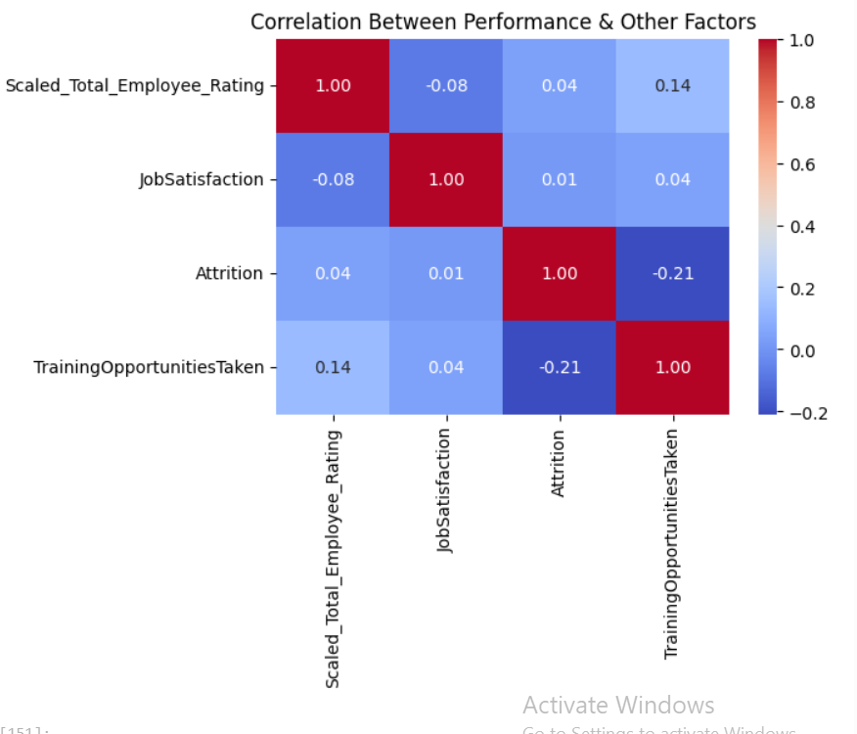
- Attrition (-0.20 correlation with training opportunities taken) suggests employees who leave tend to have fewer opportunities.
Figure (185): Correlation between performance & other factors

Chart 4 – Salary Growth Projection
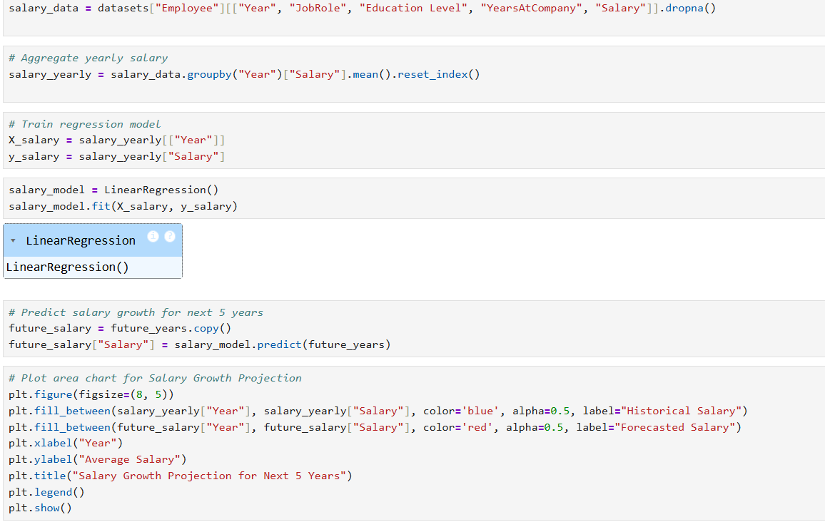
Insights from salary growth projection:
1.Historical Trends:
        - The historical salary data (blue) shows fluctuations, with some years having significant salary drops.
        - This could indicate economic downturns, changes in company policies, or shifts in industry demand.
2.Forecasted Trends:
        - The forecast (red) suggests a declining salary trend in the next five years.
        - This may indicate potential issues such as budget cuts, lack of salary adjustments, or stagnation in company growth.
3.Main features affecting prediction:
- Education level: Higher education may influence salary growth.
- Years at company: More experience typically leads to salary increases.
- Job role: Some roles have better salary progression than others.
- Company growth and market conditions: Inflation, revenue growth and hiring trends impact salaries.
Predicted Problem:
- Salary growth is skewed or stagnant for certain job roles or education levels.
- Job dissatisfaction may rise impacting productivity and morale.
- If salaries decline, employee attrition could increase as workers seek better opportunities elsewhere.
Mitigation strategy :
- Conduct a compensation review by job role and education.
- Ensure salary progression pathways are transparent and fair.
- Invest in skill development and training and training to justify salary increases.
- Align salary growth with industry trends to remain competitive.
- Improve retention strategies through better benefits and incentives.

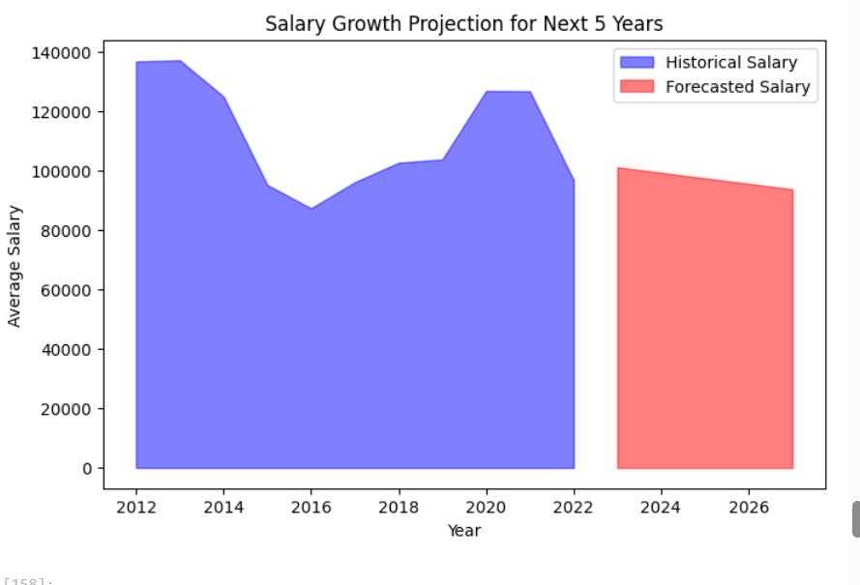
Figure (186): Salary growth projection for next 5 years

Chart 5 – Work-Life Balance Impact on Satisfaction
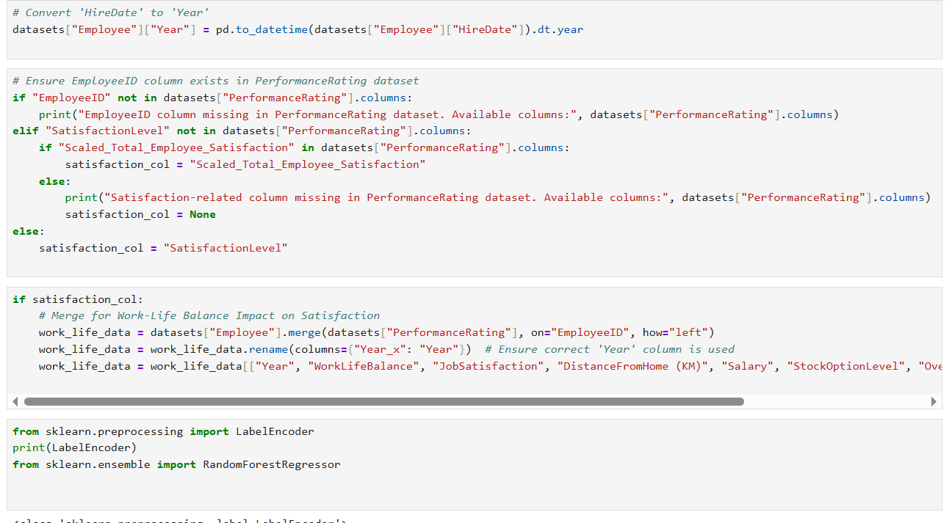
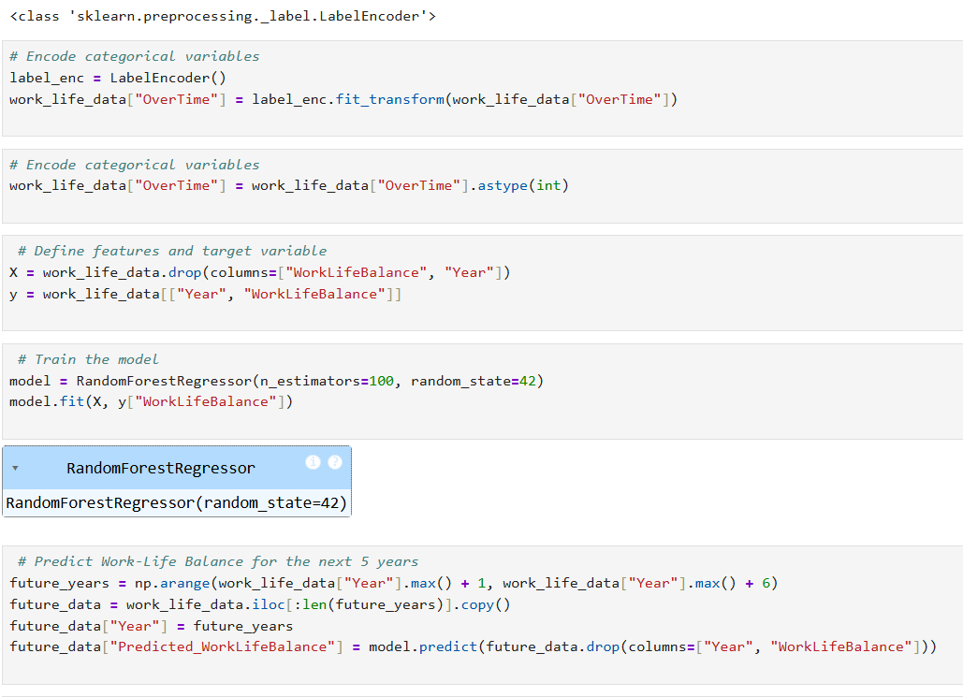
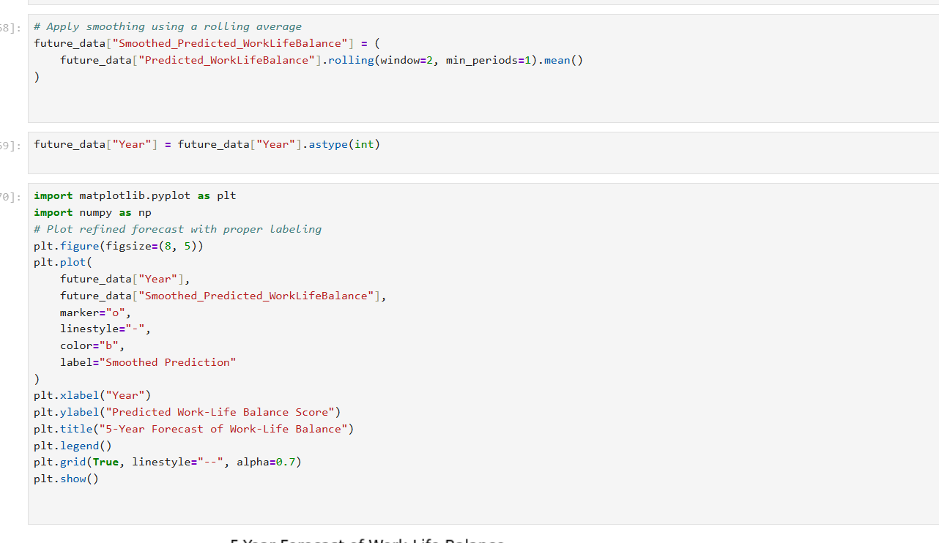

Insights from work-life balance forecast:
- The prediction shows sharp fluctuations in work-life balance over the next 5 years.
- There is a decline in 2024, a peak in 2025, another decline in 2026, and a slight recovery in 2027.
- Features affecting work-life balance :
            - Job satisfaction; Employees with lower job satisfaction might experience worse work-life balance.
            - Distance from home: Long commutes negatively impact work-life balance.
            - Salary: Financial stress can reduce work0life balance, while competitive salaries may improve it.
            - Stock option level: Employee benefits contribute to retention and satisfaction.
            - Overtime work; More overtime often correlates with poorer work-life balance.

Predicted Problem:
- Employees with poor work-life balance show noticeably lower satisfaction, and the trend seems to worsen over time.
- Correlates with rising attrition risk and lower performance.
- The sharp drop in 2024 could indicate upcoming work place challenges such as increased workload, leadership changes, or lower job satisfaction.
- The peak in 2025 may reflect new policies improving employee well-being (e.g. better benefits, flexible options, higher salaries).
- The second drop in 2026 suggests a potential decline in these benefits or economic conditions affecting work-life balance.

Mitigation Strategy:
- Train managers on creating healthier team dynamics and work expectations.
- Monitor Job Satisfaction Trends: Conduct regular employee feedback surveys and track signs of dissatisfaction.
- Flexible Work Policies: Hybrid/remote work can ease commute-related stress and improve morale.
- Limit Excessive Overtime: Encourage work-life balance through workload management and realistic deadlines.
- Enhance Employee Benefits: Competitive salaries, stock options, and health benefits help maintain satisfaction.
- Sustain Positive Changes: If 2025 brings improvements, ensure long-term strategies are in place to maintain that momentum and prevent regression in future years.

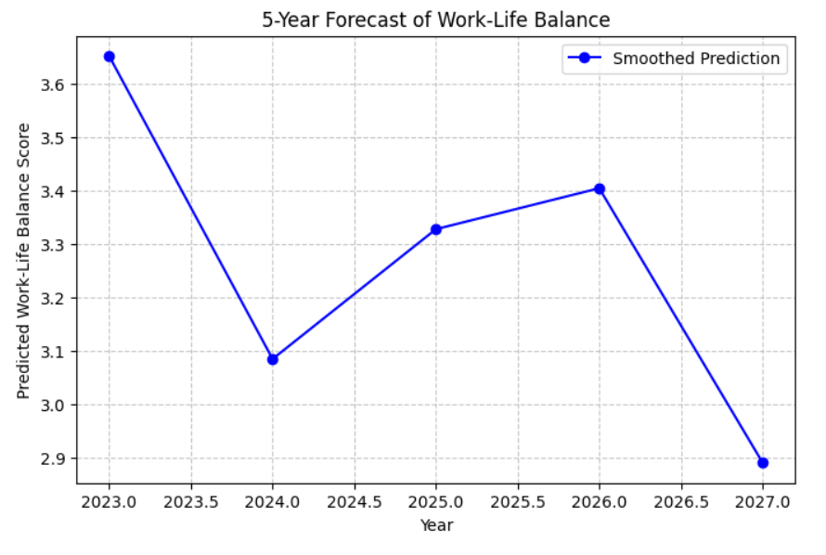
Figure (187): forecast of work-life balance for next 5 years

Chart 6 – Workforce Education Trends and Age Categorization & Workforce Distribution (Next 5 Years)
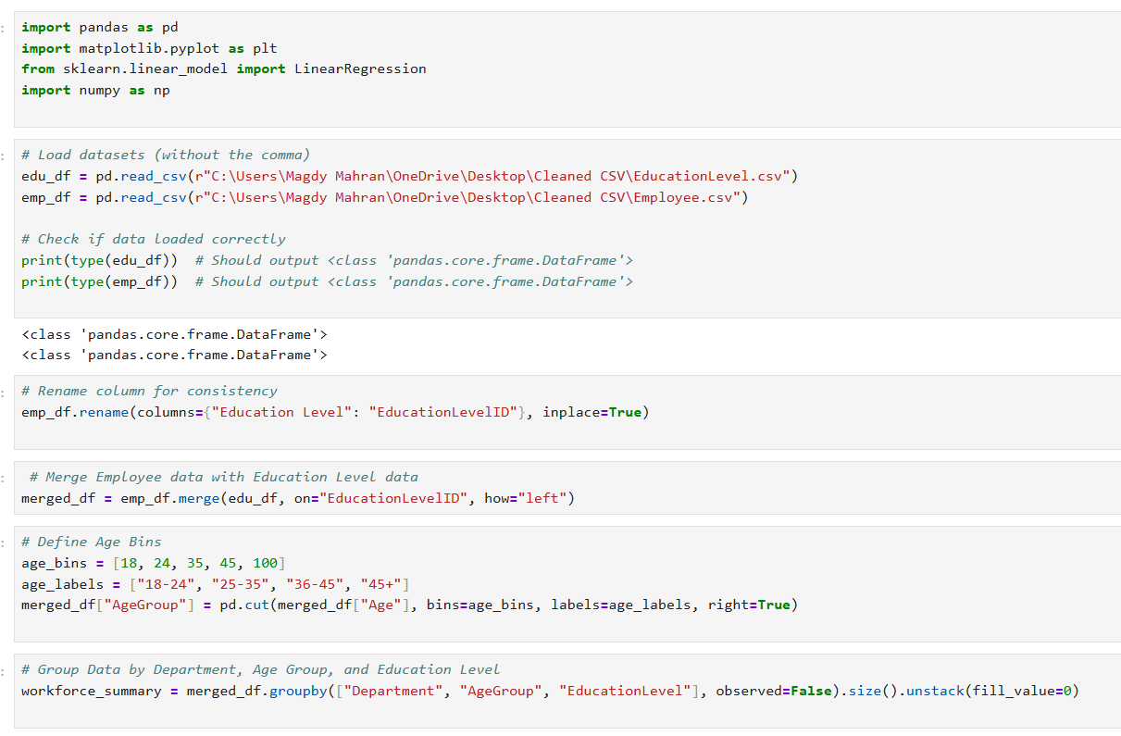
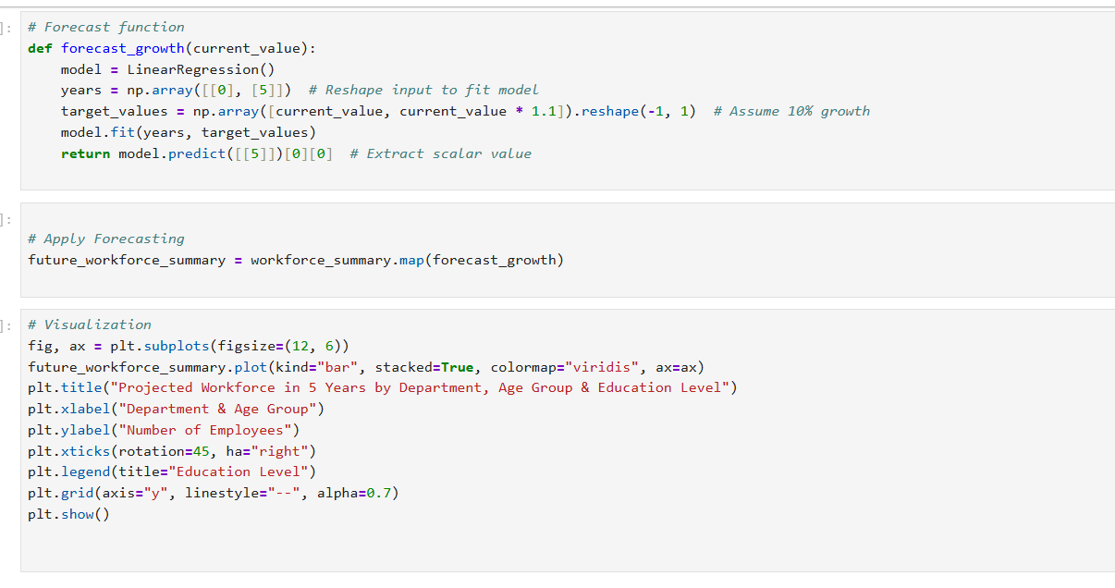
Insights from the chart:
1.Work force distribution by Age and Education:
        - Younger employees (20-30) have a higher share of lower education levels and mostly in entry-level roles.
        - Mid-career professionals (31-40) and experienced employees (41-50) employees have a mix of bachelor's and master's degree.
        - Senior employees (51+) tend to have more stable education levels overtime and more likely in managerial roles.
        - Technology department has the highest projected workforce across all age groups.
        - Sales department trends:
                - Strong workforce presence in the 25-35 age group, but lower in the 36-45+.
                - Growth in High school and bachelor's levels suggest potential for skill development programs.

        - HR department stability:
                - Relatively smaller workforce with little variation across age group.
                - Higher proportion of master's and bachelor's degree holders, indicating or experienced professionals.
2-Trends for the next 5 years:
        - The workforce composition remains stable, but there is a slight shift towards higher education levels in younger employees.
        - Senior employees may gradually retire, reducing their presence in the workforce.
        - The hiring trend suggests a focus on mid-career professionals with higher education levels.

3.Features affecting workforce prediction:
            - Hiring trends.
            - Educational requirements.
            - Age demographics.
            - Industry demand.
Predicted Problem:
- Low representation of advanced degrees in projected hiring trends.
- Might signal under-investment in high-skill talent or lack of advanced role development.
- Over-reliance on mid-age workforce (31–40), while 20–30 and 51+ age groups are underrepresented as younger employees are more likely to switch jobs.
- Shortage of experienced employees (45+ years) if retention polices are not improved a lack of senior professionals may impact decision making and mentorship.
- Mismatch of skills and education: Employees InTechnology need higher qualifications but fewer Doctorate holders are projected possibly limiting high level expertise.
- Risk of future talent shortage and lack of generational diversity.

Mitigation strategy:
- Encourage professional development through sponsorships and certification reimbursements.
- Partner with universities or platforms for talent pipelines and continuous education.
- Attract younger talent with internships, entry-level training, and career progression plans.
- Retain older employees through phased retirement, knowledge-sharing programs, and wellness support.
- Talent Acquisition strategy:
                - Technology: Focus on recruiting and training tech professionals in AI, software development and data analytics.
                - Sales: Upskill employees and offer management training for career progression.
                - HR; Maintain stability but prepare for succession planning as senior employees retire.

    - Training and development:
                - Increase investment in graduate programs and certifications for the Sales and HR department.
                - Encourage continuous learning for Technology professionals to stay updated with industry advancements.

    - Succession planning and retention:
                - Develop mentorship programs in HR and Sales to retain knowledge from senior employees.
                - Create a career path framework to encourage internal promotion and reduce turnover.
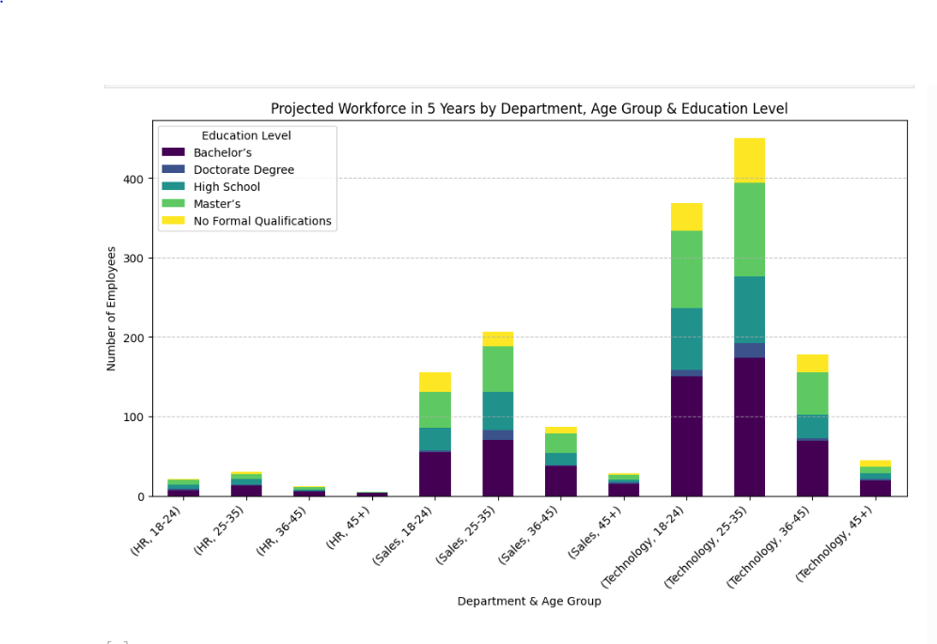
Figure (188): projected workforce in 5 years by department

CHAPTER 5
VISUALIZATION AND TABLEAU
5.1 Introduction
In this chapter, we present the data visualization and dashboarding phase of our HR Analytics project, which was conducted using Tableau. This stage played a crucial role in transforming complex HR data into insightful and interactive visuals that support data-driven decision-making.
The main objective of this phase was to explore key HR metrics — such as employee satisfaction, performance ratings, turnover rates, and education levels — and to present them in a clear and intuitive manner for stakeholders. Tableau’s dynamic and user-friendly interface enabled us to design customized dashboards that reflect the current workforce trends and uncover hidden patterns.
These visualizations not only helped in summarizing large volumes of data but also provided actionable insights to support HR strategies such as employee retention, performance management, and talent development.
In the following sections, we will showcase the main dashboards created, describe the visual choices made, and explain how each component contributes to understanding and improving HR performance.

1.Employee Demographics Dashboard:

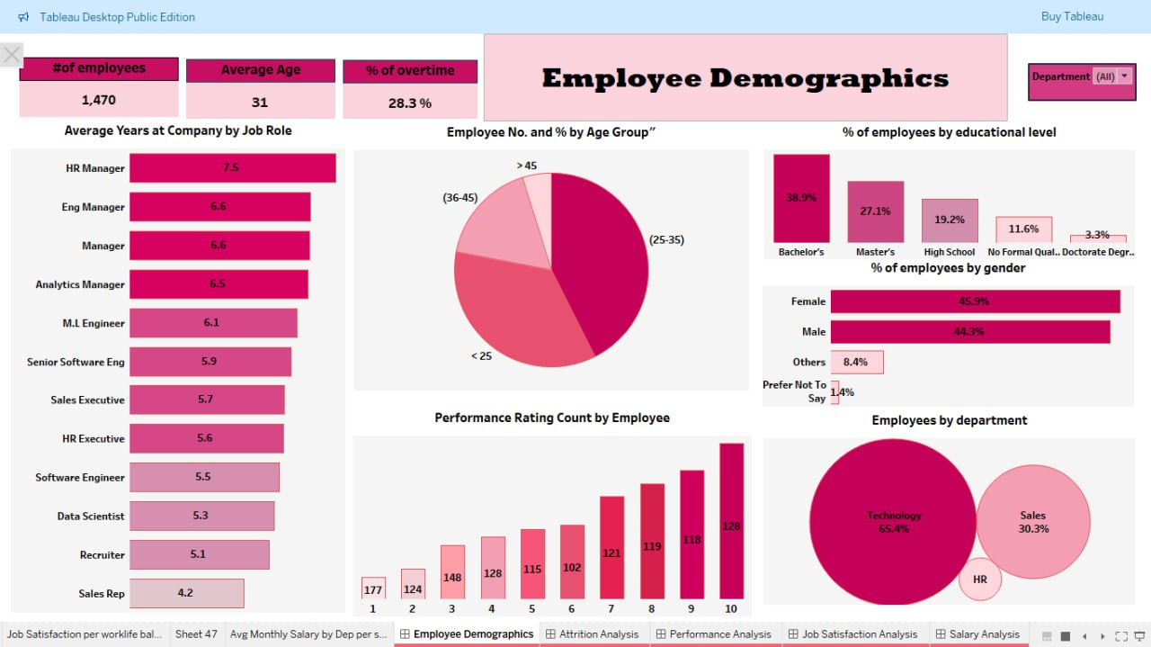
Figure (189): Employee demographics dashboard

In Detailed:
a.Average years at company by job role: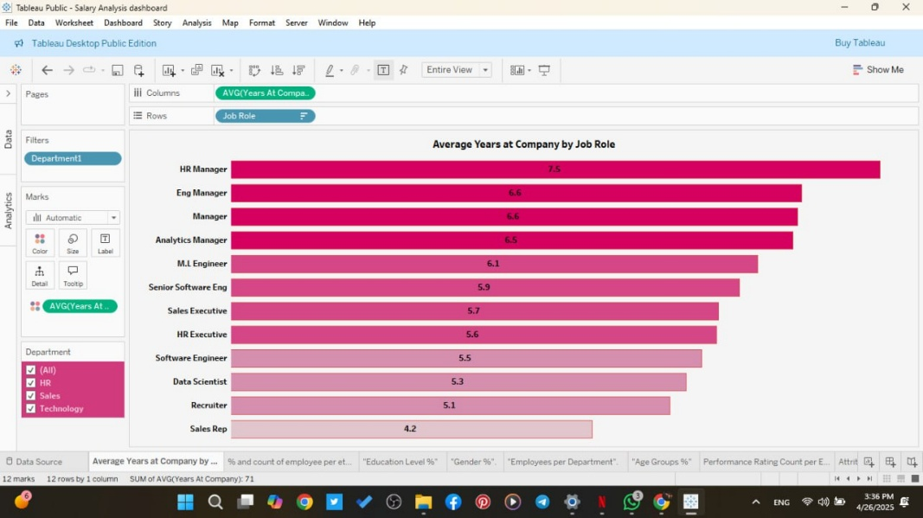

b.Employee No. & % by Age Group:
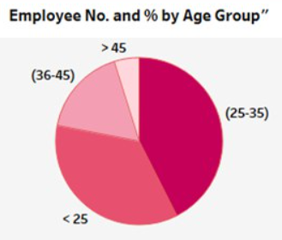

c.% of employees by gender:
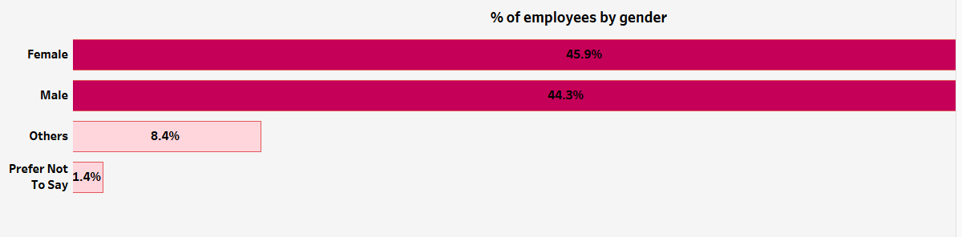
d.% of employees by department: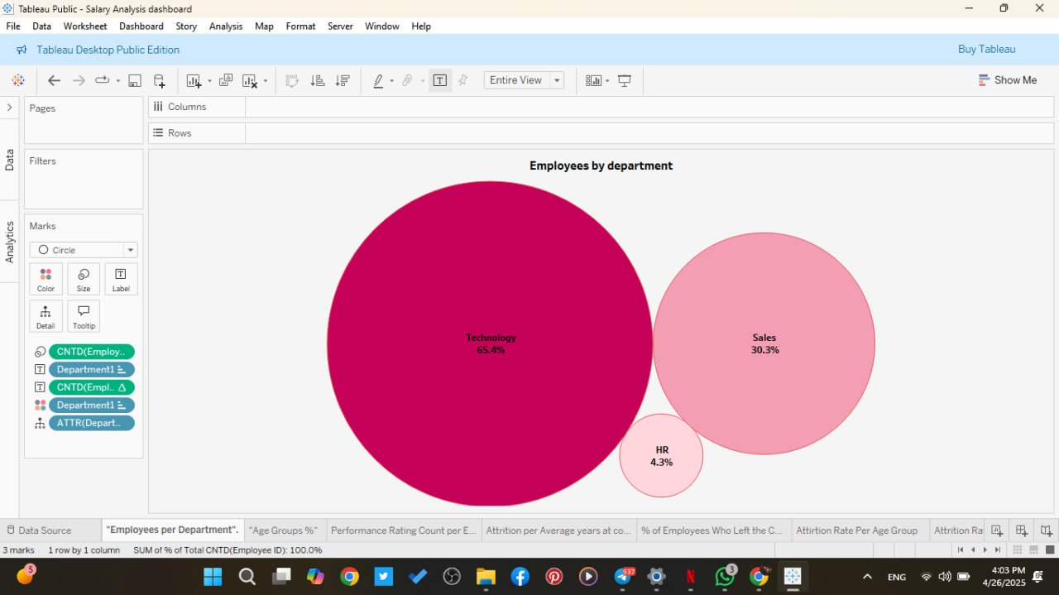
e.% of Employee by Educational level:
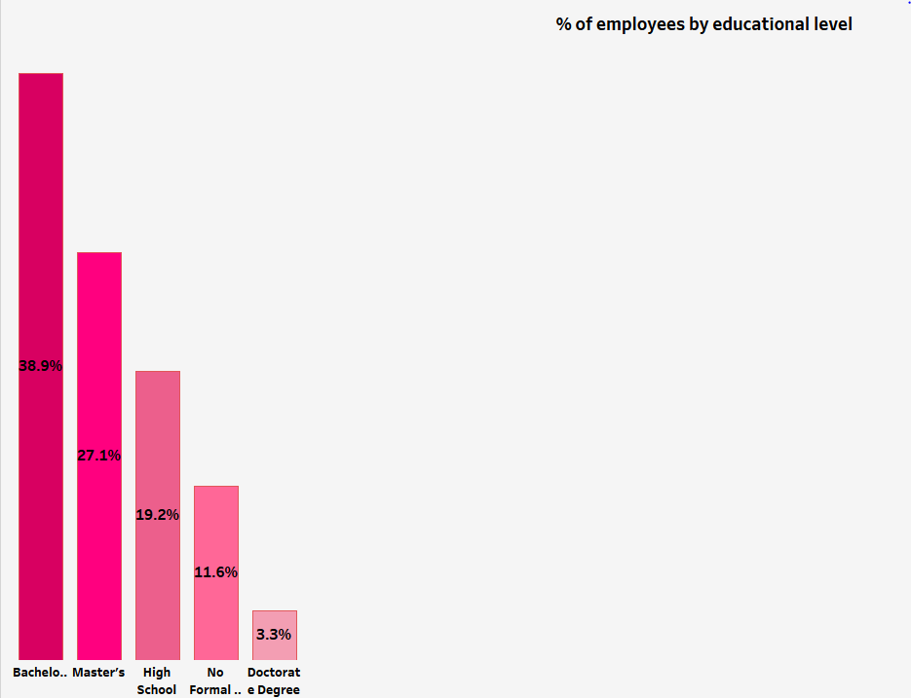
f. Performance rating count by employee:
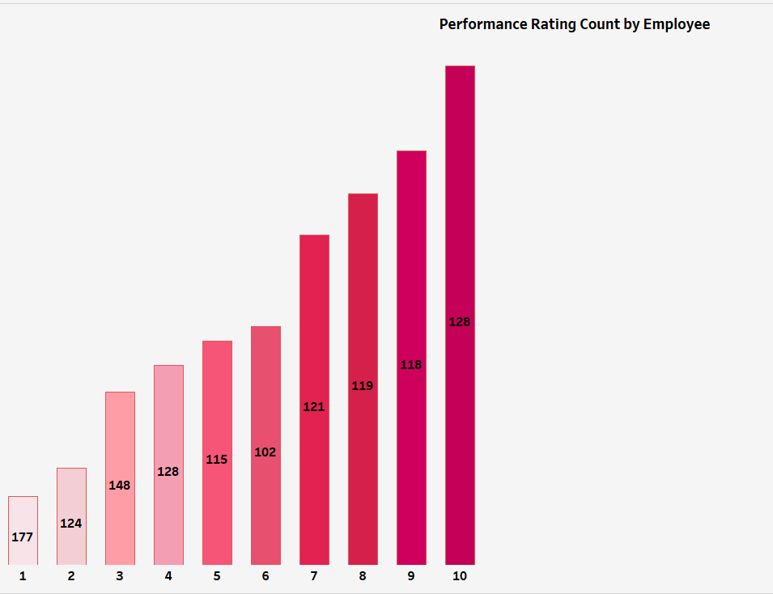

2-Attrition Analysis Dashboard
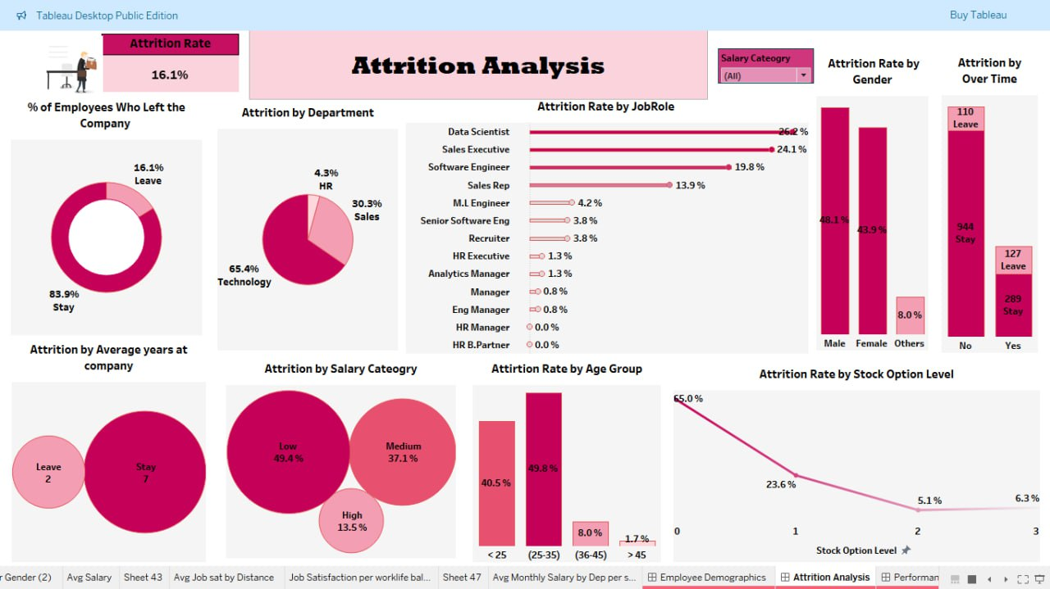
Figure (190): Attrition analysis dashboard

In Detailed:
a. % of leave VS. Stay employees:
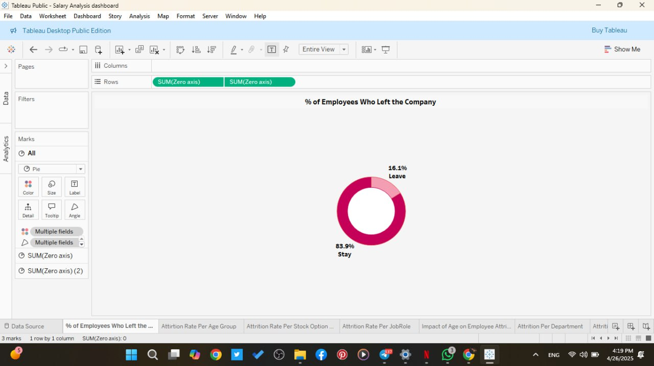
b. Attrition by Department:
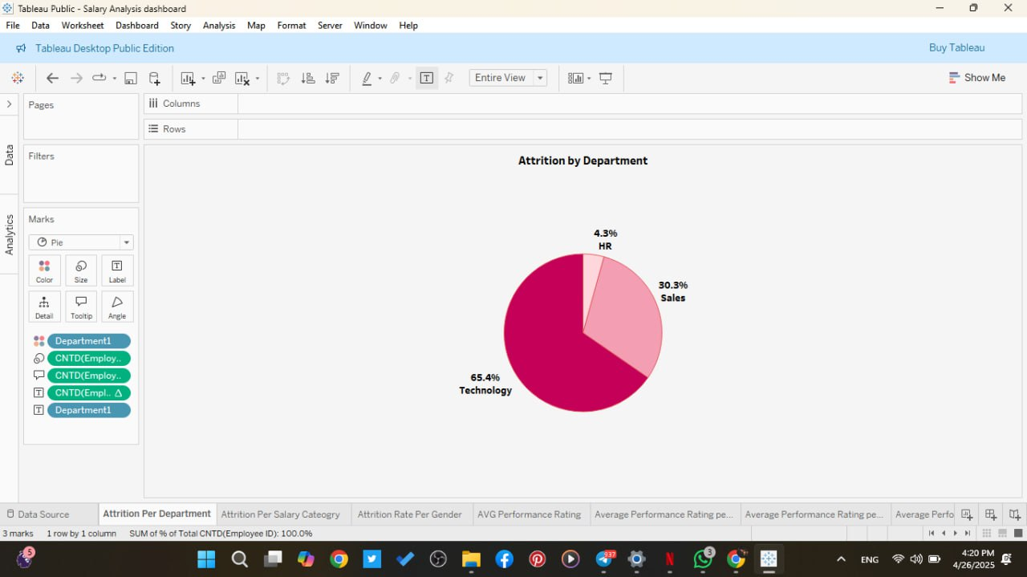

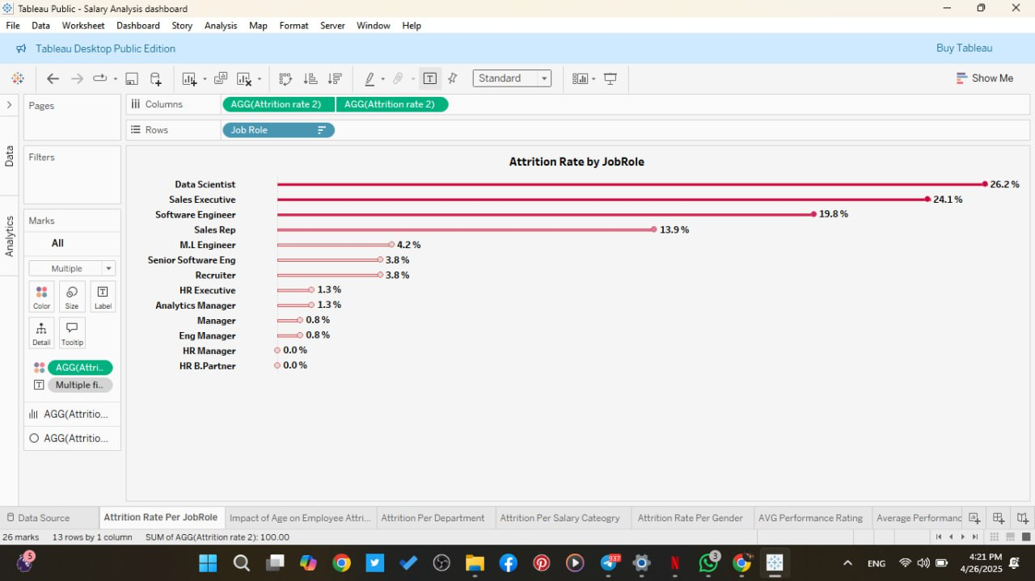
c. Attrition rate by job Role:

d. Attrition rate by gender:
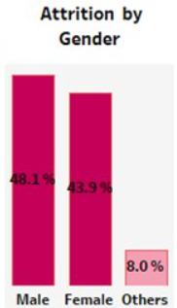

e. Attrition by Overtime:
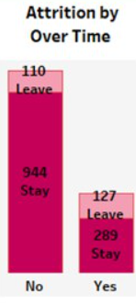

f. Attrition by average years at company:
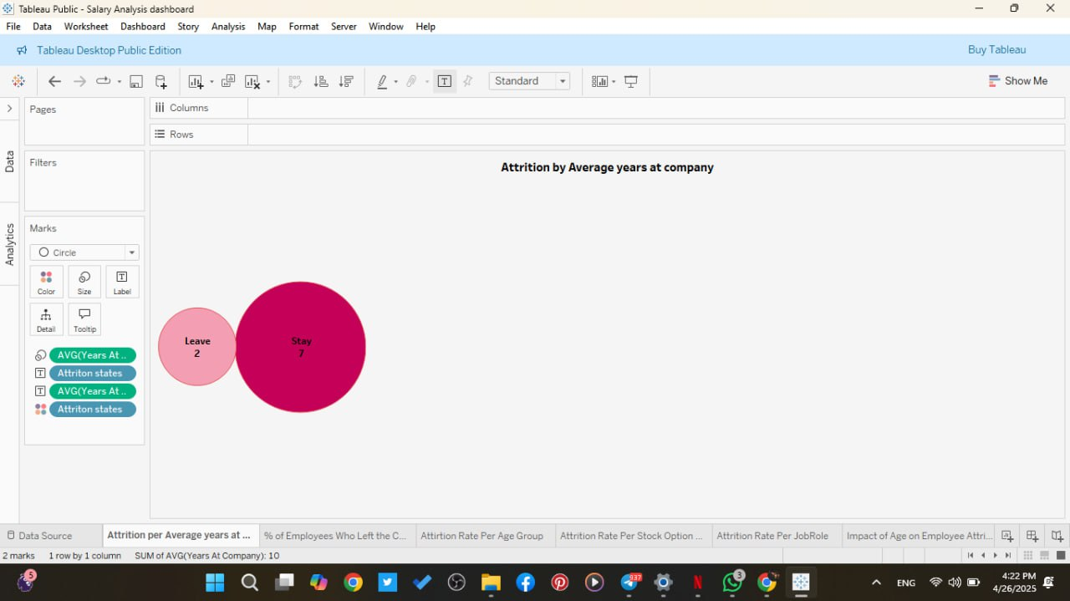

g. Attrition by salary category:
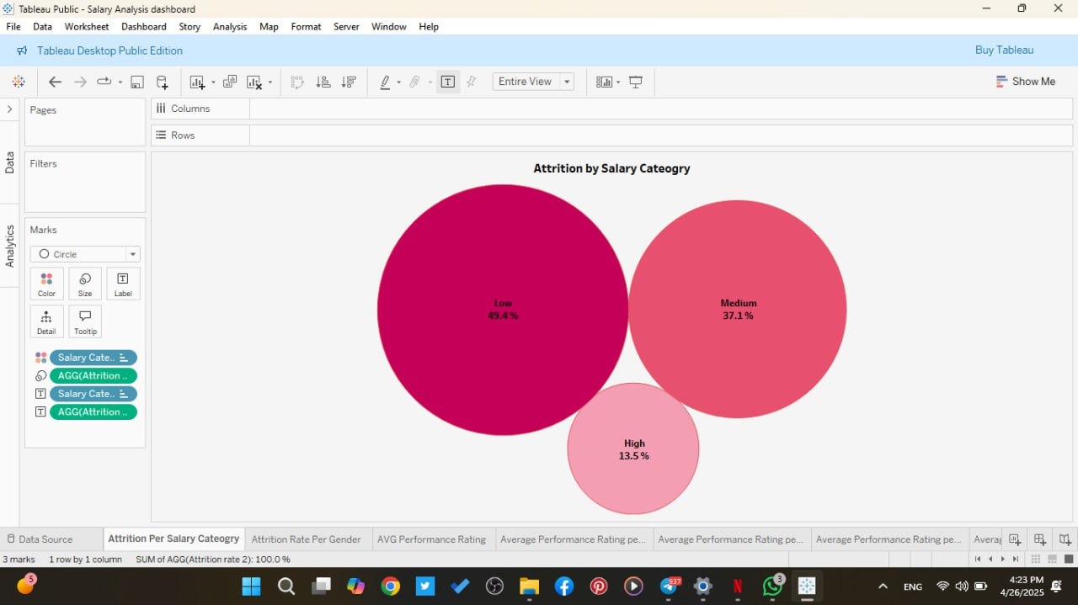
h. Attrition rate by age group:
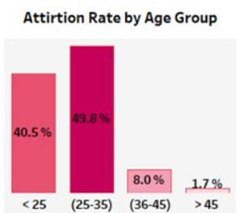

i. Attrition rate per stock option level:
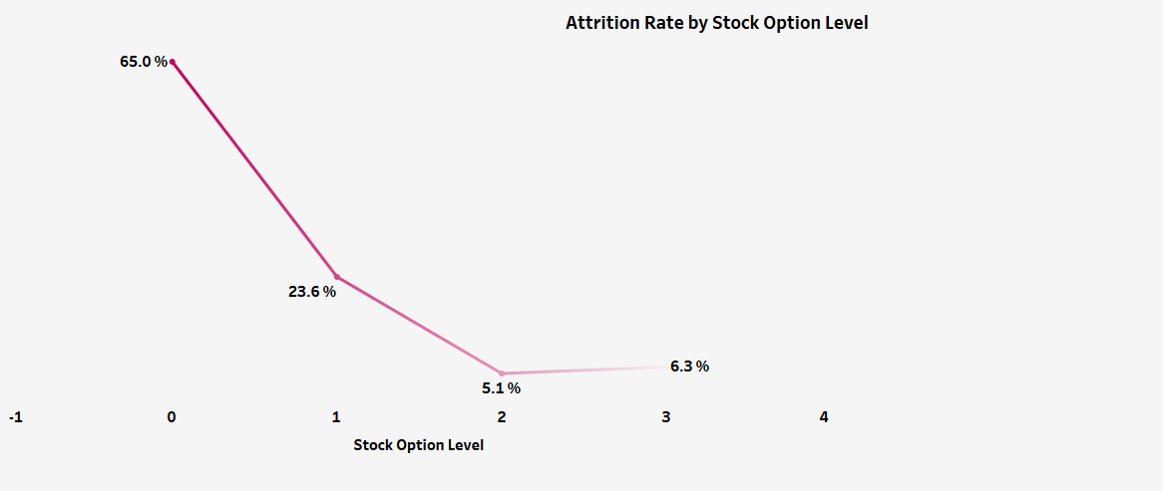
j. % of leave VS. Stay employees:
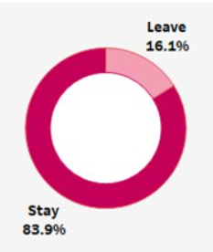

k. Attrition by departement:
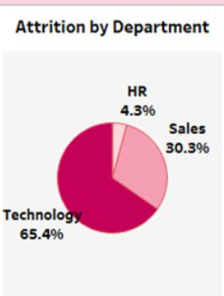

4.Job Satisfaction Analysis Dashboard
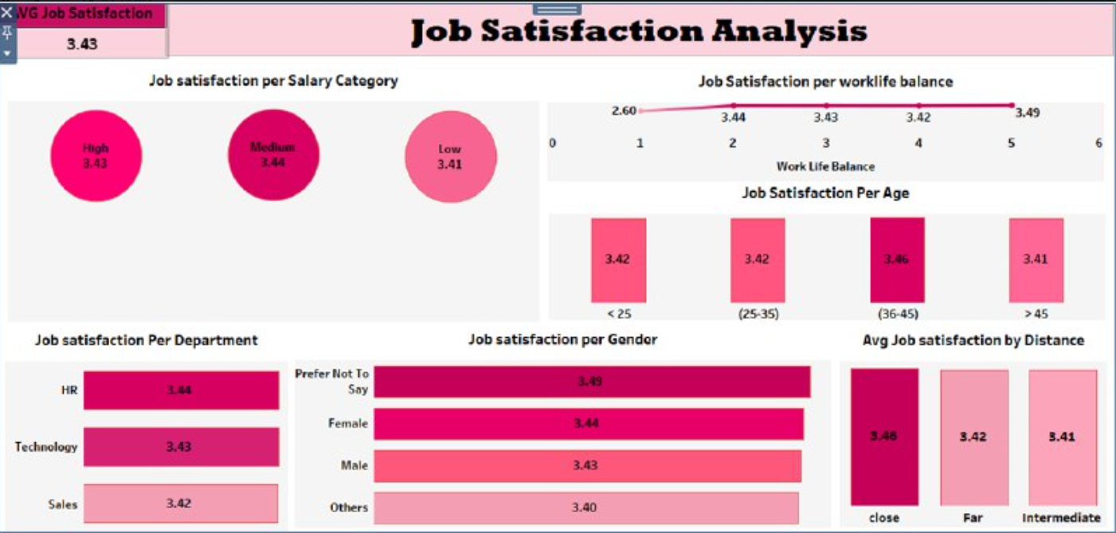
Figure (191): Job satisfaction analysis dashboard
In Detailed:
a. Job satisfaction per job category:
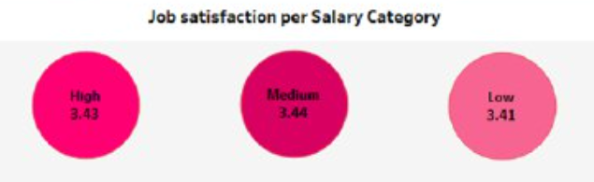
b. Job satisfaction per Worklife balance:
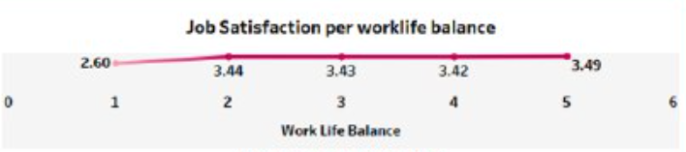
c. Job satisfaction per age:
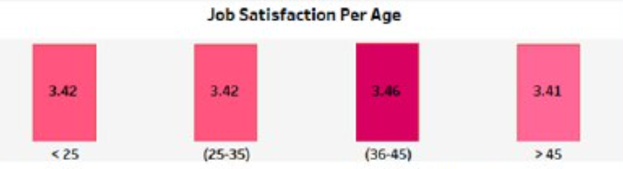d. Job satisfaction per department:
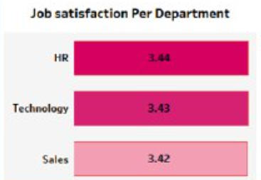

e. Job satisfaction per Gender:
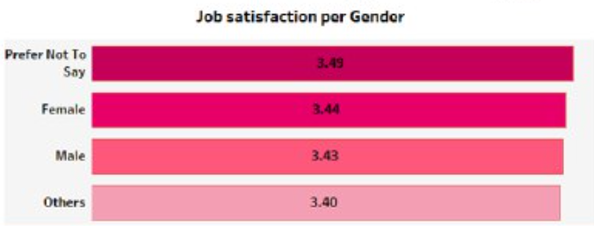f. AVG job satisfaction by distance:
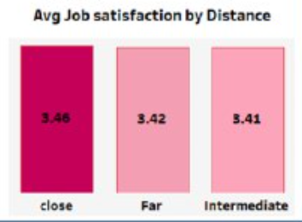

5-Salary Analysis Dashboard
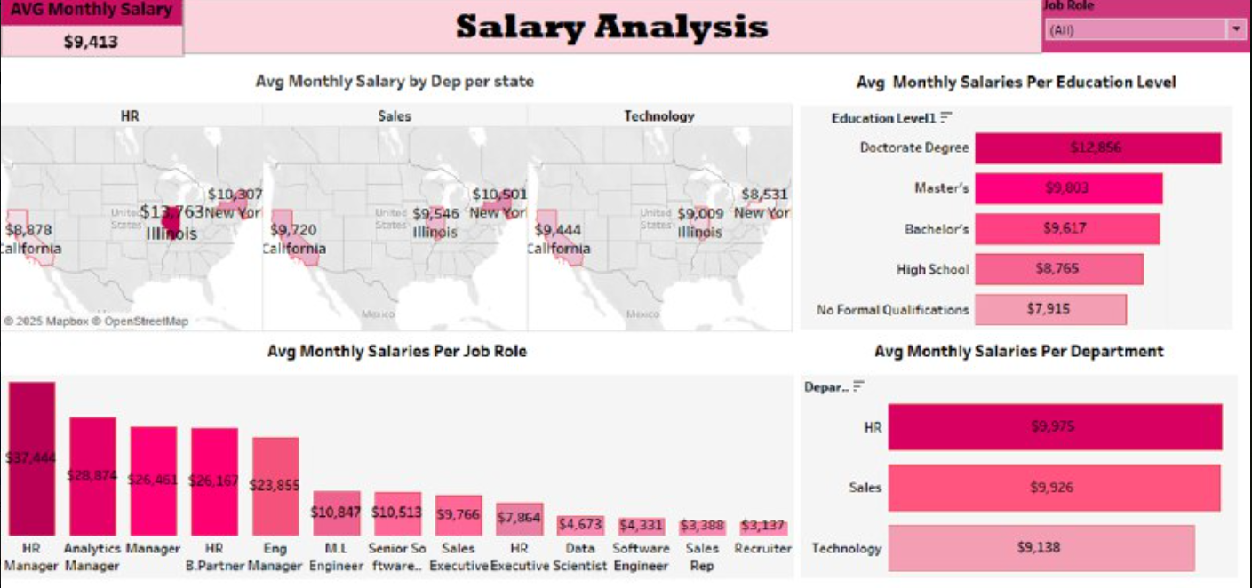
Figure (192): Salary Analysis Dashboard
In Detailed:
a. AVG monthly salary by Dep. Per state:
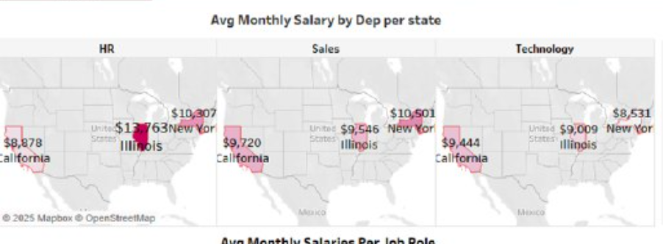

b. AVG monthly salary per Education Level:
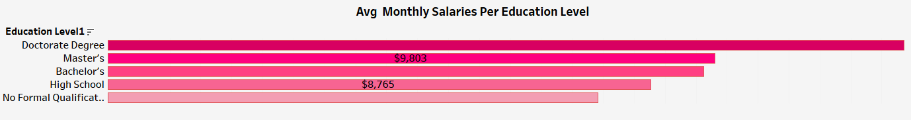
c. AVG monthly salaries per job role:
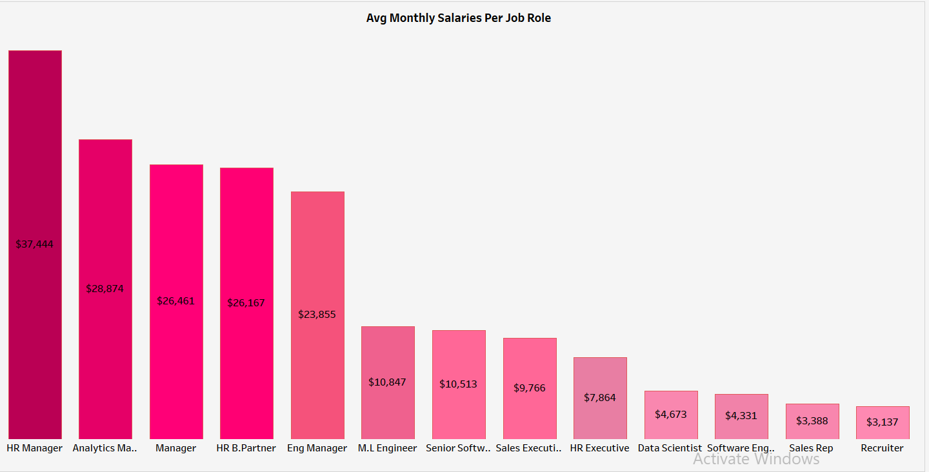

d.AVG monthly salaries per department:
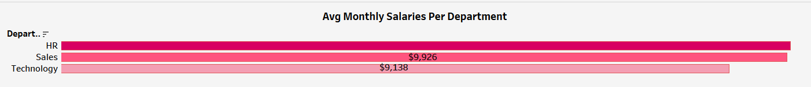

CHAPTER 6
Conclusions & Recommendations
Introduction
Based on the analysis conducted throughout this project, several key insights have been identified regarding employee retention, satisfaction, performance, and organizational development. This chapter presents detailed conclusions drawn from the data and provides actionable recommendations aimed at improving HR practices and organizational outcomes.

6.1 Retention in Sales & Technology
Issue:
High attrition rates were observed among Sales Executives and Data Scientists (24.2%).
Recommendations:
- Conduct Exit and Stay Interviews to understand turnover reasons.
- Revise role expectations and ensure realistic sales targets and meaningful projects for Data Scientists.
- Define clear career growth paths supported by certifications and learning budgets.
- Introduce role-specific incentives, such as quarterly bonuses and public recognition.

6.2 Improve Compensation & Benefits
Issue:
Employees with low salaries and no stock options exhibited the highest attrition rates.
Recommendations:
- Conduct market benchmarking to ensure competitive salaries.
- Expand stock option plans to junior and mid-level employees.
- Implement performance and tenure-based bonuses.
- Maintain transparent salary bands and growth criteria.

6.3 Manage Overtime Effectively
Issue:
28.3% of employees reported working overtime, which correlated with higher attrition.
Recommendations:
- Assess departmental workloads and redistribute tasks where necessary.
- Implement systems for overtime monitoring and alerts.
- Establish “No Meeting Days” to increase productivity during working hours.
- Shift the culture towards rewarding efficiency over long working hours.

6.4 Support for Early-Career Employees (Ages 25–35)
Issue:
This age group experienced the highest attrition rate (49.8%).
Recommendations:
- Implement mentorship programs and structured onboarding.
- Create leadership development programs targeting young talent.
- Schedule regular feedback sessions and tailored engagement activities.

6.5 Sustain and Enhance Diversity & Inclusion
Issue:
Balanced age group presentation was observed, indicating an opportunity to sustain progress.
Recommendations:
- Develop diverse hiring pipelines and ensure equal promotion opportunities.
- Provide inclusive leadership training for managers.
- Support Employee Resource Groups (ERGs) to foster belonging.
- Track and report Diversity & Inclusion metrics transparently.

6.6 Improve Work-Life Balance
Issue:
Positive impact of work-life balance on satisfaction and retention.
Recommendations:
- Offer flexible work policies including hybrid and remote options.
- Provide mental health support resources.
- Conduct quarterly well-being surveys.
- Promote the importance of taking time off.

6.7 Leverage and Retain Tenured Employees
Issue:
High retention rates were observed among roles with longer tenure, such as HR Managers.
Recommendations:
- Assign tenured employees as mentors and coaches.
- Establish recognition programs for service milestones.
- Involve senior employees in process improvement initiatives.
- Document institutional knowledge through knowledge bases and SOPs.

6.8 Address Mid-Tenure Performance Decline
Issue:
Employee performance peaked in Year 2 but declined during Years 3–6.
Recommendations:
- Develop a Mid-Tenure Growth Program with role enrichment and progression opportunities.
- Conduct stay interviews to address disengagement factors.
- Recognize milestones at the 3-year and 5-year marks.
- Establish mentorship circles to maintain engagement.

6.9 Strengthen the Link Between Job Satisfaction and Performance
Issue:
Minimal correlation between satisfaction and performance ratings.
Recommendations:
- Revise employee engagement surveys to capture actionable insights.
- Train managers on performance coaching techniques.
- Segment team-level metrics to identify discrepancies.
- Implement role-specific recognition programs.

6.10 Address Departmental Performance Gaps
Issue:
Technology department outperformed HR and Sales departments.
Recommendations:
- Conduct departmental best practice audits.
- Promote cross-functional collaboration projects.
- Provide non-tech teams with tools and resources to enhance performance.
- Organize productivity workshops led by the Technology department.

6.11 Optimize Salary Strategy for Performance
Issue:
Higher salaries did not significantly impact employee performance.

Recommendations:
- Focus on development opportunities rather than salary increases.
- Use medium-salary tier employees as a leadership pipeline.
- Implement value-based recognition aligned with performance outcomes.
- Maintain transparent career growth paths.

6.12 Final Note:
Addressing the identified issues with these recommendations is crucial for enhancing employee retention, increasing satisfaction, and sustaining organizational performance. Continuous monitoring, employee feedback, and data-driven HR strategies will ensure long-term success and support a positive work environment

